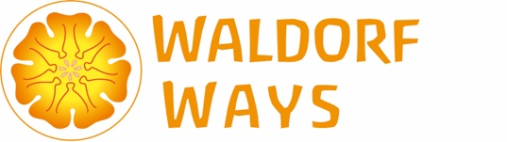
SAYING YES TO THE WORLD REGISTRATION FORM

Registration Fee $20
Workshop block Fee $60

First Name |  | Last Name
Email Address |  | Mobile Number (Including dialling codes)
Occupation |  | Course Fee to pay via Bank or Paypal
Address
Please tell us your interest in Waldorf Education
Where did you hear about this course?

Once completed, please email this form to the Waldorf Ways Administrator Donovan Gay
donovan.gay@waldorfways.com
Please pay your registration fee of $20 (per participant) via PayPal to
donovan.gay@waldorfways.com
Once you have registered you will be put in contact with Sven for your course payment of $60 via PayPal or Bank Transfer
Once we have received both your completed registration form, registration and workshop fees Sven will supply you with the workshop link. You cannot access the workshop without pre-payment.

