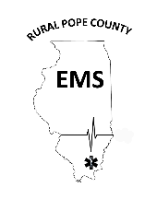
Rural Pope County Emergency Medical Services
Standard Operating Procedures

Section: General Rules & Administration- 100.00
SOP # 100.01 | Subject: Mission, Values, and Statement of Core Values |  | Page: 1 of 1
Effective: 02/17/2022 |  | Authorized: Tiffany Lamp- Asst. Director
Revised: |  | Authorized:

100,01.01 Mission
The mission of Rural Pope County Emergency Medical Service is to preserve the health, safety and welfare of Pope County and the surrounding communities by providing the highest level of emergency services the department is capable of and public education with compassion and excellence. We promise to always strive to reach a higher level of education and certification in order to serve Pope County to the best of our ability. In the workplace, we foster teamwork, value diversity, and offer opportunities for personal and professional growth.
100.01.02 Vision
Our vision is to achieve the optimal outcome for each life we serve by providing the highest level of service the department is capable of, through an all-hazards emergency response capability while staying on the forefront of medical advancements with training and technology in a workplace built on trust, opportunity, and teamwork.
100.01.03 Statement of Core Values
We strive to consistently demonstrate:
• Integrity
• Compassion
• Respect - for Life
• Sacrifice
• Pride – in Making a Difference
• Education • Proficiency
• Teamwork

100.01.04 Department Motto
“We Make Every Second Count”

