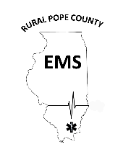

|  |  |  |  |
| --- | --- | --- | --- |
| Section: Human Resources 101.00 | | | |
| SOP # 101.06 | Subject: Pay Rates | | Page: 1 of 1 |
| Effective: 02/17/2022 | | Authorized: Tiffany Lamp- Asst. Director | |
| Revised: | | Authorized: | |

Rural Pope County Emergency Medical Services

Standard Operating Procedures

101.06.01 Purpose

To establish Departmental policy and procedures for holiday pay compensation specific to personnel.

101.06.02 Policy

1. This SOP applies to all personnel.

2. Normal pay for employees of any licensure is $13 for every hour up to 40 hours in a pay period. Any hours after 40 hours in a single pay period will remain at the normal pay rate, but will accrue Compensation time at a rate of .5 per hours for every hour over 40 in a single pay period, in accordance with local and state guidelines regarding overtime pay. This time can be used by the employee at any point in accordance with the Leave SOP 101.03.

3. Holiday pay will be time and half for all holidays approved by the department which are listed below:

1. New Years Eve
2. New Years Day
3. Easter
4. Thanksgiving
5. Christmas Eve
6. Christmas Day

4.All other holidays will be paid at the regular rate of pay unless authorized by the director.

5. Paydays will be every Friday with the pay period being Saturday 0000 to the following Saturday 0000.