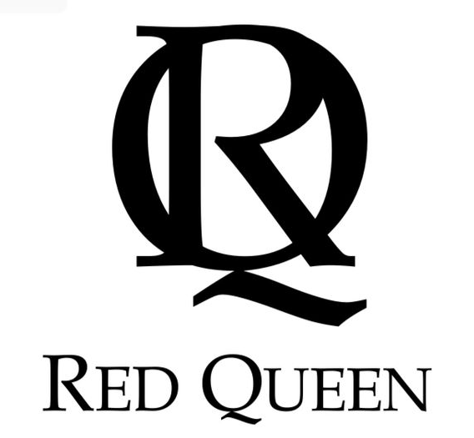

FOR IMMEDIATE RELEASE Contact:
(862) 571-8649
RQCosmetics@aol.com

RED QUEEN COSMETICS LAUNCHES 2019 COLLECTION AND
ANNOUNCES NEW MASTER CLASS EVENTS AIMING TO EMPOWER WOMEN
Red Queen Cosmetics Expands On Popular Cosmetics Line With New Products,
Interactive Tutorial Classes And Private Glam Events

NEW YORK, NEW YORK – June 11, 2019 – The infamous private label mineral makeup and skincare line known for its high-quality, all-natural multi-functional products, Red Queen Cosmetics is thrilled to announce the expansion of its makeup, skincare and services. The new collection will include the Bronzed Empress summer palette, a DIY pressed powder palette, a new celebrity-inspired lipgloss collection and their exclusive Queen’s Youth Elixir serum. Red Queen Cosmetics is also excited to be offering a new menu of services, including The Queen’s Master Class events providing makeup tutorials, expert tips and a chance to shop the collection in a private or corporate event setting.

Red Queen’s Bronzed Empress summer palette is a new twist on the popular Queen’s Palette. The summer palette features shades of warm bronze pressed mineral powders, including a bronzer (Sandune), blush (Ginger) and highlighter (Sorbet), all of which may be used on cheeks, eyes and/or lips; as well as a set of four eyeshadows in Pink A Boo, Golden Girls, Brown Sugar and Brown Derby. Conveniently stored in a portable, refillable, magnetic compact with a large mirror, Red Queen’s palette’s are great for a woman on-the-go. The palette will retail for $120 and can be purchased online. Red Queen Cosmetics also sells blank palette wallets and liner refills allowing clients to build a custom tailored palette of their own according to their favorite products, shades and needs.

A collection of nine new celebrity-inspired lip glosses have recently been added to the Red Queen Cosmetics family and have already become a fan favorite. Inspired by iconic females with names like Cher, Gaga, Summer, Pink!, Keys and Madonna, Red Queen lipglosses can be worn alone or over a favorite lipstick for a silky shine and come in nine shades to fit any personality or mood—from plums and nudes, to fun shimmery pops of pink and red hues. Each gloss is Vitamin E infused to condition and protect lips. Lipgloss retails for $18.

New to the Red Queen’s skincare line The Queen’s Youth Elixir is an ultra-luxe rosy-toned serum that primes the skin with an instant visible boost and lit-from-within glow while targeting dryness and signs of aging over time. This soft- touch formula leaves the skin feeling plumped and hydrated with a light matte finish. It is powered by known hydrating ingredients, such as hyaluronic acid, along with orobanche rapum, a revolutionary, multi-benefit plant extract. It helps to moisturize, reduce the look of wrinkles and smooth the skin’s appearance. A plant sugar-derived complex helps to support hydration and water retention in the skin for the look of plumpness, firmness and bounce, maintaining the appearance of skin elasticity and firmness. Warm gold mineral pigments create a brightening effect and help to diffuse the look of redness, skin irregularities and wrinkles. The Queen’s Youth Elixir is currently available for pre-sale online retailing for $48.

This year, Red Queen Cosmetics is excited to venture beyond the standard makeup application services they have offered for weddings and special events, and expand its on-site offerings to include master makeup tutorial classes tailored for any occasion—from a ladies night in to corporate team building experiences and much more. These events are offered privately or can occasionally be found at a local retailer or business who have parternered with Red Queen for special shopper events open to the public. Red Queen’s certified specialists and master artists will share their beauty tips and secrets, conduct makeup tutorials, consultations and guest applications, as well as the opportunity to shop any of their products right on the spot.

“Our events and products allow us to meet women from all walks of life and custom tailor looks that suit their lifestyle while educating them about skincare. As the beauty industry continues to evolve it often gets complicated and frustrating to keep up with trends. The Red Queen offers easy to use products infused with the highest quality ingredients. We keep it simple and most importantly fun,” says Sanela Dila, Red Queen Cosmetics co-founder.

Since 2008, Red Queen Cosmetics co-founders Frank Fasolo and Sanela Dila have worked closely with a team of professional dermatologists and chemists to develop a cruelty-free all-natural skincare and mineral enriched luxury cosmetics line “fit for a queen.” With over 30 years of experience in the beauty and skincare industry, the certified team at Red Queen Cosmetics has made it their mission to empower women with the tools they need to look and feel their very best—simply, confidently and without all of the unnecessary noise. Red Queen has strategically created each product in their collection with today’s woman in mind.

“We are so very excited about the new products and services Red Queen is offering this year, not only are we growing as a company, but we are expanding our reach to so many more women and making them feel confident in the process. In a world where we are uncertain about a lot of things, we shouldn’t have to be uncertain about what we are putting on our faces everyday. Just as we are conscious about what we put into our bodies, we should also do the same with what we put on our skin and that’s what Red Queen Cosmetics is all about—getting the look of glam with all the benefits!” explains Red Queen Cosmetics co-founder, Frank Fasolo.

For more information on the new collection, to book a private glam event or to shop all products, please visit www.RedQueenCosmetics.com.

For the latest news, specials or product announcements, follow Red Queen Cosmetics:
Facebook: @RQRedQueenCosmetics
Instagram: @RedQueenCosmetics #RedQueenCosmetics

About Red Queen Cosmetics

Founded in 2008, Red Queen Cosmetics was launched at a quaint boutique in historic Chester, New Jersey. Co-founding partners and beauty mogul experts, Frank Fasolo and Sanela Dila used their combined 30 years experience of working with the biggest company’s and names in the beauty industry, to grow the Red Queen Cosmetics name to what we know today. They have worked closely with a team of professional dermatologists and chemists to develop and perfect a cruelty-free all-natural skincare and mineral enriched luxury cosmetics line “fit for a queen.” They have mastered a natural mineral based makeup that's actually beneficial and healthy, protecting skin from UVA and UVB rays, free of talc, alcohol and oil and infused with Vitamins A, E, D and aromatherapy. The certified team at Red Queen Cosmetics has made it their mission to empower women with the tools they need to look and feel their very best and has strategically created each product in their collection with today’s woman in mind. For more information, please visit www.RedQueenCosmetics.com.

# # #

