Eugene Garden Club Presentation March 19, 2025

Erin Wickliffe, , MS Bioagricultural Science & Pest Management, ODA Horticulturist

Abiotic Issues such as

Air pollutants. Cold injury Drought injury Herbicide damage Nutrient deficiencies or toxicity Poor planting sites Mechanical

Pest and Disease

Bacteria. Insect Fungi. Mycoplasma Nematodes Parasitic plants Viruses

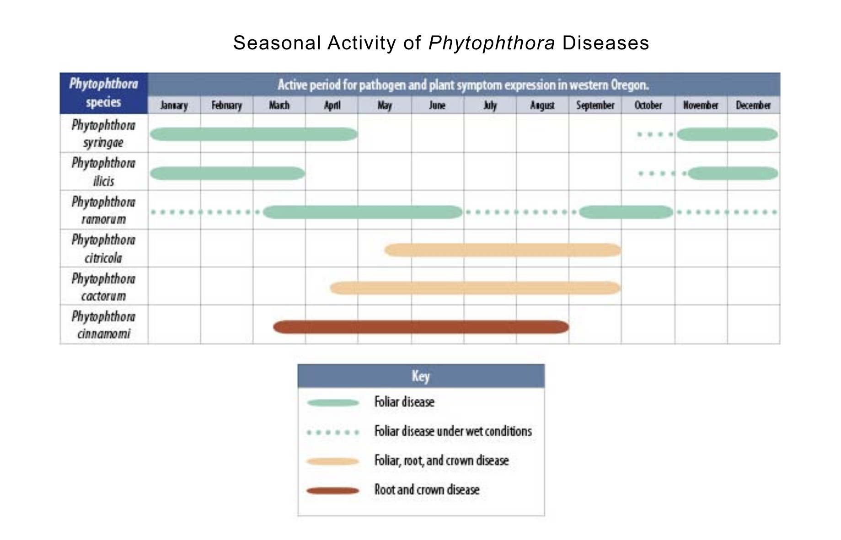

Phytophthora disease is very prevalent in the Pacific Northwest. This pathogen is in the

Water Mold family. That means that it’s spores move through standing water.

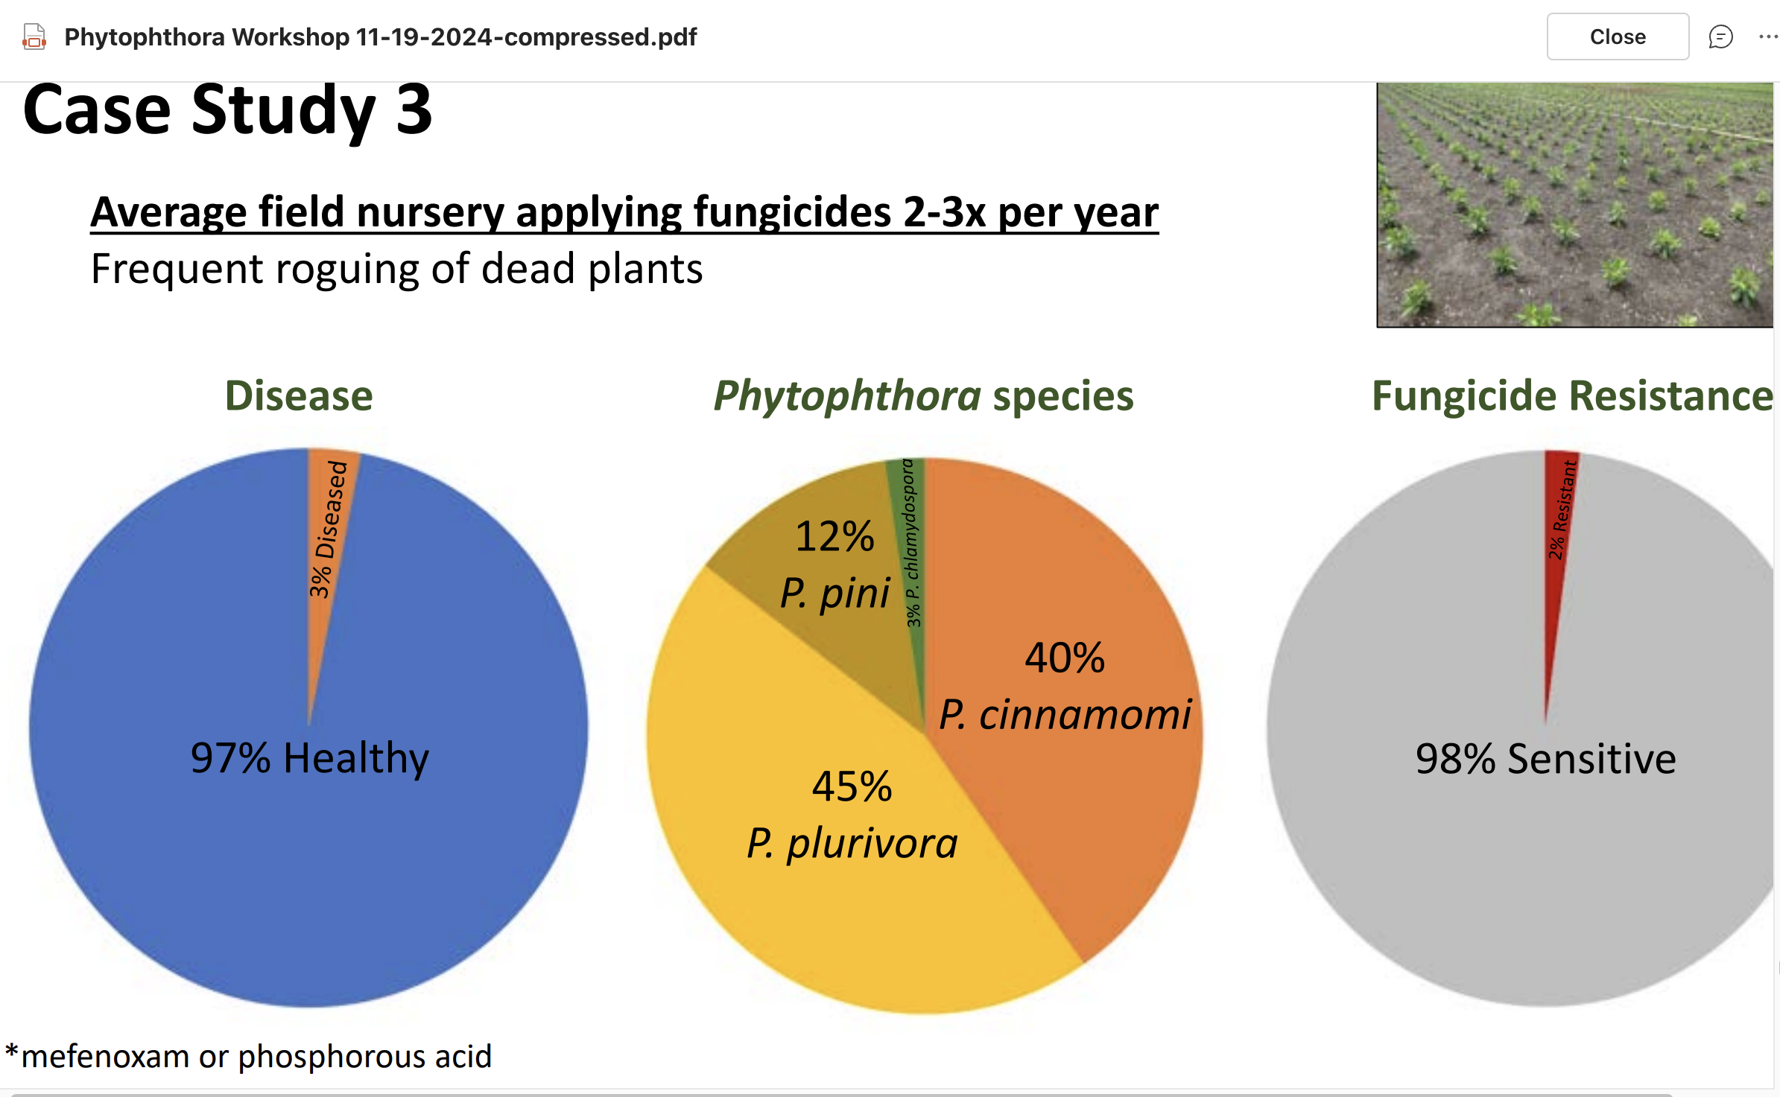

Most susceptible hosts are: Rhododendron. Viburnum Kalmia. Pieris Camellia

Take Home Message:

* There are over 10+ species causing Phythophthora Root Rot
* P cinnamomi and P plurivora are most common
* Frequent Roguing of dead plants and plant material is the best solution

**Cultural Controls to reduce disease**

* Purchase disease and insect free plants
* Quarantine incoming plants for 30-45 days before planting in garden
* Do not store soilless medium, tools, equipment, etc in direct contact with dirt and/or standing water
* Plant in new or containers and unused soilless medium
* Use disinfectant liberally
* Scout for insect and disease regularly
* Remove diseased foliage and plants right away
* Do not make compost from diseased plants
* Avoid applying excess fertilizer. (Succulent new growth is susceptible to disease.)
* Avoid watering foliage as much as possible
* Prune during dry weather
* Plant tolerant or resistant host varieties
* Prevent contaminating soils by bringing mud from potentially infested areas on tools, shoes, etc
* If plants are diseased replace the plant with non-host plant species

Common Rhododendron insect pests

* Aphids Scale Thrips. Whitefly. Gnats and flies Leafroller Leafminer Lacebug.
* Root weevil. Sawfly Spider mite

Lacebug

* Eggs laid along midrib
* Nymphs hatch early summer
* Damage looks similar to iron chlorosis – white
* Lots of fecal specks

Control Measures:

Water sprayed at underside of leaves

Favorite Predators:

* LaceWing Larvae
* Minute Pirate Bug
* Horticultural Oils
* Neem Oils

Lacebug

* Eggs laid along midrib
* Nymphs hatch early summer
* Damage looks similar to iron chlorosis – white
* Lots of fecal specks

Sawfly

* Eggs laid singly along leaf edge
* larvae feed on leaves at the tips of twigs and branches
* Sawflies overwinter in cocoons in the soil and emerge just as the new leaves emerge.
* Adults can be seen swarming on warm, sunny spring days
* Adults are a tiny black fly insect

Control Measures

* Little is known about Biological control insects
* Scouting and removing larvae by hand

Spinosad, BT and oils

Leafminer

* Eggs are laid on underside of leaf
* Larvae mine into and roll leaf
* Overwintering pupae in rolled leaf hatch in spring
* adult insect is a golden yellow moth

Control Measures:

* Predatory insects
* Remove infested leaves

Beneficial insects native to our community

* Scouting for naturally occurring beneficials in a nursery setting often reveals complex interactions of a powerful workforce that we may not even realize is working around the clock.
* The beneficial insects found will vary on time of year, nursery stock present, weeds and surrounding vegetation, pesticide spray program
* Beneficial insects are more likely to be seen in the warm season when flower pollen and prey insects are available.
* Some beneficial insects can be found during the cold season in leaf debris, underground in larval stage, in a warm shelter or as an egg waiting for spring temperatures.
* There are many ways that native beneficial insects can be encouraged to establish residence throughout the year.

3 types of beneficial insects

* Predators – Beetles, flies, arachnids, arthropods, mites
* Pollinators – bees, flies, moths and beetles
* Parasitoids – flies and wasps

Generalizations about predatory insects

* Fast moving
* Will work rain or shine, 24/7 and can get to the needed location on the plant to capture prey. (unlike some chemical controls)
* Often can survive on alternative food sources if prey and/or prey eggs are unavailable.
* Alternative food sources can be pollen, nectar and sometimes fungal spores.

Native Beneficials

**Assassin Bug-** family*Reduviidae*

* Adults lay eggs in leaf debris, branches and plant crevices in Autumn
* Eggs hatch in April- June and go through several nymph stages
* Feed on true bugs such as aphids, leafhoppers, sawfly and beetle larvae, caterpillars

**Big Eyed Bug -** *Geocoris spp.*

* Adults lay eggs in leaf debris, branches and plant crevices in Autumn
* Eggs hatch in April- June and go through several nymph stages
* Both nymph and adults feed on true bugs such as Lygus bug, aphids, cutworm, armyworm

**Ground Beetle -** family*Carabidae*

* One of the largest insect families, with approximately 40,000 species worldwide and 2,339 species in the United States (Lövei and Sunderland 1996; Kromp 1999; Bousquet 2012).
* Fast-moving beetle found under rocks, containers, bark and leaves
* The egg, larval, and pupal stages are spent primarily underground while the adult life-stage is spent primarily aboveground.
* Larvae feed on soil insects and, also eat seeds of plants (including weed seeds)
* Feed on soft-bodied insects like cutworms and cranefly larvae, grasshoppers, flies, snails and slugs, and insect eggs

Damsel Bug – Family *Nabidae*

* Eggs are oblong and flattened on top. Females insert eggs into soft tissue of plants with only the circular, flat opening (operculum) visible.
* Egg to adult development requires 1 to 2 months during warm weather. There are 2 or more generations per year. Overwintering is mostly as adults in protected places.
* Both adult and nymph feed on aphids, beetles, caterpillars, mites, thrips, various true bugs such as *Lygus* species

Hover Fly / Syrphid Fly - Family *Syrphidae*

* great pollinators as an adult
* the larvae eat lots of aphids

Minute Pirate Bug / Insidious Flower bug – Family *Anthocoridae*

* Nymph emerge early in the spring
* Both nymph and adults feed on aphids, leafhoppers, beetles, spider mites, thrips, whitefly, mealybugs

Robber Fly – family *Asilidae*

* larvae live in rotting wood and feed on insect eggs, larvae and soft bodied insects
* Adults eat other types of flying insects
* They fly over prey, drop down on top of them and hold on tight.
* Unfortunately, they will eat Bees too!

Lacewings – Family *Chrysopoidea*

* Eggs laid on stalks on underside of plant leaves
* Juvenile’s favorite food are aphids but will eat caterpillars, moth eggs, scale insects, mealybugs, psyllids, thrips, white fly, leafhoppers and lace bugs
* Adults eat pollen, nectar, and honeydew

Rove Beetle (Devils Coach Horse) -

Family *Staphylinidae*

* Adults lay eggs in a cocoon
* Both adult and larvae can be found scavenging in soil for shore fly and fungus gnat

Parasitic Wasps

* Wasps belong to the order*Hymenoptera*, which includes more parasitoids than any other order of insects
* They may be the single most important biological control method gardeners have
* Adults lay their eggs in or on the host insect.
* The fly will ”hatch” from host leaving behind a host “mummy”
* Parasitoids- the larval stage of Parasitic wasps or fly insects that feed on or inside of other insects, killing their hosts.

Resources

* <https://solvepestproblems.oregonstate.edu/>
* [https://oregoninvasiveshotline.org/](https://oregoninvasiveshotline.org/reports/list)
* [https://www.appliedbio-nomics.com/wp-content/uploads/The-Bio-Control-Handbook-Second-Edition.pdf](http://www.pnwhandbook.org/)
* [www.pnwhandbook.org](http://www.pnwhandbook.org/)
* <https://www.oregon.gov/oda/ippm/insects-spiders/pages/pest-alerts.aspx>
* <https://horticulture.oregonstate.edu/nursery/nursery/phytophthora-online-course-training-nursery-growers>
* <https://workspace.oregonstate.edu/course/plant-disease-prevention-and-diagnosis-for-nursery-crops>
* <https://pnwhandbooks.org/sites/pnwhandbooks/files/insect/horticultural-landscape-ornamental/content/pdf/pdfs/insect24f-9chemicalcontrollandscape.pdf>