**Meeting the Challenge of Azalea Lacebugs**

Emily Aune

Eugene, OR

American Rhododendron Society Journal

Vol. 75 Number 4 Fall 2021



Azalea lace bugs (*Stephanitis pyrioides*) have been a recent topic of concern among rhododendron growers and plant enthusiasts here in the Northwest. I have even heard garden clubs and other landscapers dissuading the use of rhododendrons in their landscapes, due to the aesthetic damage from these pests. No, they don’t just suck chlorophyll out of the leaves of azaleas, but they damage rhododendrons too, as they are all in the same genus. As a caretaker of a 13-acre public garden with thousands of rhododendrons, and a great admirer of this plant, I do not want people to give up on rhododendrons completely. Through my years of management of this pest, without using neonicotinoids, I am seeing that many rhododendrons show resistance to damage, and I have learned some other organic management practices that can help.

Azalea lace bugs have been an issue in the eastern United States since 1915, but were only just found in Oregon in 2009, and have since exploded in populations. I first noticed this pest in the Hendricks Park Rhododendron Garden the summer of 2013, and we have been experimenting with management practices ever since. Since this garden is owned by a municipality with a very strong commitment to the responsible use of pesticides, I am prohibited from the use of any neonicotinoid within the garden. Although I have heard that this type of insecticide can be very effective in mitigating azalea lace bug damage, this chemical is also known to have negative effects on our bee populations. Because of this, we are steering clear of using them, and since 2014 it has been prohibited for use on any City of Eugene property.

This puts me in a unique position to manage an infestation in a large rhododendron garden using cultural practices, organic sprays or oils, beneficial insects, and planting into the future with more resistant varieties. I have tried all of these tactics with varying degrees of success and currently rely most heavily on cultural practices like proper irrigation, fertilization, some pruning, as well as completing five insecticidal soap sprays a year in the main garden. Ultimately, planting resistant varieties is going to be the best long term solution for keeping a nice looking garden, as none of these other tactics will get rid of the bug completely.

At home, the first step is to determine whether or not you have azalea lace bugs. You may first notice tiny yellow spots on your leaves. As this infestation worsens, the whole leaf may end up turning yellow. The insects live on the underside of the leaf and feed by piercing the lower surface and sucking out chlorophyll. Too much of this will reduce photosynthesis and transpiration and stress the plant, but mostly it just makes it look horrible. Now, flip over your leaf and you may see the actual insect. The adults are about 1/8” long, so they are visible but quite small. They have clear wings with black net-like patterns, perhaps one would say, lacelike. They do not move quickly and they barely fly, so they spend a long time on one plant before moving to the next, and they don’t spread far very quickly. You will also see a lot of black sooty material, which is their excrement or stains left from it. Very lovely little creatures. They lay their 5-7 eggs a day which hatch based on warmer temperatures. They average about 5 life cycles every season, which is a lot, and they persist from June - October before overwintering their eggs within the leaves as all the adults die off.

Because they are called azalea lace bugs, one would assume that damage would be the worst on azaleas. I would agree that *evergreen* azaleas seem to be heavily impacted. However, I would not stop planting *deciduous* azaleas in your garden, like our native Western Azalea (*Rhododendron occidentale*) or any of its crosses. I personally have not seen much lace bug damage on these. If they do suffer damage, it would only be for a short window in the summer, and then the plants will drop their egg infested leaves and start fresh next year. Our typical Rhododendrons are what I really get concerned about. As an evergreen, they tend to keep their leaves for three years or more, so the damage is visible from all the previous years as well as the current year. The goal would be to control the pest population before they get to the new growth on a plant, and to pay attention to which plants they eat, and which ones they stay away from. 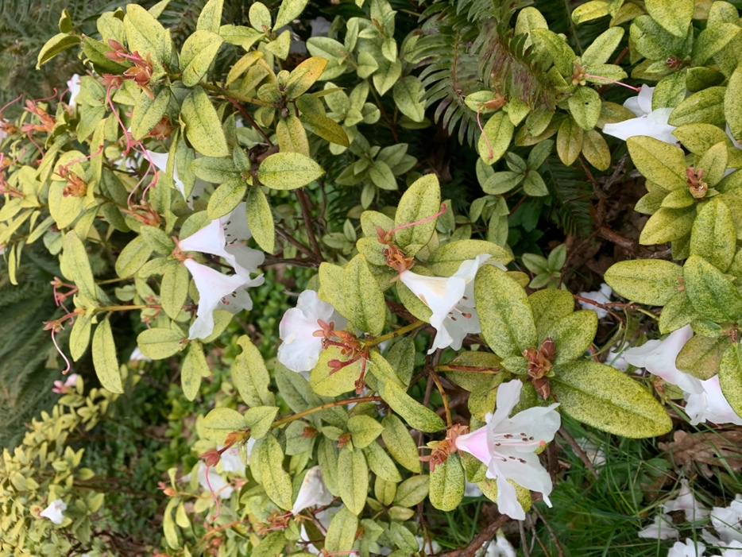

Fig. 1. ‘Cilpenense’, which can be eaten so badly by lacebugs that there is almost no green left on the leaf.

The biggest help in preventing any pests is to keep your plants as healthy as possible with cultural practices. Proper irrigation, fertilizing, mulching, and proper placement for sun/shade, will all help a rhododendron fight this pest. I would say that irrigation may be the most important of these factors, as a drought stressed plant can really suffer from an infestation. I have also done some heavy pruning in the wintertime and early spring to control populations on the evergreen azaleas. I have cut them completely to the ground in early spring to remove all the little eggs that are overwintering. Evergreen azaleas can usually take this amount of pruning, and pop back up with fresher, cleaner non-infected leaves. I miss a year of bloom that way, but I found it to be worth it in some areas. If you only had an insect population in your evergreen azaleas, I would do that soon and get them off of your property.

Even with the best of practices, there are just some plants that get it so severely, I choose to spray them with insecticidal soap sprays. Most organic sprays need to contact your insect, so you will need to wait until they hatch. Monitor your leaves closely in May, because this is when the overwintering eggs begin to hatch. Warm springtime weather would result in a quicker hatch, but typically they don’t hatch until the end of May here in the Pacific Northwest. This is why your flower and new growth will look very good through the spring, but by June you may start to see more damage. They also hatch on last year’s leaves and spend some time feeding on those leaves before even making it to the new leaves (remember how slowly they move).

I hire a company to spray insecticidal soap in a portion of the garden beginning in May or June, and continue once a month through October. They use high-pressure hoses that can reach into the canopy of my tall shrubs and spray the undersides of the leaves. Ideally, I would want to spray them every three weeks, as the insects have prolific life cycles and making contact with every bug simply doesn’t happen. There is only so much time and money, though.

Also, this is a lot of work, and I personally enjoy other tasks like pruning, planting, even weeding compared to spraying my plants. That is why the long term goal is to replace stressed and dying plants with resistant varieties along with keeping spray zones very condensed or just choosing a couple very special plants in your garden that need long-term insect control.

So, let’s go plant shopping! The easiest way to choose a lacebug resistant rhododendron is to simply choose a plant with indumentum. 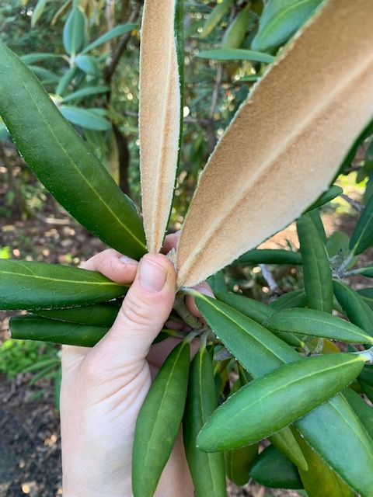

Fig. 2 A plant with very fuzzy indumentum and perfectly unharmed leaves.

Indumentum is the collection of tiny hairs on the underside of the leaves of some rhododendrons, that make the bottom feel fuzzy to the touch. And, when it comes to protecting for azalea lace bugs, the fuzzier the better. Indumentum seems to make it physically too hard for the tiny little lace bug to walk around in or pierce with its mouth. A very common, good looking, and easy to find rhododendron with indumentum is *Rhododendron degronianum* ssp. *yakushimanum*, casually referred to as the ‘yaks’. There are thousands of hybrids with this parent that will defend against lace bug. There are also many other species of rhododendrons that have indumentum.

Surprisingly, what I am also finding is that there are plants that DON’T have any traditional indumentum but still look very, very free from damage, even in sections of the garden where we don’t spray, or in areas where they are growing right beside heavily infested plants. There was a study at Oregon State University theorizing that a higher wax content in the leaf may be improving resiliency, which seems plausible, but hard to tell. I’m also noticing that plants with plastered indumentum, which appears as a thick, shiny underside, are showing resistance, particularly in my *Rhododendron insigne*. I have compiled a list of plants in the park that are not being damaged by lace bugs. You may know of others that could be added to the list. Perhaps we can find the common parentage or another reason behind these resilient groups and add more of these plants in to our landscapes. At the very least, it will give you a list to take on your next nursery visit!

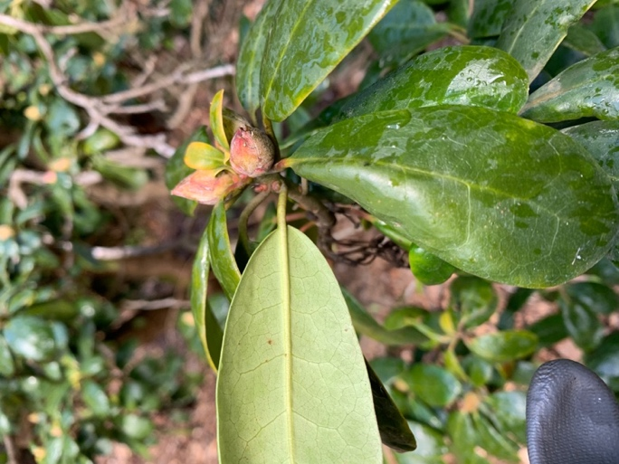

Fig 3. This is an example of a very “clean” ‘Daphnoides’ leaf (not damaged by lacebugs) that has no visible indumentum.

|  |  |  |  |
| --- | --- | --- | --- |
| **The following are lists of Rhododendrons I have observed to be free from Azalea Lacebug Damage.** | | |  |
| **These are not complete lists, and limited to plants growing at Hendricks Park.** | | |  |
|  | |  |  |
| **Rhododendron species not affected by Azalea Lacebug** | |  |  |
| |  |  | | --- | --- | | *R. anhweiense* | *R. lutescense* | | *R. arboreum* | *R. mallotum* | | *R. argyrophyllum* | *R. orbiculare 'Edinburgh'* | | *R. asterochnoum* | *R. oreodoxa var. fargesii. (R. erubescens)* | | *R. auriculatum* | *R. pocophorum* | | *R. bureavii* | *R. ponticum 'Variegatum'* | | *R. bureavioides* | *R. pseudochrysanthum* | | *R. callimorphum* | *R. pseudochrysanthum '*Ben Nelson*'* | | *R. davidsonianum '*Ruth Lyons*'* | *R. racemosum* | | *R. decorum* | *R. ramsdenianum* | | *R. decorum* ssp *diaprepes* | *R. recurvoides* | | *R. degronianum ssp yakushimanum* | *R. ririei* | | *R. degronianum ssp yakushimanum* 'Ken Janeck' | *R. scabrifolium* | | *R. discolor* | *R. spinuliferum* | | *R. diversipilosum 'Milky Way'* | *R. strigilosum* | | *R. hodgsonii 'affinity'* | *R. sutchuenense* | | *R. impeditum* | *R. wiltonii* | | *R. insigne* |  | | |
|  | |
|  | |
| **Rhododendron Hybrids not affected by Azalea Lacebug** | |  |  |
| **Name Parents** | |  |  |
| ‘Alice' | *griffithianum hybrid* | |  |
| ‘Atroflow' | *atrosanguineum* x *floccigerum* | |  |
| ‘Avalanche' | Loderi Group' x calophytum var calophytum' | |  |
| ‘Azor' | *griersonianum* x *fortunei* ssp. *discolor* | |  |
| ‘Barto Alpine | Lapponicum Subsection hybrid | |  |
| ‘Barto's favorite' |  | |  |
| ‘Bibiani' | Moser's Maroon' x *arboreum* | |  |
| ‘Cadis' | *catawbiense x discolor* | |  |
| ‘Cinnamon Bear' | *degronianum ssp yakushimanum* 'Koichiro Wada' x *bureavii* | |  |
| ‘Colonel Coen' | *ponticum* | |  |
| ‘Daphnoides' | *ponticum* selection or hybrid | |  |
| ‘Fabia Tangerine' | *dichroanthum x griersonianum* | |  |
| ‘Fabia' | *dichroanthum x griersonianum*' | |  |
| ‘Golden Gate' | *dichroanthum ssp scyphocalyx x unk.* | |  |
| ‘Golfer' | *yak x pseudochrysanthum* | |  |
| ‘Kodiak' | *bureavii* x *degronianum* ssp. *yakushimanum* 'Ken Janeck' | |  |
| ‘Laramie' | *degronianum* ssp *yakushimanum*, Exbury form x *macabeanum* | |  |
| ‘Lem's Cameo' | Dido' x 'Anna' | |  |
| ‘Lem's Monarch' | Anna' x 'Marinus Koster' | |  |
| ‘Lem's Walloper' | Walloper Group | |  |
| ‘Loderi Superlative' | *fortunei* ssp. *fortunei* x *griffithianum* | |  |
| ‘Mardis Gras' | *yakushimanum* 'Koichiro Wada' x 'Vanessa' | |  |
| ‘May Day' | *haematoes* x *griersonianum* | |  |
| ‘Molly Smith' | *degronianum ssp yakushimanum* 'Koichiro Wada' x 'Mrs Furnivall' | |  |
| ‘Noyo Brave' | Noyo Chief' yak 'Kochiro Wada' | |  |
| ‘Noyo Maiden' | *yakushimanum* 'Koichiro Wada' x 'Noyo Chief' | |  |
| ‘Powder Snow' | *degronianum* ssp *yakushimanum*, Exbury form x *R. macabeanum* | |  |
| ‘September Song' | Dido' x 'Fawn' | |  |
| ‘Showboat' | *yakushimanum* 'Exbury' x 'Tumalo' | |  |
| ‘Silver Skies' | *degronianum* ssp *yakushimanum* 'Koichiro Wada' x 'Medusa' | |  |
| ‘Sir Charles Lemon' | *arboreum* ssp *cinnamoneum* x *campanulatum* | |  |
| ‘The Honorable Jean Marie de Montague' | *griffithianum* hybrid | |  |
| ‘White Pearl' | *griffithianum* x *maximum* | |  |
| ‘White Swan' | *decorum* x 'Pink Pearl' | |  |
| ‘White Velvet' | Seedling from Japan | |  |
| ‘Yak -Pac' | *yakushimanum* x *pachysanthum* | |  |
| un-named cross | Fawn' x 'Ray' | |  |
| un-named cross | *vernicosum x chlorops* | |  |
| un-named cross | *venator* x *strigillosum* | |  |
|  |  | |  |
|  |  | |  |
|  |  | |  |
|  |  | |  |
|  |  | |  |
|  |  | |  |
|  |  | |  |
|  |  | |  |
|  |  | |  |
|  |  | |  |
|  |  | |  |
|  |  | |  |
|  |  | |  |
|  |  | |  |
|  |  | |  |
|  |  | |  |
|  | |  |  |