HB Watch Meeting Summary
December 10th, 2022

Key Points

- Response times can be longer than desired/ideal because of understaffing. Currently the East Precinct has an average allocation of only 12 officers per shift – effective on-the-job numbers can be lower.
- Priority is given to calls for in-progress issues, situations in which harm to people or property are imminent.
- Reporting issues is essential as funding for staffing and resources is directly tied to the number and type of reported incidents (“if it isn’t reported, it didn’t happen”).
- Area maps used during the meeting revealed a large number of issues occurring in our area regularly, but few are being reported.
- Our top priority is to be more alert and report issues. It is better when multiple people report. Use “911” for Emergencies and In-progress Issues; use the “Find It, Fix It” App to report things like encampments, garbage, & graffiti among others. Non-emergency line (206) 625-5011 for all other reports.

General Summary

We had an attendance of about 40 members, with two Seattle Police Department guest speakers, Joe Elenbaas, Crime Prevention Coordinator for the East Precinct and Dorian Korieo, Officer at the East Precinct, and leader of the “Safe Place” Program.

To guide our conversation, those in attendance used color coded markers to indicate the locations and types of issues they have witnessed or been affected by. Images of the maps are included below. The data reveals that our area is being affected by:
- Thefts (30)
- Encampments (24)
- Garbage (21)
- Open Drug Use (17)
Trespass (17)
- Violence (9)
- Property Damage (8)
An additional 13 issues under the category “other” including some attempted arsons, indecent exposure, and abandoned vehicles were shared by neighbors.

Only a fraction of these issues has been reported to the authorities. The total number of occurrences is likely much greater, but we won’t know how much larger unless everyone in our neighborhood participates.

Our SPD guest speakers explained how due to insufficient funding, staffing in the department is low, which can result in delayed response times, especially for non-urgent calls. They stressed the importance of remaining alert and reporting all issues. Even if they can’t respond as quickly as they would like to all calls, having the data helps track what is happening and can be used to allocate resources where they are needed most. Our resources section has the link to the “Find It, Fix It” App, and a contact list for reporting various issues. In emergency cases or to report an in-progress situation, please call 911. Call the non-emergency line (206) 625-5011 to report all other issues.

Our guest speakers also shared that the Parks department has asked them to help with an assessment based on the principles of crime prevention through environmental design (CPTED) for the future park. We hope to be able to contribute to this process and work in partnership to enhance and maintain the safety of our community.

Next Steps

- Stay vigilant and report issues.
- Actively participate in the future park planning project by attending meetings and providing feedback.
- Decide on signage for the neighborhood (see “Crime Watch Signs” document in resources section).
- HB Watch meetings will be held quarterly. Next meeting in March, date TBD.
- HB Watch “Block Point Person” volunteers (thank you for volunteering ) will be meeting soon to plan future actions, session offerings, and trainings.
- Please email your suggestions, questions, and concerns.
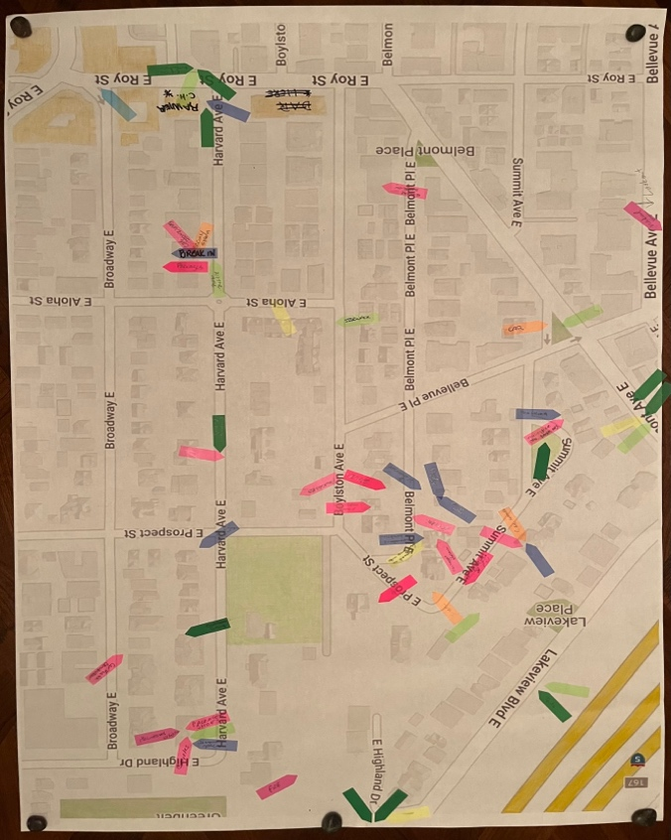 | 