Sunny weather  Hopefully the sun will be shining down on us more frequently now. The weatherforcast is checked daily and we ensure activites are planned appropriatly throughout the day. Please ensure your child has their own suncream in their bag for us to apply.  Funding  Thank you to everyone for confirming any changes to their hours for this term including holidays. It really helps me stretch your funding for you, especially with it being such a long term.  Online journals  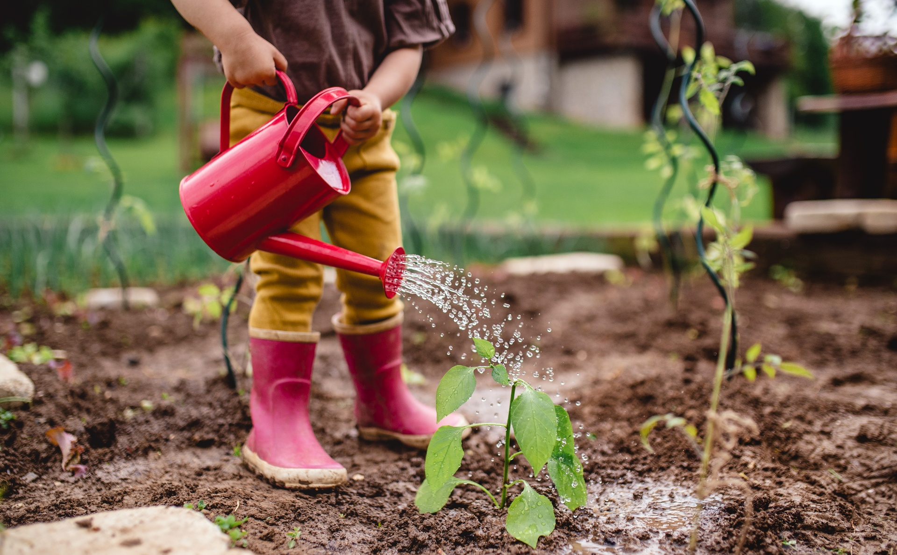  I have been busy creating journals for your children online in hopes to navigate away from our whatsapp group and give you reular updates via kinderly. I anticipate that it will take some time to get everyone signed up but hope that it will all be ready by May half term |  | 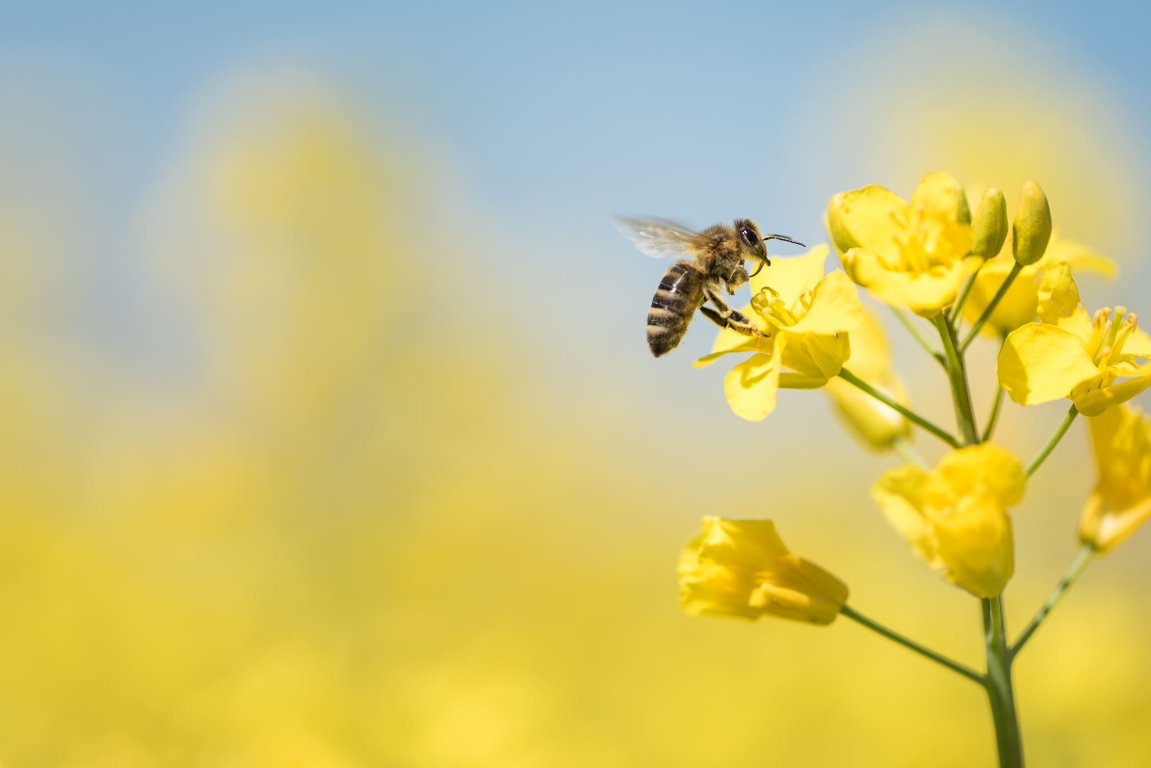  What we have been up to.
 |  | This month we have been so busy enjoying the sunshine spending much of our time looking for mini beasts and thinking about life cycles. Our focus has been the butterflys and catapillas as we look how they change though their lives. The Children have been creating some brilliant joint artwork aswell as their own pieces. We have had some wonderful butterfly wings to make and wear too. The children have been busy looking for bugs and thinking about their environments. Water play is always a big part of the childrens play outside and with the warmer weather we are able to expand this with all sorts of activities. Using paint bruches and water on the patio is a great way to practice our writing skills and watching it evaporate in the sunshine. The children have been enjoying some new songs and some old ones with our outdoor music and singing at snack time.
May’s learning
This month our key areas of learing will be moving and handerling, numbers, self-confidence and exploring materials. The children will have oportunities to explore the vegetable garden and newly renewed pollytunnel in smaller groups, whilst we sow, water and care for vegetables and flowers over the coming months. Our wildflower garden will be a key focus as it blooms and we can look out for bees and butterflys.
May 2026 | Sweetpeas Childminding  Latest news and bulletin updates | Issue 22
Upcoming closures | Website. | Half term
Summer dates.  Closed Friday 7th -16th August  Friday 21st and 28th August | There are previous news letters and more on the website including our new menu. | We still have some extra spaces for may half term and summer holiday. These can be found on the website for those that are usually term time only or want to bring siblings.

