Spare clothes  We have reduced our spare clothes in order to free up some more space in the cabin. Although we continue to have spares for emergencies, these are now limited. Please send your child with enough spare clothes for each day and return ours promtly.  Thank you for your understanding  Funding  New funding hours are due to be submitted soon, so please let me know if you need any changes coming up.  Toys  Due to recent events we are having to change our policy regarding bringing in toys from home.  We love when children bring in their toys but we will have to ask that unless it is a comforter that it stays at home. We will be looking at possibly having some show and tell days in the future, so children can bring in their toys. We will keep you posted. Thank you for your support on this. |  | What we have been up to.
 |  | This month we have been busy celebrating Easter and Spring. We have been very lucky with the weather but have noticed lots of changes. Wind, sun, rain, clouds and hail can all happen in a matter of hours in the spring. We have loved having some of our older children back with us, including lots who used to be here weekly before heading off to school. It is always a treat to have the older kids and our little ones love playing with them too. Back in March we had so much fun exploring colours and different foods for our science and nutrition weeks. We used some huge boxes in the garden to mix our paints on and tried some different foods we havent had before.
Easter holiday fun
Over the Easter holidays the children had lots of opportunities to paint,draw and colour a range of different materials. The children have also been busy in the new mud kitchen and new sandpit, cooking up a storm and creating wonderful sandcastles.

April’s learning
We are already half way through the month, but still have plenty to get on with. Some of focus areas of learning will be, shapes, writing, the world and speaking. We will be learning new songs, practicing our mark making and looking at the world around us as we explore life cycles and mini beasts.
April 2026 | Sweetpeas Childminding  Latest news and bulletin updates | Issue 21
Upcoming closures | Website. | Half term
Summer dates.  Closed Friday 7th -16th August  Friday 21st and 28th August | 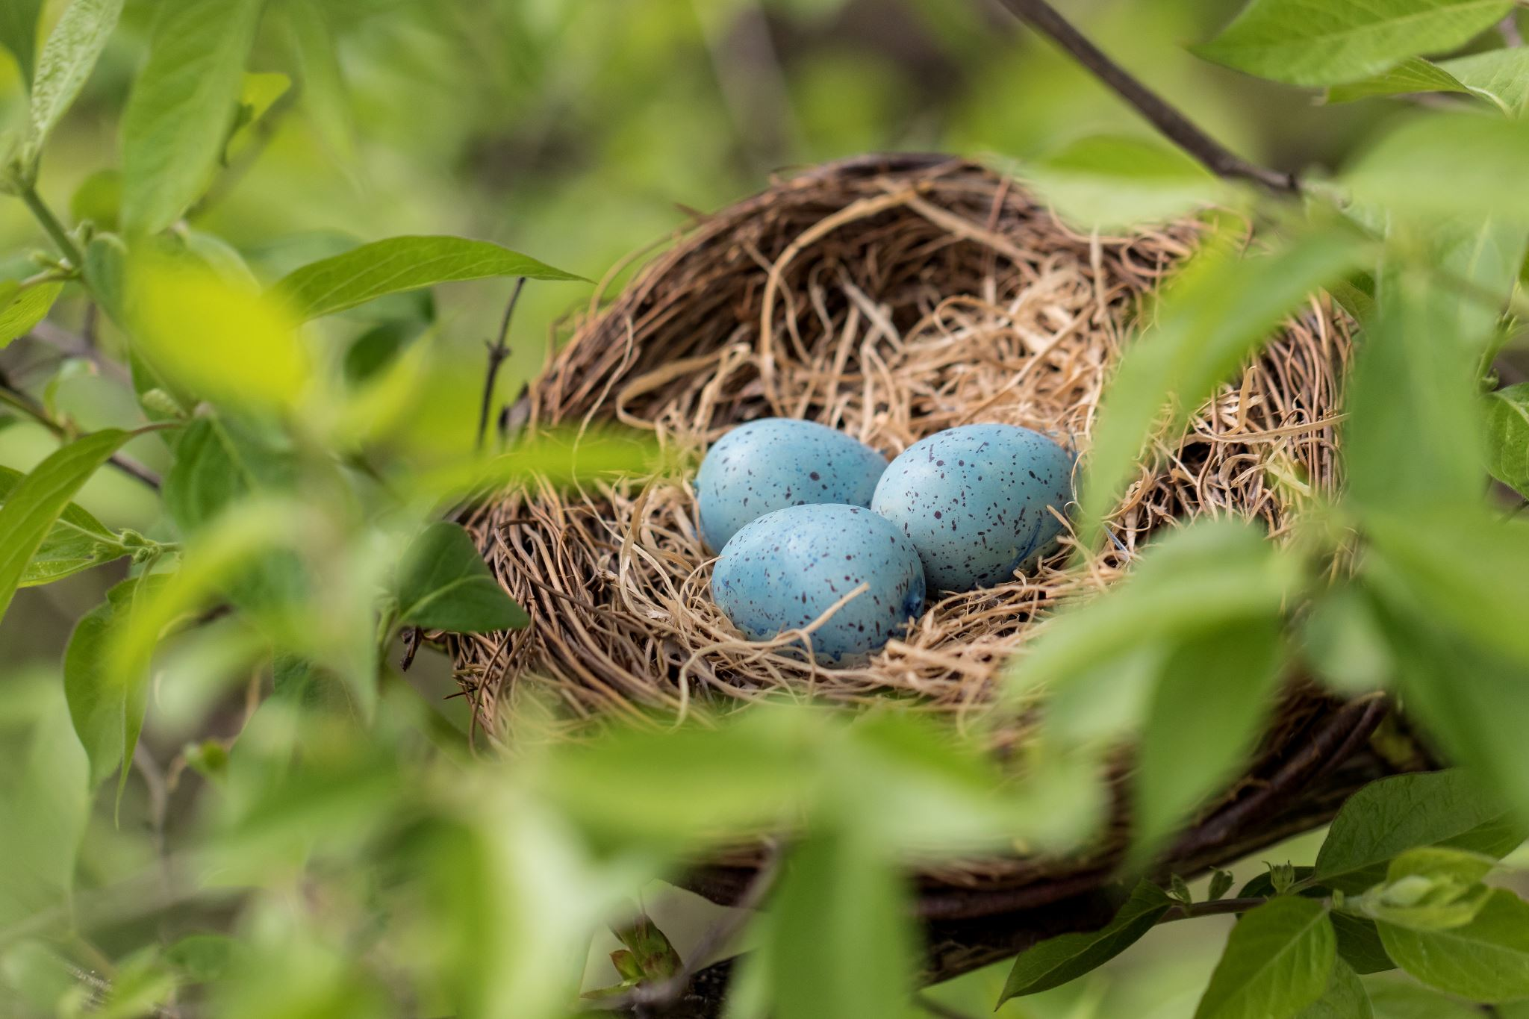  There are previous news letters and more on the website including our new menu. | We still have some extra spaces for may half term and summer holiday. These can be found on the website for those that are usually term time only or want to bring siblings.

