Seasons greatings.  Happy New Year!  It has been wonderful to have everyone back  The children have all settled in beautifully after the break and have been enjoying the first weeks of activities all about the Tiger Who came to Tea and There’s a Tiger in the garden.  We move onto Bird watching for the end of this month and have been ejoying some milder dry day s outside.  It is still cold so please pack pleanty of layers which we will put on the children before we go outside.  Personal belongings  Reminder to please remove your peronal belongings from your childs bag and notify us of any medication, including calpol that is in their bags. |  | 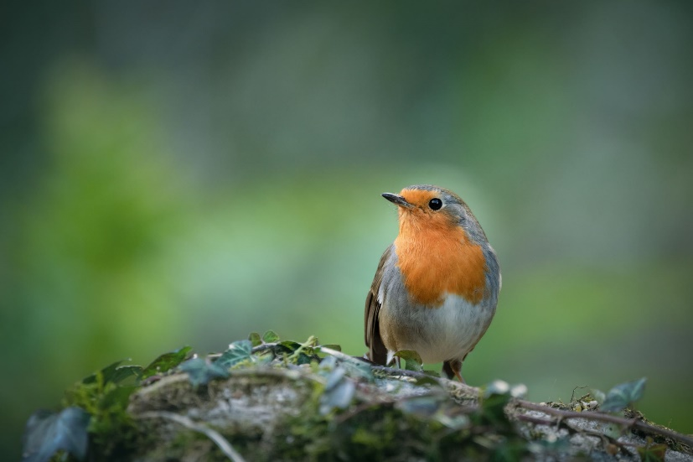
 |  | Changes to funding
 |  | There are a number of changes coming up for funding options. I recommend that you look at the childcare calculator to see what you are eligble for. You can still claim tax free childcare and receive the new funding aswell. This means you could get 15 hours of free childcare and still claim back upto 85% of your remaining balance. Please feel free to ask me any questions you may have about this.
January 2024 | Sweetpeas Childminding  Latest news and bulletin updates | Issue 2
Tapestry | Half Term  Additional spaces avaiable | Track safety  Reminder
There have been a number of ongoing issues with Tapestry my end so please bare with me while I catch up and hopefully you will be able to see everything your children have been getting up to. | Siblings of children who attend have first reserved places for half terms but please ensure you book these by Monday 5th to ensure spaces. Easter half term books up quickly so I recommend you book these dates early esspecially if you have specific days you require | Please remember that it is important to drive slowly and carefully along the track.  Thank you

