Spring is in the air
We are all eager to start seeing the first signs of spring, although we know those long warm days are still a way off, they are getting ever closer now. We have been busy in the garden getting lots done to make it even nicer for the children to enjoy throughout the year. We have our gardener here every week busy getting things ready for spring, and he will be able to share some tips with the children as they plant up their vegetable garden in the coming months.

Staff changes
At the end of March we say goodbye to Nanny Angie as she officially retires! Though she has promised to visit, She will definetly be missed by the children who have gotten to know her so well over the past 18 months she has worked with us. I know she will miss them all too.
We have been busy interviewing new staff for the role and so you may see some new faces in the coming weeks, as they come for their trial runs. Please rest assured all nesecery checks have been made before they start and will be closely supervised during this period.
This half terms topics
This half term we will be celebrating St Davids day, while we get to know some dragons around the garden, as we begin to plant our vegetables and hunt for mini beasts. We will also be exploring life cycles with the children and looking at some more magical creatures such as unicorns, mermaids and leprecorns, in time for St Patricks day. This world book day we will be focusing on Elmer the patchwork elephant as we continue to look at colours and colour mixing throughout the term.

  February 2025 | Sweetpeas Childminding  Latest news and bulletin updates | Issue 8
Upcoming closures | Tapestry and Website. | Half term.
There are no planned closures untill 18th April and we will return to work 28th April | 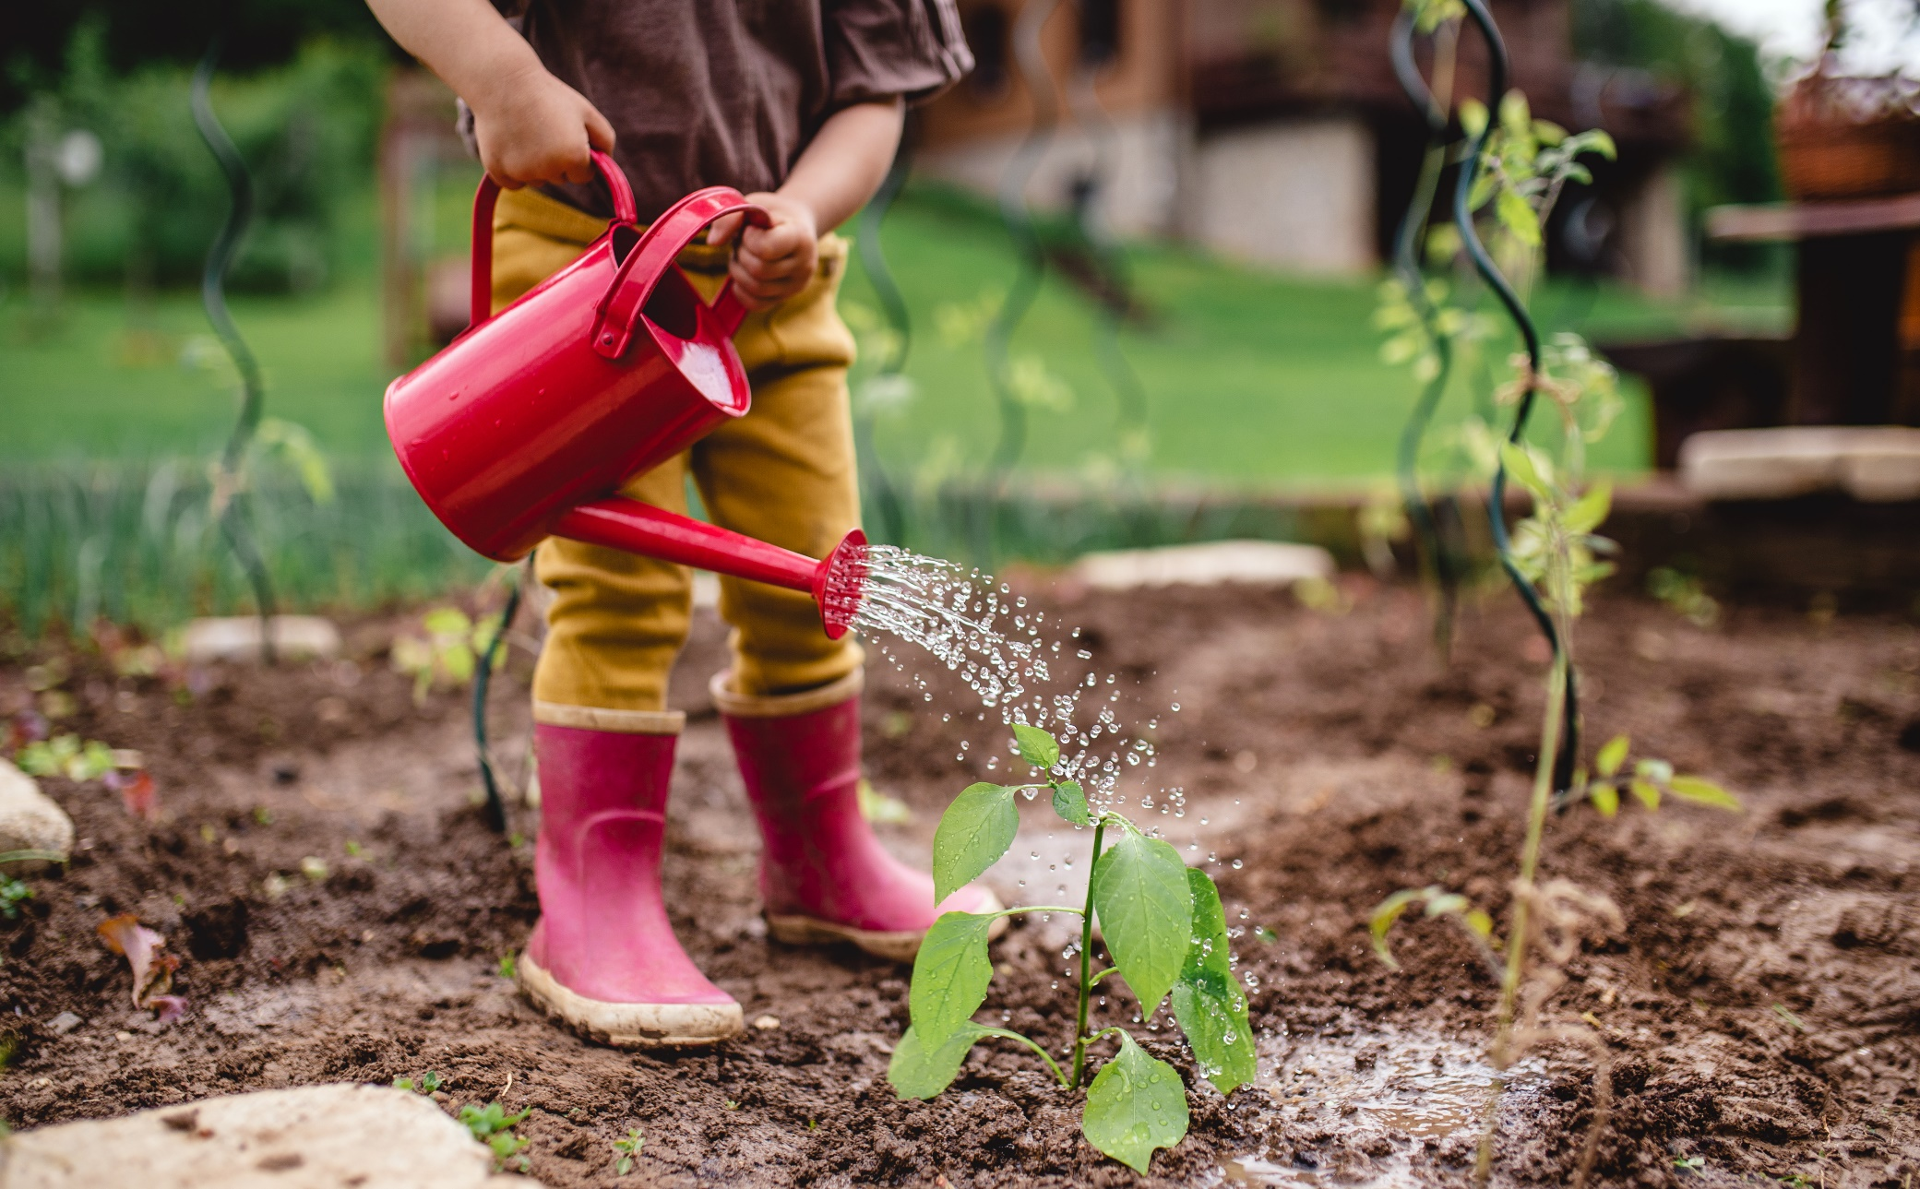  Lots of information about what your child has been up to is on your Tapestry account. If you have any questions do let me know.  Online you can find our menu, past newsletters, holiday club contracts and more.  Sweetpeaschildcarenorfolk.co.uk | Easter is 7th-17thApril

