Seasons greatings.  Halloween is just around the corner and not far behind is Christmas. Our topics this month are based on the changing seasons and animals preparing for winter. We will be carving pumpkins, exploring the chaning colours of leaves and making bird food.  After the half term 23rd-27th October, we will be starting our christmas crafts.  Personal belongings  Reminder to please remove your peronal belongings from your childs bag. |  | 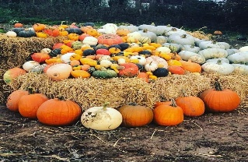
 |  | Halloween 31.10.23
 |  | Track safety
 |  | This track is a restricted by -way, therefore it is first and foremost a public foot path and bridal way with only limited access for motor vehicles. The track is maintained regularly in order to allow cars to access Sweetpeas childminding, but this can only be done during good weather. Please maintain a central position whilst driving and refrain from driving around potholes that will inevitably appear as we get worse weather. This only causes the potholes to get larger and reduces the effectiveness of the slope that has been created to allow water sitting on the track to drain. It is especially important that you drive slowly when the track is wet as the splashing of puddles further expands the potholes. | Please also avoid parking in a way that blocks other vehicles from traveling along the track. If you are not aware yet there is a large gate and layby a little down the track on the right which allows for you to turn around safely. This track officially is regarded as having a national speed limit but it has been agreed with the farmer that uses and maintains the track that 20-30mph is to be observed by all vehicles in order to stay safe and avoid unnecessary damage to the track. This track is used by heavy farm machinery daily and we remind you to drive accordingly
October 2023 | Sweetpeas Childminding  Latest news and bulletin updates | Issue 1
Pumpkin Patch  Visit to Alby pumpkin patch. | Half Term  Additional spaces avaiable | Christmas holiday  Last working day
We will be visiting Alby pumpkin patch on Monday 16th in the morning for a private booking. If your child is with us on this day and you do not wish them to join us please let us know by Friday 13th. | Siblings of children who attend have first reserved places for half terms but please ensure you book these by Monday 16th to ensure spaces. | Last working day will be 19th December and we will return to work Thursday 4th January

