Welcome back  Welcome back everyone. We hope you all have had a womderful break with your families.  Funding  Please ensure that your funding code is kept up to date as this may affect your funding entiltlment. Also you may still be entilited to tax free childcare if you have any remaing balance.  Boot and Waterproofs  Please ensure you pack boots and waterproofs for your child. You are welcome to leave spares here for your child if you prefer.  Also if you have any spares that no longer fit your child we are always looking for more to keep here. |  | 
 |  | This half terms topics
This half term we will be exploring the Tiger who came to Tea, Theres a Tiger in the Garden, Bird watching, Chinese New year, Childrens mental health and Valentines Day. Other events this half term include burns night, lego day, Nspcc numbers day and national bubble day.
Plenty to keep us busy untill the half term when we will be busy making love potions, bath bombs and baking lovely biscuits.

January 2025 | Sweetpeas Childminding  Latest news and bulletin updates | Issue 7
Upcoming closures | Tapestry and Website | Half term.
There are no planned closures untill 18th April and we will return to work 28th April | Lots of information about what your child has been up to is on your Tapestry account. If you have any questions do let me know.  Online you can find our menu, past newsletters, holiday club contracts and more.  Sweetpeaschildcarenorfolk.co.uk | 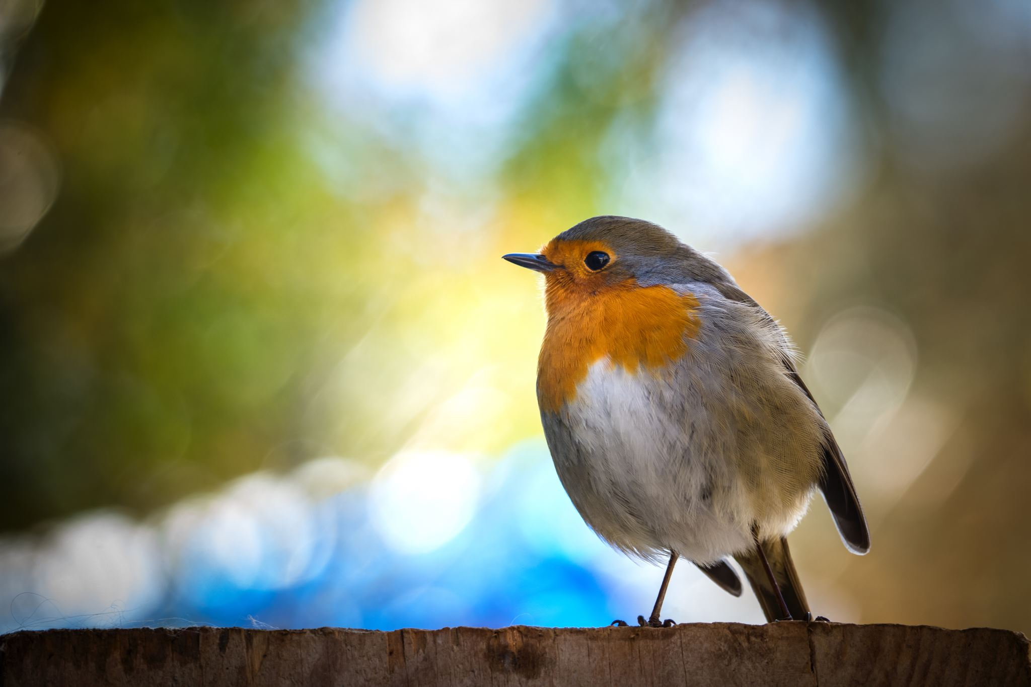  February half term is 17th – 21st February  Easter is 7th-17th April

