Spring.  It has been wonderful to start to see signs of spring despite the continuous rain we have had! We still spend as much time as we can outside with free flow into the cabin.  Over the upcoming months our focus will be on expanding our knowledge of nature and the changes we see through spring.  We start off this half term with our topics covering life cycles, endangered species and dragons. After the may half term we explore growing our own vegetables, healthy eating and looking aftre ourselves and others.  It’s not as cold now but it is still wet! Wellies and waterproofs are still a must.  Personal belongings  Reminder to please remove your peronal belongings from your childs bag and notify us of any medications, including calpol that is in their bags. |  | 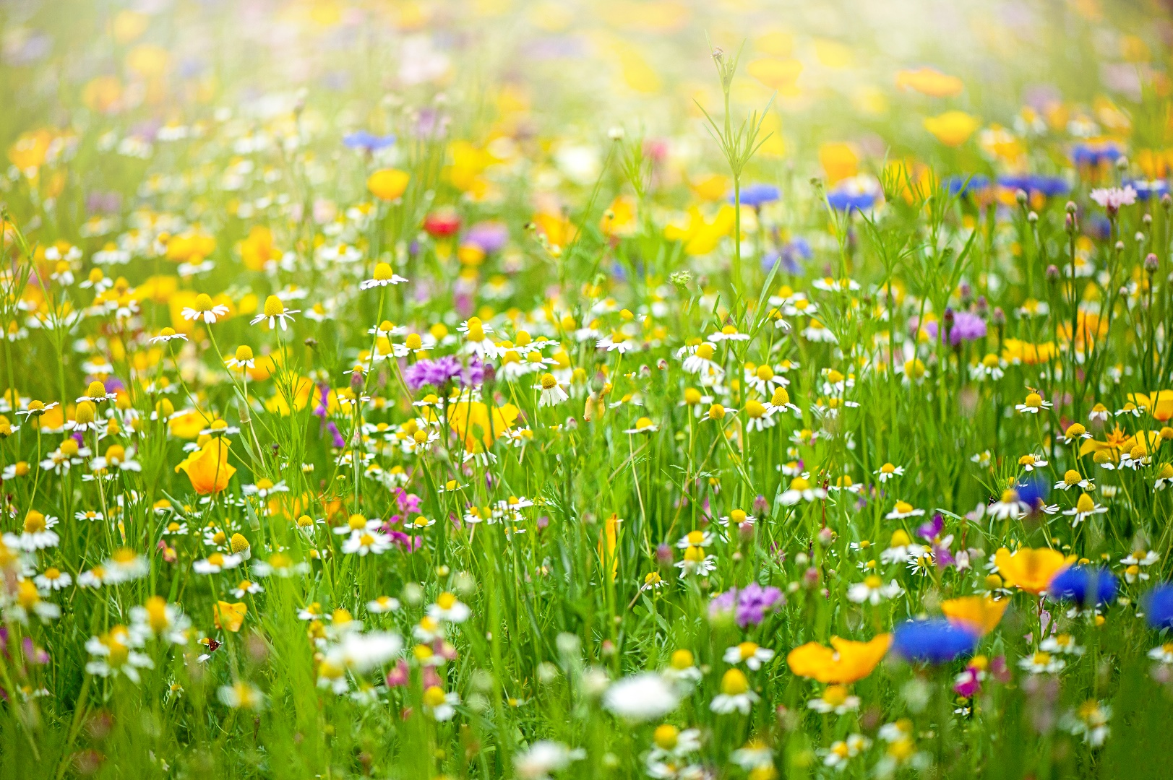
 |  | Ofsted Inspection
As many of you know we received our Ofsted inspection on Friday 8thMarch.
We received a Good grade in Quality of eduaction and good in Behaviours and development. Which we are super proud of.
Unfortunetly due to receiving inadiquate in both personal development, and leadership and management we received an over all inadiquate grade. The areas that required improvement have been addressed and we are looking forward to receiving another inspection within 6 months. If you have any questions please feel free to get intouch and when we receive our final inspection report I will email it out to you all.

April 2024 | Sweetpeas Childminding  Latest news and bulletin updates | Issue 3
Upcoming closures | Summer holiday  Additional spaces avaiable | 15 hours Funding
We will be closed for 1 week from 6th May and back Monday 13th May.  We are also closed Friday 14th June. | Siblings of children who attend have first reserved places for half terms but please ensure you book these as soon as possiable. | Don’t forget to keep your details upto date for this or it can affect your funding. You will be advised when to do this.

