Welcome back  Welcome back everyone, for some, with the half term and our week closed it has been a long time since we have seen you. I have hopefully caught up with all the boring stuff that goes on behind the scenes aswell as some fun planning and getting things ready for the summer months.  Warmer weather and outdoor play.  Hopefully the weather continues to stay bright and dry but waterproofs and boots are still the best for our outdoor play. Please provide suncream for your child and we will apply it regularly throughout the day.  Staff changes  We said goodbye to Nanny Angie at the end of March but welcomed Charlotte who has already settled in over the Easter holidays and is looking forward to meeting the rest of the children. Those that have already met her have made her feel very welcome. |  | 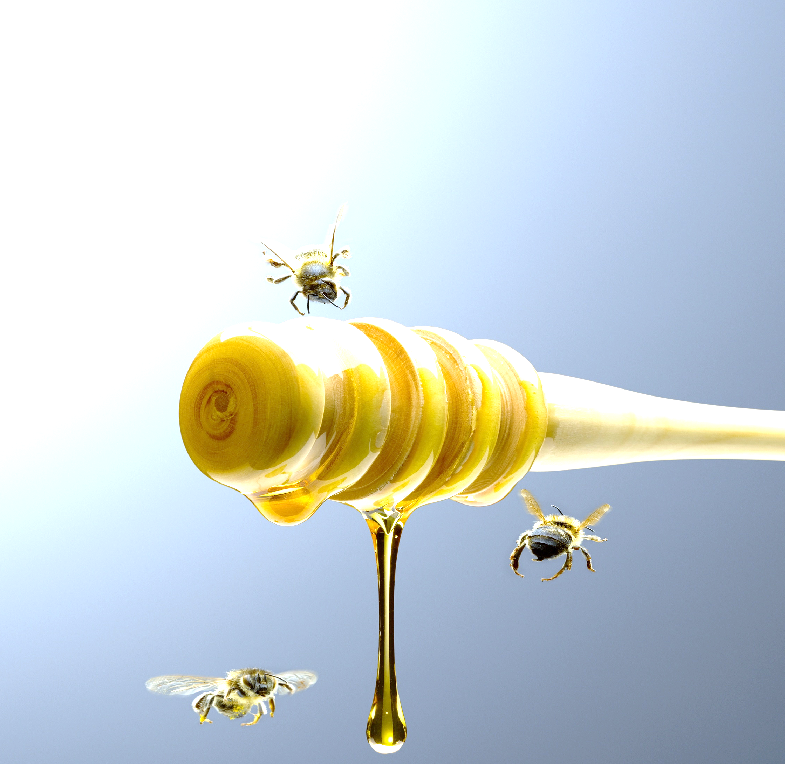
 |  | This half terms topics

This half term we will be starting off with some roarsome fun as we explore dinosaurs in all their giant wonder. We then move onto looking at extint animals around the world.
We will also cover butterflys, flowers and Bees as we celebrate World Bee Day at the end of the month. We have our own wildflower garden planted and hope to see lots of insects visit us soon.
This term we hope to be able to arrange a few trips out to further our learning, more information will be provided for these when they have been confirmed.
May 2025 | Sweetpeas Childminding  Latest news and bulletin updates | Issue 10
Upcoming closures | Tapestry and Website. | Half term.
We will be closed -  Bank holiday 5th May  Bank holiday 26th May  7th,8th 11th August | Lots of information about what your child has been up to is on your Tapestry account. If you have any questions do let me know.  Online you can find our menu, past newsletters, holiday club contracts and more.  Sweetpeaschildcarenorfolk.co.uk | May half term 27th-30th

