Spring on its way.  As the days get longer we hope to see some brighter, dryer weather.  We will continue to be outside in all weathers in the meantime, so please make sure your child has appropriate footwear and outerwear. We can help provide this if you need.  Invoicing  Invoice formats have changed recently, to hopefully make it easier. If you are not receiving these or would also have a printed copy please let me know. |  | What we have been up to.
 |  | 
This month we have been enjoying lots of tea party’s, making our own biscuits and thinking about yummy food we would eat, or a tiger might eat at a tea party. We have also explored where tigers live, and wonder why they have stripes. Its been tricky to find them in the garden, but with help from a book, There’s a Tiger in the Garden, and some face paint we found plenty.
We have also been busy watching our very bold birds, feeding on our new window feeder, as well as hop closer when we feed them outside.Our key areas of learning this month have been making relationships, moving and handling, reading , numbers and the world. We have certinly had fun exploring it all.

February’s learning
Next month our key areas of learning will be self-confidence, listening and attention, health and self-care, shapes, measure and writing. We will be looking at how we care for pets and the different type of pets we have. We will of course also be looking at the people in our lives we love too. At the end of the month we will be exploring Chinese New Year.
Feruary 2026 | Sweetpeas Childminding  Latest news and bulletin updates | Issue 19
Upcoming closures | 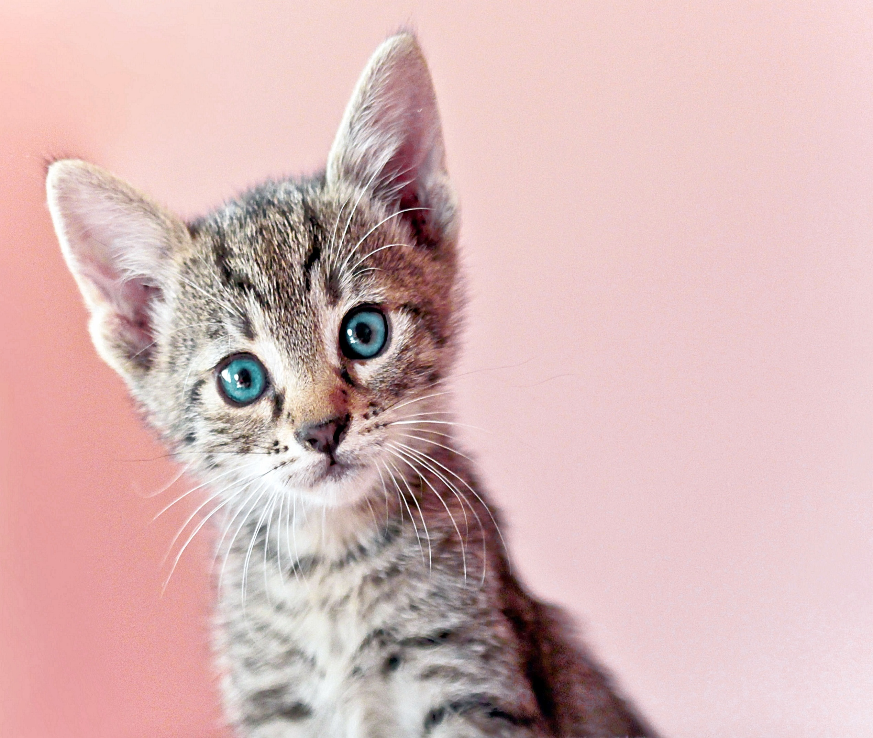  Website. | Half term
Closed 23rd-27th March  Summer dates to be confirmed soon. | There are previous news letters and more on the website including our up to date menu. | We are almost full for February half term now, but have opened spaces for Easter which can be found on the website for those that are usually term time only or siblings.

