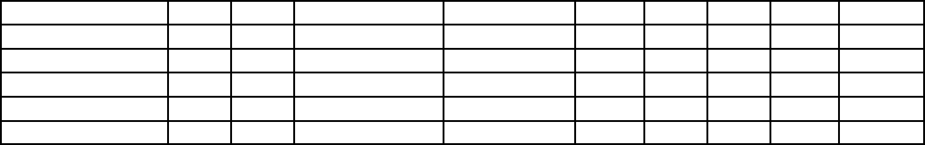

***Closing Date 5pm Thursday 23rd October 2025 Please send Entries via Email to:*** [***calaisminiatures@gmail.com***](mailto:calaisminiatures@gmail.com) ***$7.00 per pony*** *Inc. GST* ***Payment* / proof of payment must accompany this entry form.Copies of BOTH SIDES of registration papers must be attached to this entry form along with a copy of your current Membership card and your PIC card.** Any Incomplete or Incorrect paperwork will **NOT** be accepted. Paperwork can be returned to member

ABN: 89 501 336 192  
  
ENTRY FORM  
**AMPS® WESTERNPORT GROUP SHOW 2025**

# 8.30am Sunday 26th OCTOBER 2025

# AKOONAH PARK BERWICK

# 

ADD SHOW DATE AND VENUE

~ AUSTRALIAN MINIATURE PONY SOCIETY VICTORIAN BRANCH ~

*Owner’s Name: ________________________________________________Membership No:________ Property Identification Code(PIC) No:________*

*Address: ___________________________________________________________________________Postcode: ______________EMAIL ________________*

*Phone No: ___________________________ Signature: _______________________________________________________*

*Exhibitor’s / Handler’s Name: _________________________________________ Membership No: ____________*

*Exhibitor’s / Handler’s Name: _________________________________________ Membership No: ____________*

*Signature____________________________________*

*_______________*

Cheques payable to Australian Miniature Pony Society Inc.

*PAYMENT BY DIRECT DEPOSIT TO LBC*

*BSB: 032689 ACC: 128288*

*AC NAME: Australian Miniature Pony Society*

*IN THE CUSTOMER REFERENCE SECTION:* ***3000******Westernport Show***

*Copy of transaction receipt MUST accompany this entry form.*

***IF MEMBERS ARE BY DIRECT DEPOSIT IT IS THEIR RESPONSIBLITY TO FAX OR EMAIL A COPY OF THIS ENTRY FORM TO LBC BEFORE CLOSING DATE***  
  
  
  
___________________________________________________________________Postcode: ________________   
  
Phone No: ___________________________ Signature: _______________________________________________

***Show Entry Form Declaration:***

*I / We hereby certify that the above details are correct and in accordance with the Conditions of Entry, which I / We have read on the attached sheet and I / We agree to comply with the Conditions of Entry, as set down by the*

*AMPS Victorian Group. I / We hereby acknowledge and accept that I / We are responsible for any Non-Members who accompany me / us. Further, I & those persons accompanying me / us, agree to abide by the Society rules & regulations.*

*I / we acknowledge & have made those accompanying me / us aware that Equine sports have the potential to be dangerous and accept that while every effort will be made with regard to safety, I & those persons accompanying me,*

*will NOT hold The Australian Miniature Pony Society Inc &/or the* ***Victorian Group,*** *responsible for any damage, loss or injury incurred.*

*Class No Class No*

*Class No Class No*

*Pony’s/Handlers Name*

*Reg No.*

*D.O.B.*

*Stables*

*Class No*

*Class No*

*Class No*

***Cost***

$15.00

___________

*Entries Costs Total*

*Float Entry Fee*  
***TOTAL AMOUNT PAYABLE: $***