LEARNING
WITH
GRACE

SCHOOL SHIRT ORDER FORM

A Learning With Grace shirt must be worn to all classes unless a special day is announced.

You may order now, shirts will be available 2 weeks before classes begin. You may order shirts throughout the School year, but may encounter an extra fee.

Learning With Grace T-shirt or Polo shirt may be worn. You may choose from Yellow or Blue. Shirts are all dry blend high quality material. Machine washable and dryer safe [NOTE: For best results turn shirts inside out when machine washing and drying]. Sizes for Polos and T-shirts come in Youth S to XL; Adult S to XL; Polos are $18.00; T-shirts are $13.00. (sizes 2XL and 3XL are $5.00 more for Polos; and $2.00 more for T-shirts).

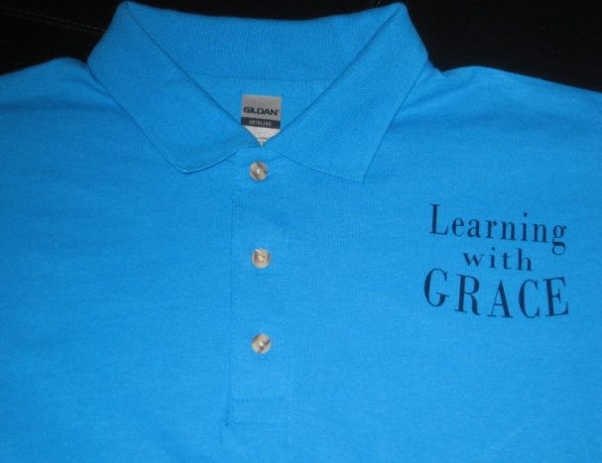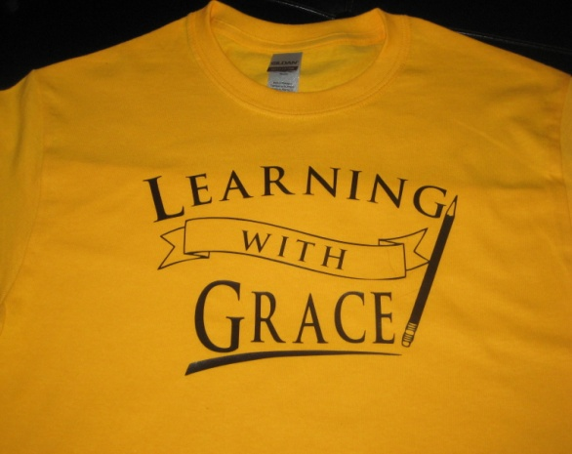
Name:____________________________________
Phone:____________________________________

SHIRT TYPE COLOR PRICE
Polo T-shirt Yellow Blue SIZE PRICE
TOTAL: $
========
PAYMENT OPTIONS: All orders must be prepay by check or PayPal. Checks payable to Dianne Spirko mail to 619 Cedarwood Lane, Crownsville, MD 21032 or PayPal at tsaplenty@gmail.com.

