LEARNING
WITH
GRACE
SCHOOL SHIRT ORDER FORM

A Learning With Grace polo or t-shirt must be worn to all classes unless a special day is announced.

You may order shirts the same day you enroll until August 1st. YOU MUST USE THIS ORDER FORM and E-MAIL IT TO: tsaplenty@gmail.com. Shirts are delivered the first day of School. LATE ORDERS WILL BE CHARGED A $10 LATE FEE.

You may choose from Yellow or Blue. Please indicate on this Order Form Youth or Adult size. Shirts are all dry blend high quality material. Machine washable and dryer safe [NOTE: For best results turn shirts inside out when machine washing and drying].

Sizes for Polos and T-shirts are Youth S to XL; Adult S to XL. Polos are $21.00; T-shirts are $16.00. (Adult sizes 2XL and 3XL are $6.00 more for Polos; and $3.00 more for T-shirts). EVERY SHIRT IS CUSTOM MADE AND ARE NOT RETURNABLE OR EXCHANGEABLE.
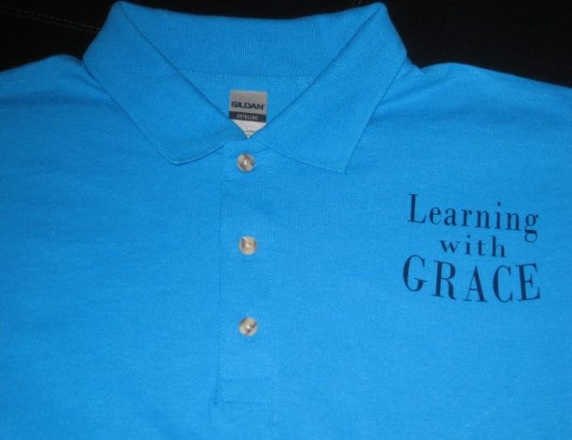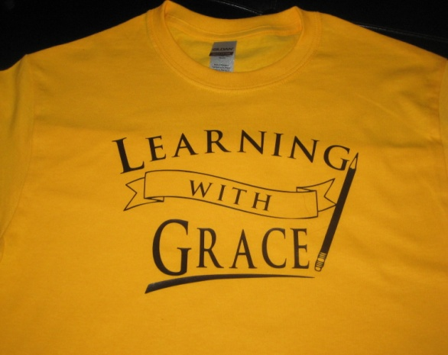
Name:____________________________________
Phone:____________________________________

SHIRT TYPE COLOR PRICE
Polo T-shirt Yellow Blue SIZE PRICE
TOTAL: $
========
PAYMENT OPTIONS: All orders must be prepaid by check or PayPal {if charged a fee for using PayPal, please add it to your order total.} Checks payable to Dianne Spirko mail to 619 Cedarwood Lane, Crownsville, MD 21032 or PayPal at tsaplenty@gmail.com.

