**INSTRUCTIONS**

1. Download the CSV files hosted in the below link and import them into Databricks Free Tier platform (Simple Google search stating ***“How to import CSV files in Databricks free tier”*** would help you here). This enables you query the CSV files like a database.
2. The CSV files are hosted here: [Ecommerce Database](https://drive.google.com/drive/folders/13QOzZzgHbJRbrMKMcGJ0ggpg8TRkZXVx?usp=sharing)
3. Entity Relationship Diagram: Helps you understand the table composition.

PK – Primary Key

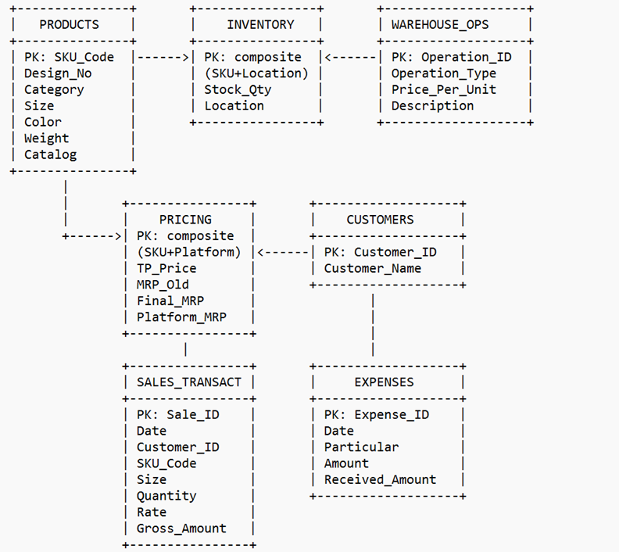

1. If you are still unable to understand the steps, then drop a note in the Data Engineering Referral WhatsApp group: <https://tinyurl.com/dadewareferral>

We will help you out! Happy learning!

**Note: This WhatsApp group is open for seeking referrals and learnings**