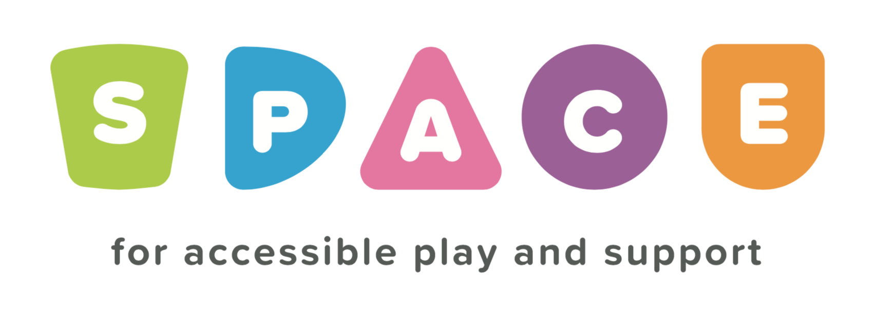
Registration Form

Name of Parent/Carer |  | Contact Number
Address |  |  |  | Postcode
Email Address

Alternative contact (For emergency purposes only)
I give permission for photographs of my child/ren to be taken during sessions and for them to be used only in promoting SPACE |  |  |  | Yes No
Parent/Carer Signature |  |  |  | Date
Signed |  |  | Date

CHILD 1
Name |  | Known as
Date of Birth | Male/Female/Other | Religion | First Language
Additional Needs/Medical Conditions (including allergies)

CHILD 2
Name |  | Known as
Date of Birth | Male/Female/Other | Religion | First Language
Additional Needs/Medical Conditions (including allergies)

CHILD 3
Name |  | Known as
Date of Birth | Male/Female/Other | Religion | First Language
Additional Needs/Medical Conditions (including allergies)

CHILD 4
Name |  | Known as
Date of Birth | Male/Female/Other | Religion | First Language
Additional Needs/Medical Conditions (including allergies)

Our GDPR Principles:

we will only process personal data for specified and lawful purposes
we will endeavour to hold relevant and accurate personal data, and where practical, we will keep it up to date
we will not keep personal data for longer than is necessary
we will keep all personal data secure
We would like your permission to contact you in the future regarding other events that may interest you. Please tick to give us permission to contact you in the following ways
Telephone Call SMS Email Letter

