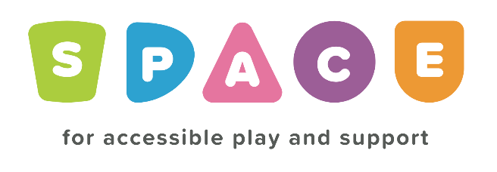
Toy Library Registration Form

Parents Name
Address

Postcode
Email address
Telephone number
Do you have a child with additional needs |  | Yes No
Are you registered with SPACE |  | Yes No

I understand that the items I loan are my responsibility and I agree to return them in the condition I loaned them in to the best of my ability and to make SPACE aware of any damages that may occur whilst in my possession. Yes No
I am happy for my details to added to the SPACE Sensory Toy Library and to remain there for as long as I am a member of SPACE Toy Library and agree to an annual cost of £10. Yes No
There are times when we may need to contact you about items you have loaned or reserved, by signing below you agree to the following statement.
I agree that any of the details I have provided above can be used to contact me, only in relation to items I have borrowed or intend to borrow from SPACE toy library.

Signed ………………………………………………
Print ………………………………………………
Date ………………………………………………

