Lauren H. Kerstein, Author

DARE TO DREAM DAZZLING DREAMS…
THEY JUST MIGHT COME TRUE!
ABOUT THE AUTHOR
Longer Bio: Lauren H. Kerstein is an author and psychotherapist. She is a Jersey girl at heart who loves reading, drinking tea, and sipping kombucha. Lauren currently lives in Colorado with her husband, Josh, their two dragons...er, daughters, Sarah and Danielle, and her rescue dogs. Lauren is the author of the Rosie the dragon and Charlie picture book series (Illustrated by Nate Wragg/Two Lions) and HOME FOR A WHILE (Illustrated by Natalia Moore/Magination Press). REMEMBERING SUNDAYS WITH GRANDPA (Illustrated by Nanette Regan/Beaming Books) danced to bookshelves November 2023. Hope Rode (Illustrated by Becca Stadtlander/Union Square Kids) will be out in 2025 as well as another soon-to-be-announced picture book. Lauren also writes books in her field. Lauren’s books include themes of courage, flexible thinking, friendship, social emotional learning, foster care, seeing your strengths, sensory issues, and emotion regulation. She is represented by Deborah Warren with East West Literary Agency. Lauren is a long-time member of SCBWI and the 12x12 PB Challenge, runs a critique business, is a judge for Rate Your Story, and is one of the founders of #ReVISIONweek. Her writing goals are simple. Read voraciously. Embrace feedback. Grow each day. Work hard. Be passionate. Write courageously. Touch children’s hearts.

Shorter Bio: Lauren H. Kerstein is an author and psychotherapist. She’s the author of the Rosie the dragon and Charlie picture book series (Nate Wragg/Two Lions), HOME FOR A WHILE (Natalia Moore/Magination Press) and REMEMBERING SUNDAYS WITH GRANDPA (Nanette Regan/Beaming Books). Hope Rode (Illustrated by Becca Stadtlander/Union Square Kids) will be out in 2025 as well as another soon-to-be-announced picture book. Lauren also writes books in her field. Lauren is a member of SCBWI, runs #ReVISIONweek, and is represented by Deborah Warren with East West Literary Agency. www.LaurenKerstein.net, lauren@laurenkerstein.com
CONTACT INFORMATION
Email: lauren@laurenkerstein.com
Website: www.LaurenKerstein.net
Phone: 303-949-9645
FB: @laurenkersteinauthor
IG: @laurenkerstein
Twitter: @laurenkerstein
ROSIE THE DRAGON AND CHARLIE MAKE WAVES
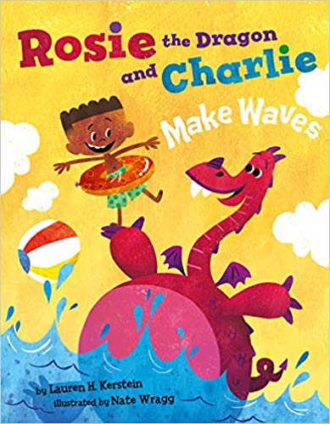
It’s summertime, and you’re invited for a rollicking day at the pool with Charlie and his pet dragon (and best friend!), Rosie. But be careful—swimming with a dragon can be, um, challenging. As Rosie and Charlie blow bubbles (don’t forget your umbrella!), practice flutter kicks (watch out for tidal waves!), and offer shoulder rides (hang on tight!), Rosie proves that dragons make the most fun pets ever. Now if only Charlie can keep Rosie’s attention focused on the rules at the pool and NOT on her gummy snacks (you know, the ones that cause stinky dragon breath!)…Grab your towels and sunscreen and join Rosie and Charlie for a fun-filled summer adventure!
BOOK INFORMATION
Illustrator: Nate Wragg
Publisher: Two Lions
Pub Date: June 1, 2019
Pages: 40 pages
ISBN-13: 9781542042925
Age: 4-8 years
Book Trailer: https://www.youtube.com/watch?v=-a9oEc6jHtQ
REVIEWS
“The digital illustrations are bright, playful, and attractive, well suited to the story…There are some young dragon lovers and fans of mischief who will revel in this silly romp.”
—Kirkus Reviews
“Kerstein’s playful story about friendship, patience, and responsibility for a pet is nicely matched by Wragg’s bold, colorful illustrations, rendered in blocky shapes and a vivid color palette. New pet owners are the natural choice for this one, but kids with younger siblings might appreciate it, too.”
—Booklist
ROSIE THE DRAGON AND CHARLIE SAY GOOD NIGHT
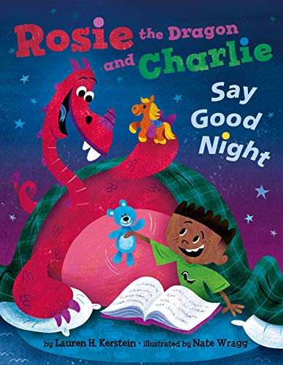
Rosie the dragon’s bedtime routine has been a little bumpy lately. But not to worry! Charlie is prepared with his lists, rules, and fire extinguisher—everything a boy needs to help guide his pet dragon (and best friend) to a peaceful night’s sleep. But with bath-time bubble trouble, fiery-hot pajamas, and stuffed animal search-and-rescues, tucking this dragon into bed is not an easy task. And what happens when thunder strikes? Snuggle up with this adorable duo as they conquer bedtime the best way: together!

BOOK INFORMATION
Illustrator: Nate Wragg
Publisher: Two Lions
Pub Date: September 1, 2020
Pages: 40 pages
ISBN-13: 9781542018487
Age: 4-8 years
Book Trailer: https://youtu.be/WTzpglfNyHs
REVIEWS
"This humorous story is a sweet representation of caretaking and patience, with a parallel that can extend to older and younger siblings as well as to parent-child relationships, perhaps making young readers a bit more self-reflective and empathetic."
—Kirkus Reviews
HOME FOR A WHILE
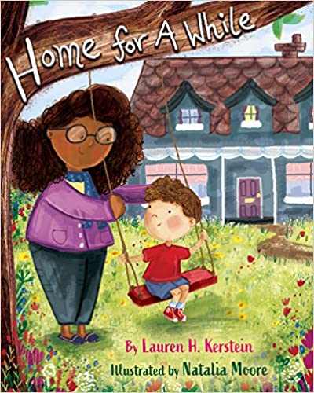
Calvin is in foster care, and he wants to trust someone, anyone, but is afraid to open his heart. He has lived in a lot of houses, but he still hasn’t found his home. When he moves in with Maggie, she shows him respect, offers him kindness, and makes him see things in himself that he’s never noticed before. Maybe this isn’t just another house, maybe this is a place Calvin can call home, for a while.

BOOK INFORMATION
Illustrator: Natalia Moore
Publisher: Magination Press/ American Psychological Association
Pub Date: February 2, 2021
Pages: 32 pages
ISBN-13: 9781433831874
Age: 4-8 years
Book Trailer: Home For A While Trailer - YouTube

REVIEWS
**STARRED REVIEW**
"takes apart the fostering experience as few books have-from the newcomer’s point of view...VERDICT Most books with this much purpose fall down on the ­lessons. This one transcends them, for a true story of how a home happens."
— School Library Journal

"...the book is as much a model for foster parents as it is a story to provide validation of foster children’s experiences...Gentle and wise—especially as a read for foster parents."
—Kirkus Reviews
REMEMBERING SUNDAYS WITH GRANDPA
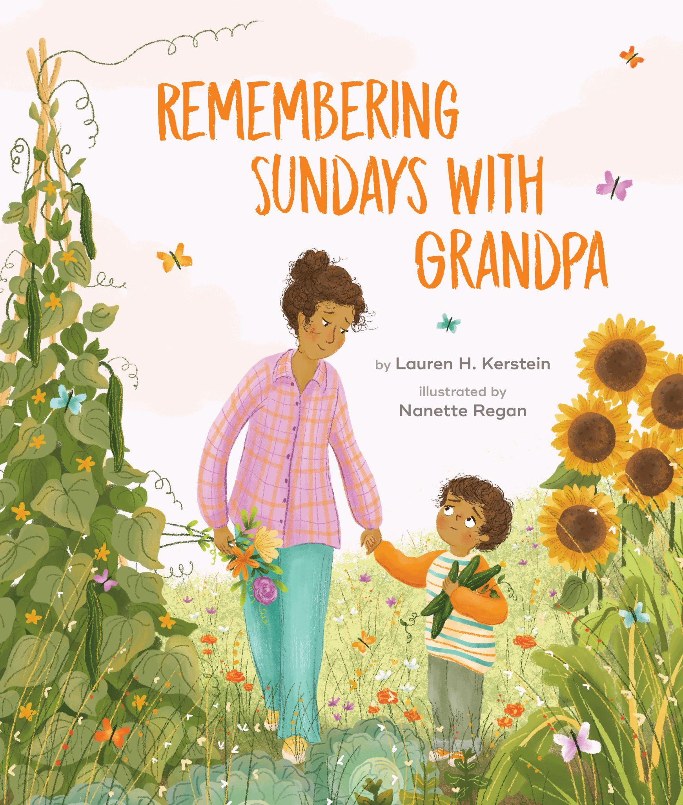
Henry and his mom feel Grandpa's love in all his special places: in the rocking chair where he read stories with silly voices, in the cucumbers that always made him hiccup, and in the jewelry box he used to wind up so they could dance. As they remember the many loving moments they shared, they work through their grief.
Remembering Sundays with Grandpa illustrates how even when someone is no longer part of the physical world, their love lives on forever.
BOOK INFORMATION
Illustrator: Nanette Regan
Publisher: Beaming Books
Pub Date: November 7, 2023
Pages: 32 pages
ISBN-13: 978-1506487410
Age: 4-8 years
Book Trailer: https://youtu.be/hGH0s9o9KGI
REMEMBERING SUNDAYS WITH GRANDPA
Remembering Sundays with Grandpa is a heartwarming story about bereavement. Sensitively written, it can help a child work through their grief after the loss of a grandparent or another special person.
- StorySnug

Sundays weren’t the same for Henry since his grandpa died. He is grieving, looking for comfort, and asking big questions like “why did he have to die?” Henry’s mom gently helps him find comfort in memories and together they remember, grieve, and begin to heal. ⁠
⁠This is a beautiful book that directly deals with the pain of loss. The author is a psychotherapist and masterfully opens doorways to impossible conversations and healing both for our littles and for us.
- Charlotte H. Offsay (Picture Book Recommendations) ⁠

In her recently released book, Remembering Sundays with Grandpa, Lauren Kerstein approaches the heavy topic of loss in a light, fresh and child-friendly manner. This book is appropriate for children ages 3 - 8. It can be helpful in addressing any kind of grief, whether it be a grandparent, a friend, a pet, or even a separation as in foster care or adoption. Lauren touches on many important points in dealing with a grieving child that I strongly support and promote as a therapist.
- Vasilia Graboski - Psyched Writer

MORE ANNOUNCEMENTS TO COME INCLUDING:
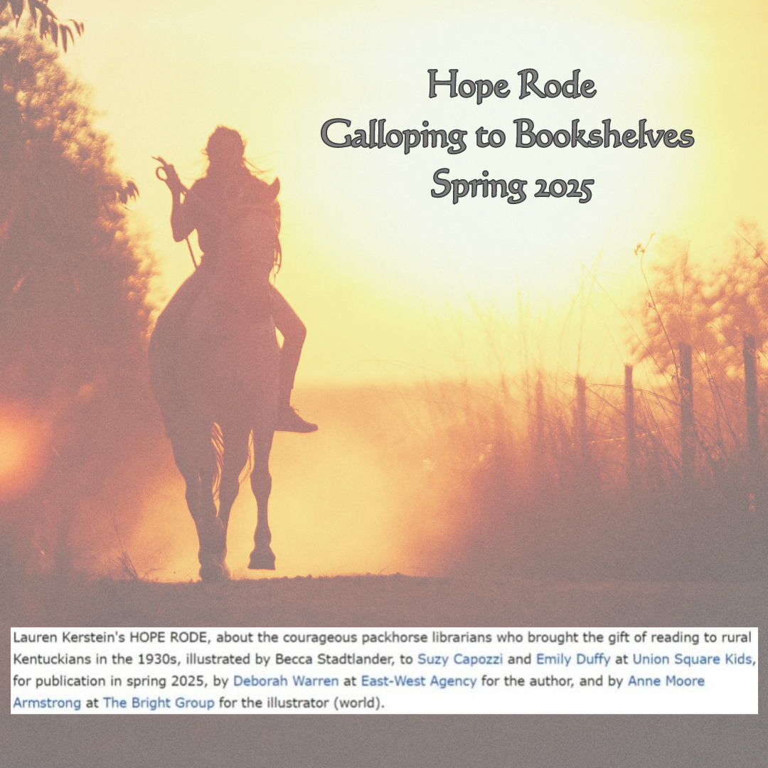

Other Media Material

