Lauren H. Kerstein, Author

DARE TO DREAM DAZZLING DREAMS…
THEY JUST MIGHT COME TRUE!
ABOUT THE AUTHOR
Lauren Kerstein is an author and psychotherapist. She is a Jersey girl at heart who loves reading, drinking tea, and devouring chocolate. Lauren currently lives in Colorado with her husband, Josh, their two dragons...er, daughters, Sarah and Danielle, and her rescue dog, Duke. Lauren is the author of books in her field that include such topics as sensory issues and emotion, flexible thinking, autism spectrum disorders, and emotion regulation. She is also a children's author. Her debut fiction picture book: Rosie the Dragon and Charlie Make Waves (Illustrated by Nate Wragg/Two Lions) swam to shelves in June 2019. The companion volume, Rosie the Dragon and Charlie Say Good Night (Illustrated by Nate Wragg/Two Lions), snuggled into shelves on September 1, 2020. Lauren’s book Home for a While (Illustrated by Natalia Moore/Magination Press) moved into bookshelves February 2, 2021. Lauren is a long-time member of SCBWI and the 12x12 PB Challenge, runs a critique business, is a judge for Rate Your Story, and is one of the founders of #ReVISIONweek. Her writing goals are simple. Read voraciously. Embrace feedback. Grow each day. Work hard. Be passionate. Write courageously. Touch children’s hearts.

CONTACT INFORMATION
Email: lauren@laurenkerstein.com
Website: www.LaurenKerstein.net
Phone: 303-949-9645
FB: @laurenkersteinauthor
IG: @laurenkerstein
Twitter: @laurenkerstein
ABOUT ROSIE THE DRAGON AND CHARLIE MAKE WAVES
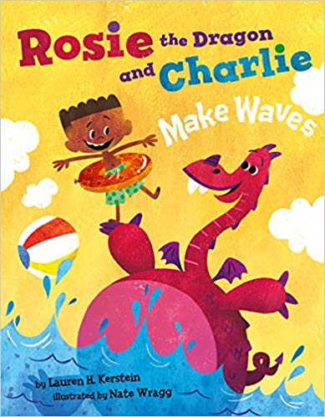
It’s summertime, and you’re invited for a rollicking day at the pool with Charlie and his pet dragon (and best friend!), Rosie. But be careful—swimming with a dragon can be, um, challenging. As Rosie and Charlie blow bubbles (don’t forget your umbrella!), practice flutter kicks (watch out for tidal waves!), and offer shoulder rides (hang on tight!), Rosie proves that dragons make the most fun pets ever. Now if only Charlie can keep Rosie’s attention focused on the rules at the pool and NOT on her gummy snacks (you know, the ones that cause stinky dragon breath!)…Grab your towels and sunscreen and join Rosie and Charlie for a fun-filled summer adventure!
BOOK INFORMATION
Illustrator: Nate Wragg
Publisher: Two Lions
Pub Date: June 1, 2019
Pages: 40 pages
ISBN-13: 9781542042925
Age: 4-8 years
Book Trailer: https://www.youtube.com/watch?v=-a9oEc6jHtQ
REVIEWS
“The digital illustrations are bright, playful, and attractive, well suited to the story…There are some young dragon lovers and fans of mischief who will revel in this silly romp.”
—Kirkus Reviews
“Kerstein’s playful story about friendship, patience, and responsibility for a pet is nicely matched by Wragg’s bold, colorful illustrations, rendered in blocky shapes and a vivid color palette. New pet owners are the natural choice for this one, but kids with younger siblings might appreciate it, too.”
—Booklist
ABOUT ROSIE THE DRAGON AND CHARLIE SAY GOOD NIGHT
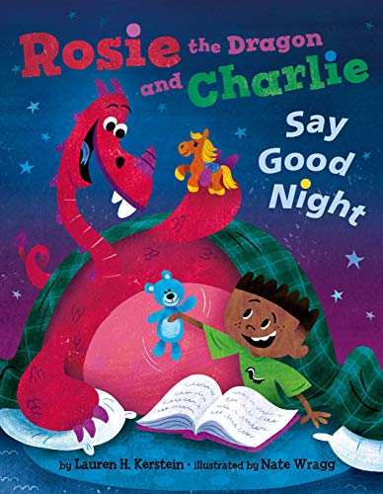
Rosie the dragon’s bedtime routine has been a little bumpy lately. But not to worry! Charlie is prepared with his lists, rules, and fire extinguisher—everything a boy needs to help guide his pet dragon (and best friend) to a peaceful night’s sleep. But with bath-time bubble trouble, fiery-hot pajamas, and stuffed animal search-and-rescues, tucking this dragon into bed is not an easy task. And what happens when thunder strikes? Snuggle up with this adorable duo as they conquer bedtime the best way: together! Rosie The Dragon And Charlie Say Good Night snuggled into shelves September 1, 2020.
BOOK INFORMATION
Illustrator: Nate Wragg
Publisher: Two Lions
Pub Date: September 1, 2020
Pages: 40 pages
ISBN-13: 9781542018487
Age: 4-8 years
Book Trailer: https://youtu.be/WTzpglfNyHs
REVIEWS
"This humorous story is a sweet representation of caretaking and patience, with a parallel that can extend to older and younger siblings as well as to parent-child relationships, perhaps making young readers a bit more self-reflective and empathetic."
—Kirkus Reviews

ABOUT HOME FOR A WHILE
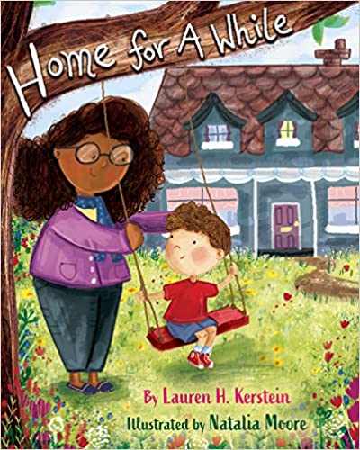
Calvin is in foster care, and he wants to trust someone, anyone, but is afraid to open his heart. He has lived in a lot of houses, but he still hasn’t found his home. When he moves in with Maggie, she shows him respect, offers him kindness, and makes him see things in himself that he’s never noticed before. Maybe this isn’t just another house, maybe this is a place Calvin can call home, for a while. Home For A While will move into bookstores on February 2, 2021.
BOOK INFORMATION
Illustrator: Natalia Moore
Publisher: Magination Press/ American Psychological Association
Pub Date: February 2, 2021
Pages: 32 pages
ISBN-13: 9781433831874
Age: 4-8 years
Book Trailer: Home For A While Trailer - YouTube

REVIEWS
**STARRED REVIEW**
"takes apart the fostering experience as few books have-from the newcomer’s point of view...VERDICT Most books with this much purpose fall down on the ­lessons. This one transcends them, for a true story of how a home happens."
— School Library Journal

"...the book is as much a model for foster parents as it is a story to provide validation of foster children’s experiences...Gentle and wise—especially as a read for foster parents."
—Kirkus Reviews

