DISCOUNT PASSES
Approved Golden Age, Access, Military & Senior Passes
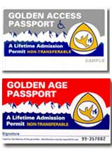

PASSES FOR 50% OFF FAMILY SITES:
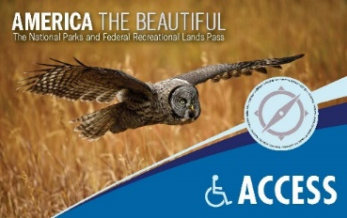
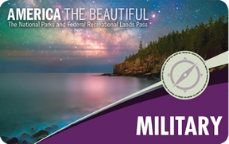

*PASS DISCOUNT ONLY ON FAMILY SITES*
Discount not available on double or group sites or day use
Only good for one campsite
Pass holder must be present

Other Passes: (NOT HONORED):
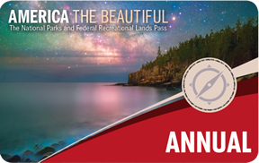
Interagency Annual Pass is NOT valid for discounting on camping or day use areas

