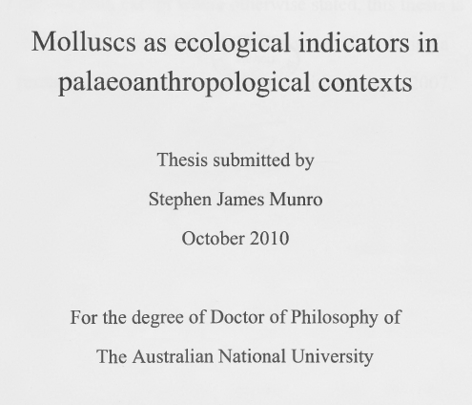

The PDF of Stephen Munro’s PhD Thesis is too large for the limits of our web site but you can still download it by clicking on the link below…
https://drive.google.com/file/d/1bNFv7uNouEywsVEsXLXMZjv1gjsRTugf/view?usp=sharing

