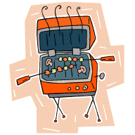

Friday, August 10th, 2018 serving begins @ 6:00 p.m.

Ag Museum – Carwell Building 301 East Iowa Hiawatha, Kansas

For Reservations - Please Call: 742-3702

Sponsored by: Area Merchants & Brown County Historical Society