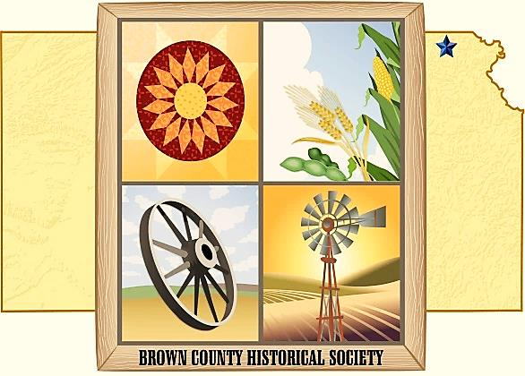

ANNUAL MEETING

March 22, 2019

Located at Country Cabin

Lower Level Meeting Room

2534 Kestrel Road, Hiawatha, KS 66434

6:00 PM

Please RSVP to 785-742-3330 or bchsdirect@gmail.com

**May 1**

Memorial Auditorium, AG Museum and Windmill Lane Opens

**May 2019 TBA**

Veterans Memorial Day Program

**July 3**

Ice-Cream Social 5:30pm Ag Museum “Carwell Building”

**August 9**

Farmers Appreciation Dinner 6:00pm Ag Museum “Carwell Building”

**September 28**

Heritage Days

**Calendar of Events**

**BROWN COUNTY HISTORICAL SOCIETY, INC.**

**“1978-2019”**

**Program**

**Board of Directors**

**Invocation**

Eugene Swearingen

**Dinner**

**Meeting Called to Order**

Gary Shear

**Introduction of Program**

Panel Discussion Progression

Speaker – Nathan Wright

&

**Treasurers’ Report**

Mary D. Waite

**President**

Gary Shear

**Vice-President**

Larry Day

**Secretary**

Wes Duesing

**Treasurer**

Mary Delores Waite

Larry Adcock

Jere Bruning

Gil Bunning

Jim Gibbs

Dennis Greer

Joe Nigus

Eugene Swearingen

Donna Thonen-- **Newsletter Editor**

## Board of Directors