6**Mark your calendars!**

**March 22, 2019 is**

**Brown County Historical Society’s Annual Meeting!**

**Dinner is to be at the Country Cabin**

**Dinner is to begin at 6 pm**

**Come enjoy an eventful day with us!**

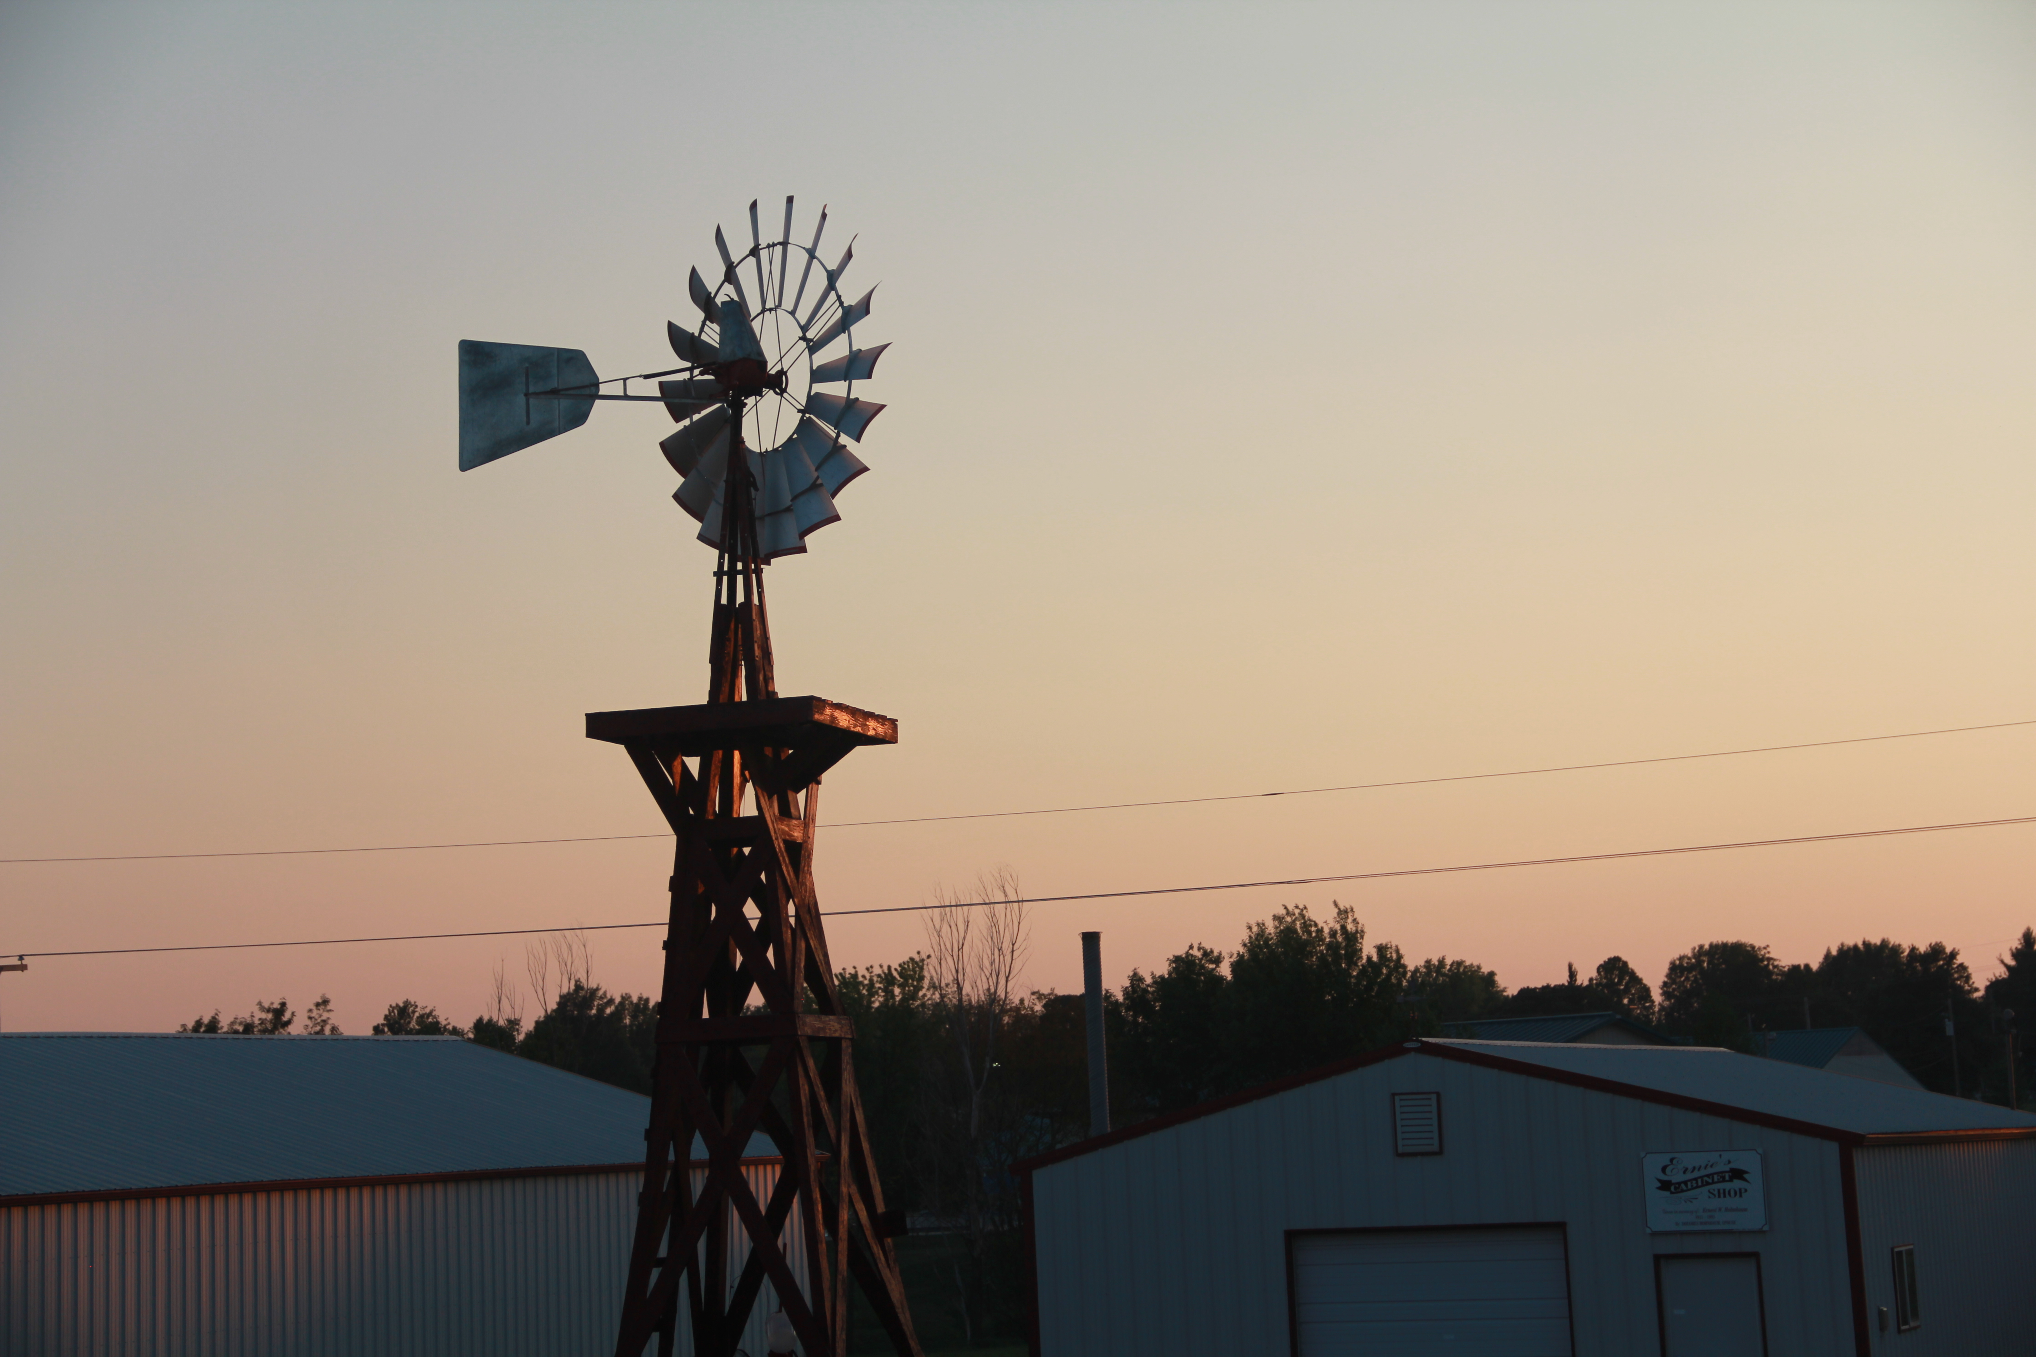

When: March 22, 2019

where: country cabin

lower level meeting room

2534 Kestrel road

Hiawatha, KS 66434

Dinner $15.50 per plate

food selections: pork loin, chicken a la orange & fish

RSVP: 785-742-3330 or bchsdirect@gmail.com