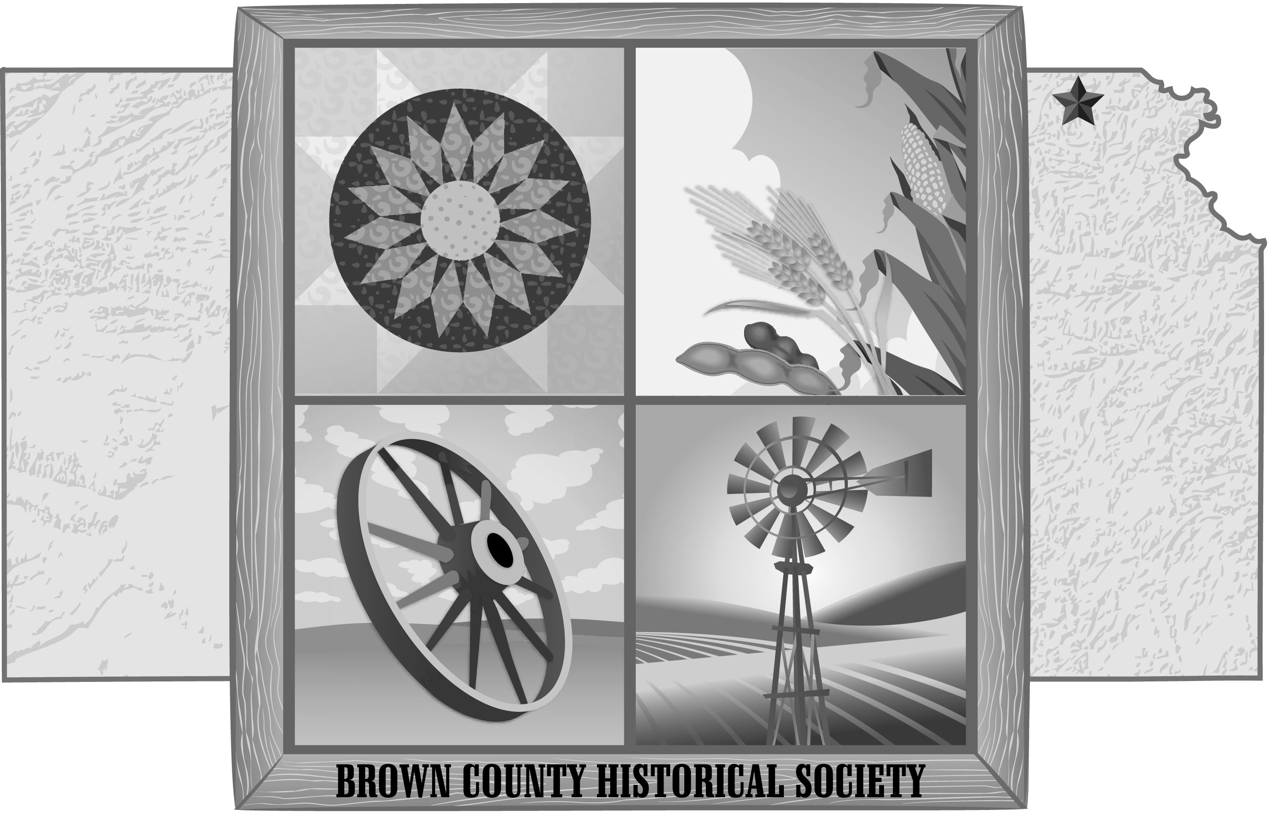
Brown County Historical Society
Memorial Auditorium and AG Museum & Windmill Lane
611 Utah Street
Hiawatha, KS 66434
(785)742-3330
www.bckshistory.com
“Enriching Our Future Through Our Past”
o

Dear Member,

The Brown County Historical Society hopes that your holiday season was festive and extend to you our best wishes for the New Year! Brown County Historical Society has appreciated your support in the museums endeavors. The New Year approached us quickly and we hope that you will renew your membership to help support Brown County Historical Society in 2019. As always, as a part of your membership you will receive the newsletter. Brown County Historical Society depends on these memberships, donations, and volunteering in order for us to be successful at meeting our mission.

This year, Brown County Historical Society had the Tarin Eicher traveling art exhibit through the summer and fall at the Plamann History Center, this art exhibit was a wonderful addition from a very talented Hiawatha native.

The summer was a busy one for Brown County Historical Society. Some of the events hosted were Meet & Greet; the annual Ice Cream Social, the annual Farmers and Merchant Appreciation Dinner and Monarch Butterfly Activity. The Auditorium has had a busy year as well. HAATS hosted several productions this year, the most successful being the “Church Basement Ladies” as well as the Christmas Music Program. The auditorium participated in the annual “Miss Mary Halloween Contest” the costumes were such a delight to be able to see.

At the Ag Museum, our Heritage Day on September 29th was a great success with lots of venders, displays, activities which included a petting zoo and pony rides. Throughout the month of October we held the “Grand Prairie One Room Schoolhouse.” Hiawatha and Horton second grade students participated in the program this year. This program is enjoyed by everyone who participated and it is our goal to include other surrounding area schools in the future.

Your help as members of the Brown County Historical Society is how we are able to fulfill these services for our members and our community. I have enclosed the membership form for you to complete and return. Thank you for your continued support which gives us the opportunity to continue to grow and be here for future generations. Please consider Brown County Historical Society for any donations/gift giving as this supports continued improvements to the museum locations.

Sincerely,

Lynn Marie Allen
Executive Director/Curator
Brown County Historical Society

Enclosure

