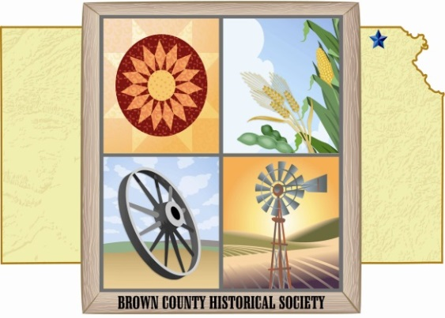
Brown County Historical Society
Memorial Auditorium, AG Museum, Windmill Lane & World Building
611 Utah Street
Hiawatha, KS 66434
(785)742-3330
www.bckshistory.com
“Enriching Our Future Through Our Past”
o

February 14, 2019
Dear Member
Bi-Laws have been reviewed and no changes are proposed for the 2019 year.
Enclosed you will find a 2019 ballot and a return envelope. Please vote, sign and mail back. Please mail back before our Annual meeting March 22, 2019. (Copy of ballot below)
Re-appointment of Board Members 3-Year Term
Gil Bunning
Donna Thonen
Gary Shear
Jim Gibbs
This year we are having our annual meeting at the Country Cabin. The meeting will be in the downstairs Meeting Room, 2534 Kestrel Road, Hiawatha, KS 66434. Dinner will be a choice of pork loin, orange a la chicken or fish. The price of the meal is $15.50 per person. Please call or respond by email letting us know that you plan to attend the meeting and the number of people attending. This year we will have a panel discussion rather than a speaker. The panel discussion will address current and prospective projects. If you have questions you would like to have addressed please feel free to contact us and let us know what Brown County Historical Society can do to continue to improve the way we provide services. We sincerely hope that you will be able to attend the annual meeting. Thank you for your continued support.
BCHS Board of Directors
Gary Shear, President
Larry Day, Vice-President
Wes Duesing, Secretary
Delores Waite, Treasurer
Donna Thonen, Newsletter Editor/Membership
Larry Adcock
Jere Bruning
Gil Bunning
Jim Gibbs
Dennis Greer
Joe Nigus
Eugene Swearingen

