Brown County Historical Society Newsletter

donna thonen NEWSPAPER EDITOR FROM 2001-2019

|  |  |  |
| --- | --- | --- |
| Brown County Historical Society | **12/25/2019** | Issue #4 for 2019 |

# **hiawatha, a community celebrated**

**Orphan Trains to Kansas**

**Special Contribution provided by**

By Lori Halfhide

Head Researcher, National Orphan Train Complex, Concordia, Kansas

Charles R. Fry, a Western Agent of the Children’s Aid Society, made arrangements to bring a company of children to Hiawatha on Saturday, January 14, 1882. Once the orphan train advertising completed and the venue arranged, Mr. Fry also selected a committee of residents to help him with the placement of the children. The local committee is a crucial factor in the successful rehoming the orphaned children in communities with which the agents were unfamiliar. This committee was a stellar group of three impressive gentlemen.

Colonel John D. Blair, a 39-year-old Canada native, was a painter and active in the community. Former Mayor, City Councilman, Constable, Blair was a member of nearly every social club in town. He was also a Civil War Veteran.

Josiah Clemmons Thomas, 48, was the proprietor of the National Bank L Store (dry goods) and was a board member of the National Bank. Mr. Thomas eventually left Brown County in 1883, moving to California.

The committee chair was one of Brown County’s most illustrious of citizens, Major Edmund Needham Morrill. Major Morrill was 47 at the time and another Civil War Veteran. He was an active politician, co-owner of Morrill and Janes Bank, and was known as “the foremost citizen of Hiawatha.” At the time of his service on the local committee, he was in the process of donating a library to the city of Hiawatha.

The local committee received the applications sent to them by Mr. Fry when he arranged to bring children to the community. The orphan applications distributed to anyone individual interested in taking one of the children into their homes. The subsequent arrangement allowed the application to

be collected when completed.

The placement was set up for January 14, but the death of one of the C.A.S. officers caused a delay in departure. Mr. Fry and the children left New York on Tuesday, January 17, and made their way halfway across the United States by train, arriving in Hiawatha on Friday the 20th. Fry took the children to a hotel to freshen up and eat, and then they made their way to the Opera House where the placement would happen. The local committee met Mr. Fry and the children at the Opera House and helped him with the assignments of the children. They knew everyone in the community and knew who could provide good homes and who was not able to do so. Families were required to

demonstrate the ability to provide a desirable home.

Once all of the children placed in suitable homes, Mr. Fry went around and visited each one to make sure that everything was working out. That wouldn’t be the end of his visits; any time he was in the area, he would check on the children. The local committee charged with looking out for the children and contacting the Society should anything go wrong. In some instances, in other communities, committee members stepped in themselves to remove children from undesirable or abusive homes.

The names of most of the children in this first company are still unknown to us. We do know that there were about twenty boys and five or six girls.

There was such demand for children that Mr. Fry arranged to bring another company in May of that year. The second company arrived in Hiawatha on Friday, May 19, and the placement was held at the Opera House that afternoon. The same committee served for this placement as well. This time, the newspaper reported the names of the children, their ages, and with whom they went home. Another item of information the newspaper reported, which (usually was not printed), was whether the child was an orphan or half orphan.

This special section has multiple stories that will be featured in upcoming newsletters.



_____________________



**Editor’s note**

*Please note newspaper sections are written verbatim and appear exactly as it appeared in print.*

_____________________

**Newsletter and Correspondence**

**Brown County Historical Society has entered the digital world. There are many ways to receive our newsletter, but to be kind to the environment, we are looking at ways to reduce the number of printed copies. Therefore you will begin to see some changes to the newsletter. If you are interested in receiving the newsletter in digital format rather than printed please reach out to us!**

**Email is** [**bchsdirect@gmail.com**](mailto:bchsdirect@gmail.com)

**Brown County Historical Society’s website:**

[**www.browncountyhistoricalsociety.com**](http://www.browncountyhistoricalsociety.com)

**Please like us on Facebook**

**@BrownCountyHistoricalSocietyMemorialAuditorium**

__________________

**History Mysteries Solved**

**Civil War Cannon**

Today, there is a cannon resting in the Hiawatha Cemetery. What you may not know is that this is a remnant of the civil war. The cannon once-fired 42.7-pound shells a distance of over 1,955 yards. To ignite the firing mechanism it required a 10.5-pound charge of black powder.

The cannon now resting in Hiawatha at the Hiawatha Cemetery was made in an East Coast foundry in 1865 and was the 36th cannon made that year. Today a curious individual could find much of specific information related to the cannon inscribed on different parts of the tube.

Hiawatha’s cannon weighs 8,748 pounds. The cannon referred as 42-pound seacoast artillery type cannon. The civil war cannon was given to the cemetery board and stood for many years on the GAR lot. The cannon even considered potentially being scraped was saved through the efforts of many people and the dedication to the cannon. Some of the first noted influential contributing fathers were J. T. Grimes, who was the father of Mrs. H, G. Amann. The Hiawatha Cemetery cannon was initially intended to be a feature in the Hiawatha Courthouse Park.

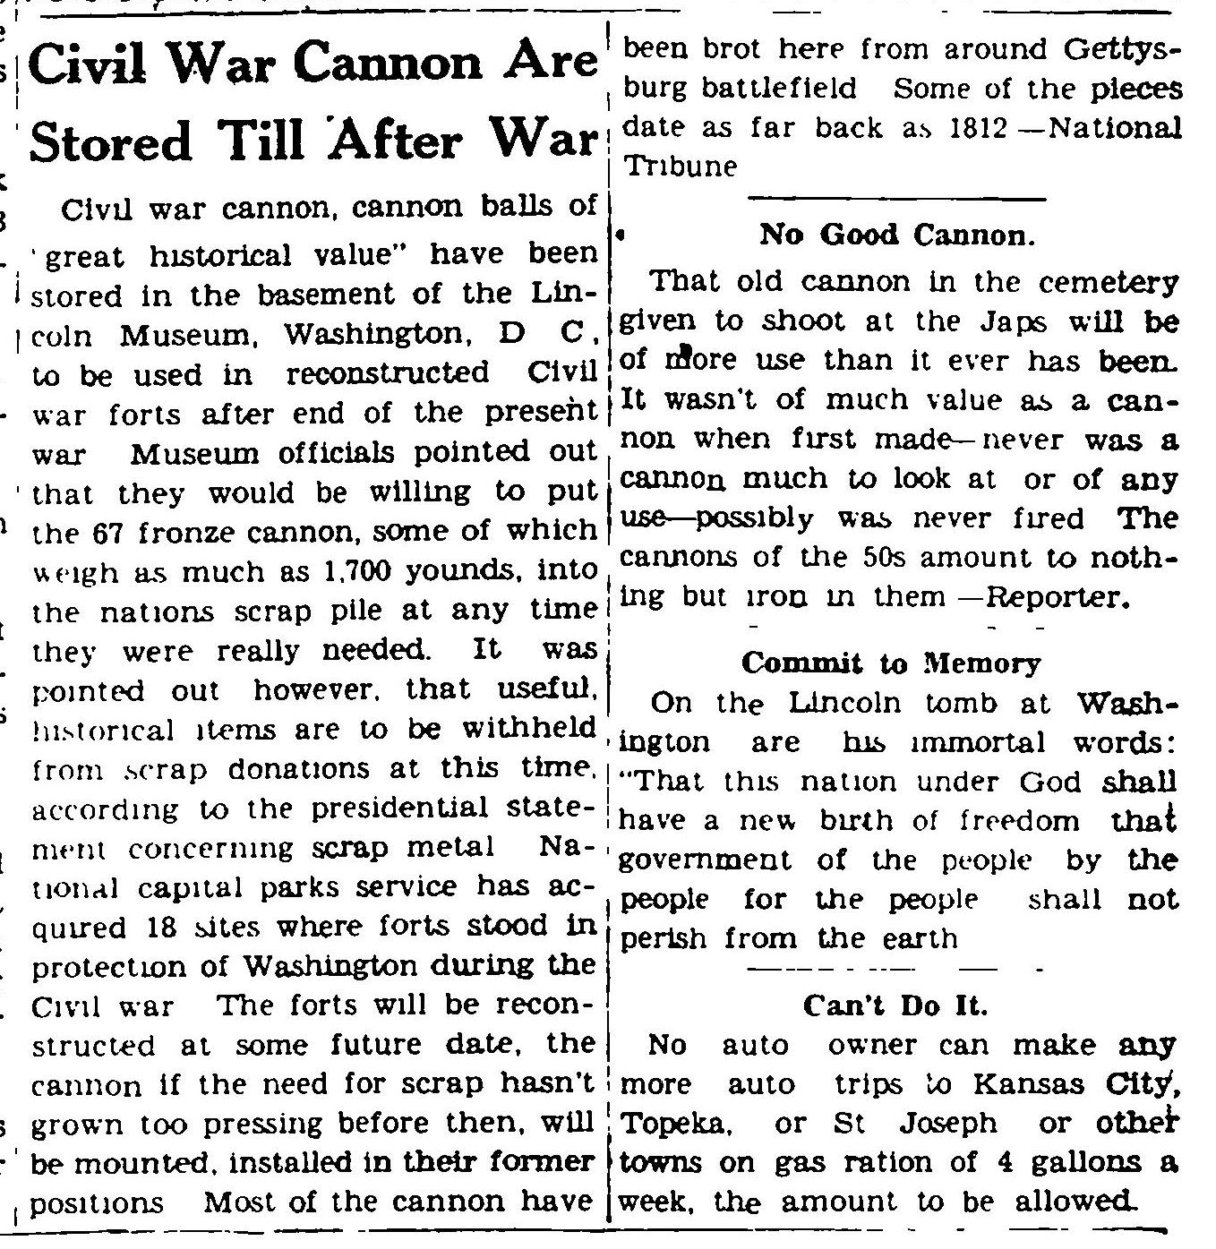

_____________________

**1st Annual Cemetery Tours**

**“Enriching Our Future Through Our Past”**

**Memorial Auditorium AG Museum & Windmill Lane**

**785-742-3330 785-742-3702**

**611 Utah Street 301 East Iowa Street**

**Hiawatha, KS 66434 Hiawatha, KS 66434**

**Website:browncountyhistoricalsociety.com**

**us on Facebook @BrownCountyHistoricalSocietyMemorialAuditorium**

It was a gorgeous fall day on Saturday, October 19, 2019, in which the first-ever Spirits Awaken Historical Cemetery Tours! The Hiawatha Chamber and Visitors Bureau and Brown County Historical Society Board collaborated and worked together to create the Cemetery Tours. Many people helped make this evening memorable! Historical lineup included. Kate Miller, Cemetery Tour Narrator. Nolan Sump, portraying Edmund Needham Morrill & John Davis. Judi Bruning portraying Mrs. Elizabeth Krebs. Allera Roberts portraying Eva Taylor Kintor, Orphan Girl. Our Halloween hooligans, Austin Hasenohr and Makenzie Gonzales. Alexander Allen portraying Homer White, hometown hero. Abigail Allen portraying Alice White, Homer's Mother.

_____________________

**Auditorium & AG Museum**

**Closed Season November 1 – April 30**

**memorial auditorium hours**

Monday –Closed

Tuesday –10 am to 3 pm

Wednesday -- 10 am to 3 pm

Thursday --10 am to 3 pm

Friday -- Closed

Curator at museum Tue-Thur @ 8 am

**AG Museum OPEN BY APPOINTMENT**

**NEW MEMBERS**

Brown County Historical Society would like to give a hearty welcome to new members. Lifetime members Jim Wolney and Lyle Chesnut, these two gentlemen serve the historical society in many ways and we are so grateful!

**MEMORIALS**

Many people continually donate to the museum mission and thanking these generous benefactors is essential to operations. Memorial (monetary gifts) are donated to the Historical Society in memory of a person or in celebration of a wedding anniversary, birthday or honoring someone. These gifts keep giving helping complete projects and help make plans for other projects.

POLLY GALLANT

By: Kathleen Palermo

By: Richard and Marsha Wenger

        GENE HOWARD

By: Gary and Sandy Shear

        EDWARD WRIGHT

By: Antique Tractors Club

MARLENE WATTS

By: Joe and Shirley Gormley

DON MAUSLEIN

By: Marvin and MaryAnn Mueller

KIM McQUEEN

By: Phyllis Jean Henry

ROMA DOVE

By: Kathy Palermo

JIM McQUEEN

By: Jere and Patty Bruning

STANLEY McCAULEY

By: Jere and Patty Bruning

CLAIR KREBS

By: Dorothy Wright

CHARLENE ELLIOTT HOGAN

By: Gene and Nancy Swearingen

By: Kathy and Douglas Moore

ALVERA GLENN

By: Jere and Patty Bruning

MELVIN HjETLAND

By: Joe and Shirley Gormley

MARY EWING

By: In memory of MARY EWING

Marvin & Mary Ann Mueller

Bradford & Sarah Mueller

Beverly J Perry

Michael and Michelle Pyle

Reschesk Family Farm

Alvin and Carol Rieger

Gale J. Saltzgiver

David and Mary Schock

John and Mary Schroff

Gerald P and Ramona J Schuster

Irv and Cleta Schwalm

John and Karen Severin

Carol and James Thiesing

Donna Trost

Paul and Marian Tubach

Stephen and Annette Wilson

Tim and Ann Bashore

Robert and Wilma Graves

Crystal F and Jack Branta

Plus several cash donations

The Mary Ewing family has asked donations sent in Mary’s memory to be used Padonia and Hamlin quilt memorabilia.

**Lynn’s Corner**

I hope that everyone as they enter the holiday season filled with happiness, and surrounded by people you love!

As with each week, I am thrilled to discover more history that I get to be a part of exploring.

The museum has many projects that are underway. Museum projects include the continuation of cleanup, organization of display areas for people in the community to enjoy.

_____________________

**Special Projects**

The Brown County Historical Society is working on several projects. On behalf of the Brown County Historical Society, I would like to thank people who have remembered all of the projects that BCHS is working to ensure is visually present for the community.

_____________________

**A.N. Ruley**

**Andrew Newton “Newt” Ruley**

Andrew Newton “Newt” Ruley, arrived in Kansas in 1870. A.N. was 33. A.N. was born in Lexington, Old Virginia, on February 6, 1837. Andrew is more often remembered by people who have read his material as A.N. Ruley.

A.N. remembered for his remarkable writing skills. One of the many contributions that A.N. will provide is a historical narration in the Annals of Brown County. A.N. is responsible for writing A.N. Ruley’s History of Brown County. This book documented events occurring in the early history of Brown County. A.N. described his work in the book as “47 years of observations.”

A.N. for a time is the owner and editor of the “The Hiawatha Dispatch,” which will later become “The World.” A.N. was a man working for the paper for nearly 47 years. A.N. had always desired that his observations and narrations be published in a book. During A.N.’s life, there were no funds to complete the publication of the book. As a tribute to A.N., his historical narrations of Brown County will be published after his death.

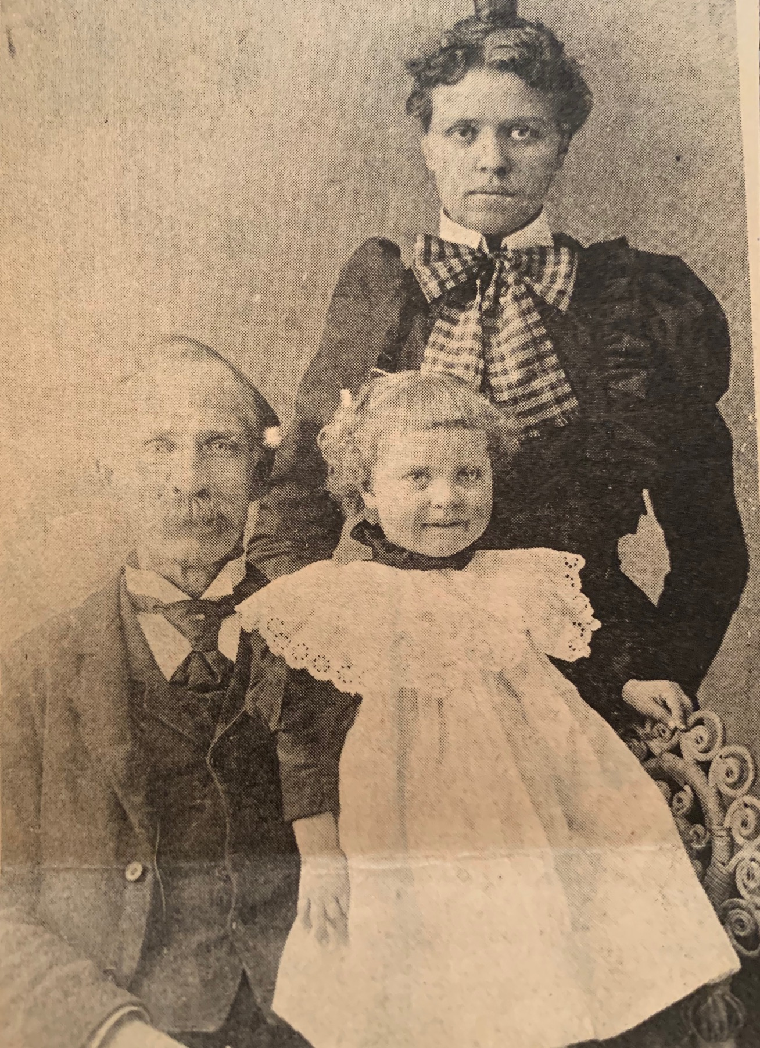

**1956, Hiawatha Courthouse Santa**

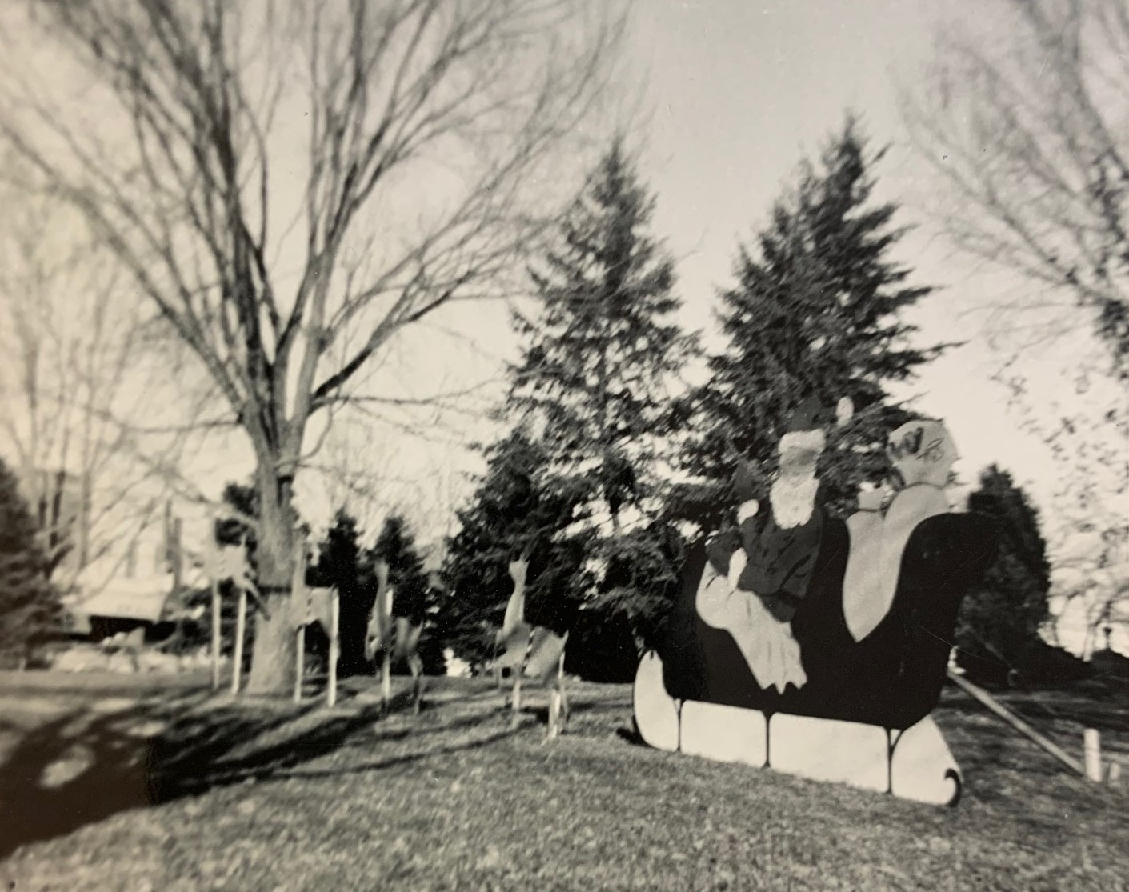

**1957, Hiawatha Courthouse Santa**

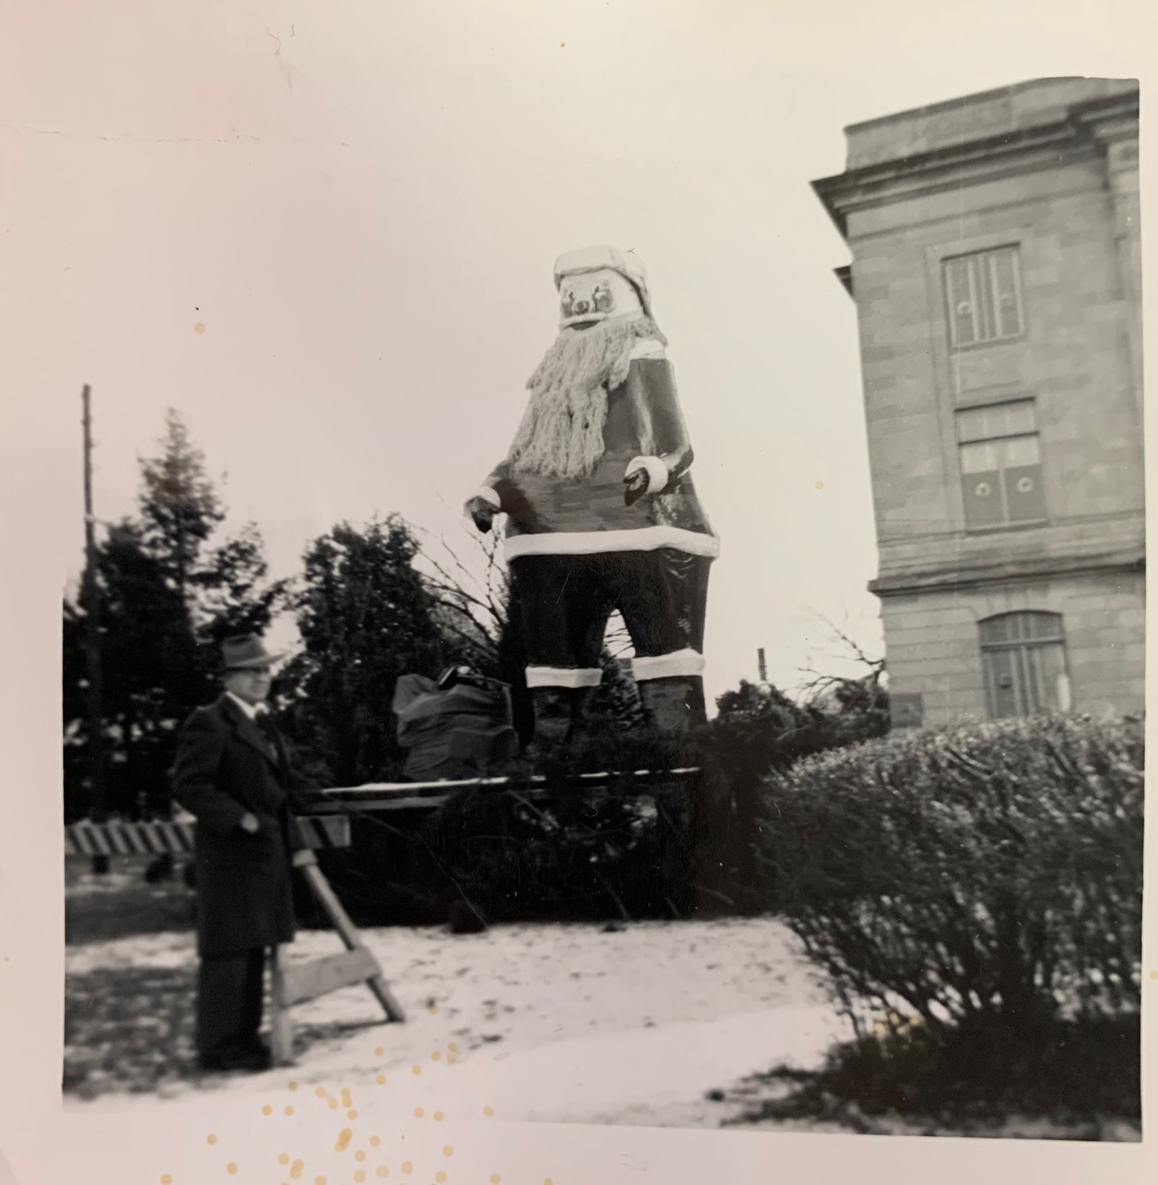

|  |
| --- |
|  |
| Brown County Historical Society **Non-Profit Org.**  611 Utah Street U.S. Postage Paid  Hiawatha, KS 66434 Hiawatha, KS 66434  **DIRECTORS**  Gary Shear –President  Larry Day – Vice President  Wesley Duesing – Secretary  Delores Waite -- Treasurer  Eugene Swearingen  Jim Gibbs Larry Adcock  Jere Bruning  Gil Bunning  Donna Thonen  Dennis Greer  Permit #27 |
| **become a member! MEMBERSHIP INDIVIDUAL $15.00, FAMILY $30.00, bUSINESS $30.00, lIFE MEMBERSHIP $200 PER PERSON** |

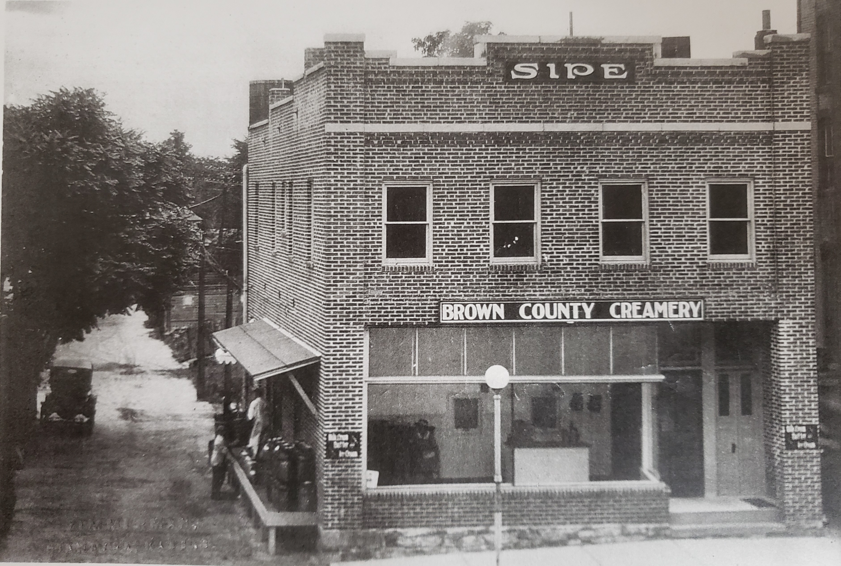

history treasure, brown county creamery, hiawatha kansas