Brown County Historical Society Newsletter
Brown County Historical Society | 12/25/2020 | Issue #4 for 2020

In rememBrance of Dennis "Denny" Greer

Dennis served diligently as a board member and never flinched when facing challenges, obstacles, or decisions.
Brown County Historical Society would be remiss if we did not remember Dennis' contributions. There are many things Brown County Historical Society would not have been able to accomplish without Dennis' wisdom and direction.
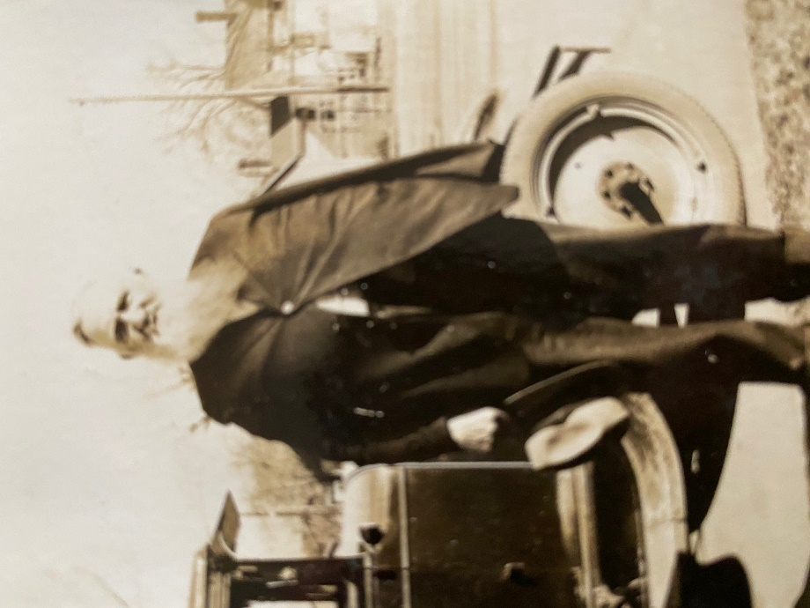
John Davis Photograph Intellectual Property of BCHS Collection donated by Rapaport Family Collection, Circa 1933
____________________

JOHN M. DAVIS
Recently William Rapaport reached out while uncovering treasures from the family photo album. The newsletter
is filled with many of these treasures.
____________________

Editor's Note
Please note newspaper sections are written verbatim and appear exactly as it appeared in print.
_____________________

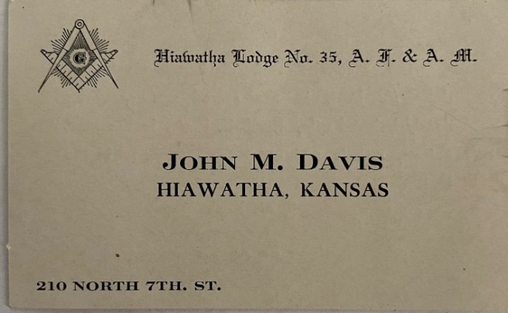
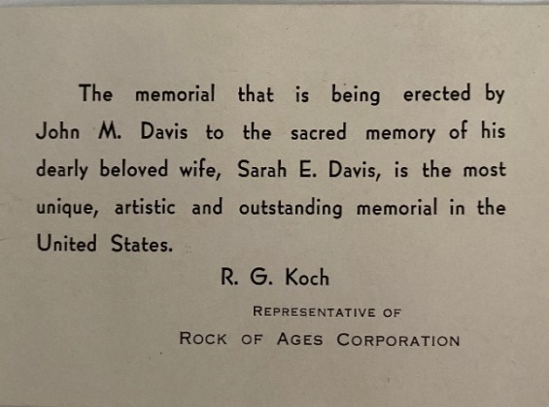
John Davis Calling Card Intellectual Property of BCHS Collection donated by Rapaport Family Collection
__________________

Newsletter and Correspondence
To reduce printing costs, please advise if you are willing to receive the newsletter in digital format. Each newsletter edition is posted to the BCHS website for easy access.

Please email us @ bchsdirect@gmail.com
BCHS website:
www.browncountyhistoricalsociety.com
Like us on Facebook @BrownCountyHistoricalSocietyMemorialAuditorium
_____________________
BIG KANSAS ROAD TRIP
May 6-9, 2021
This upcoming event is an exciting opportunity for Brown County to showcase many of the county's historical treasures. The Brown County Historical Society will have special hours this week to accommodate the visitors.
____________________
Auditorium & A.G. Museum
CLOSED Season November 1 – May 1
Please remember to social distancing and avoiding contact/spread with germs. Stay Safe!

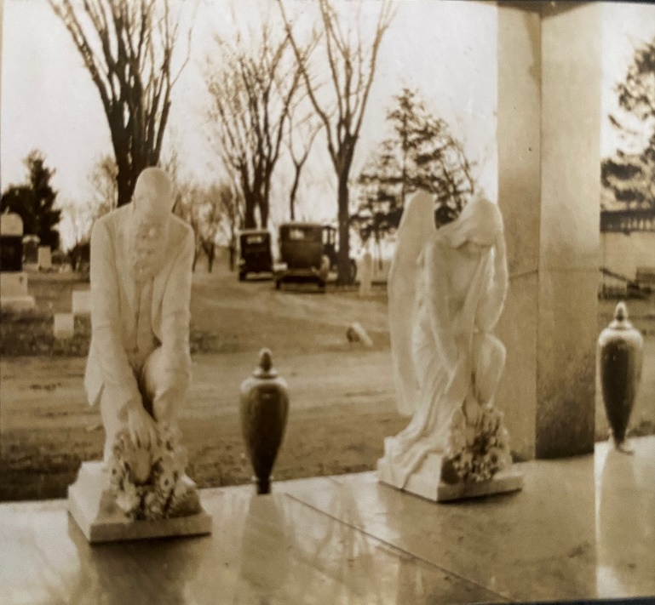
John Davis Photograph Intellectual Property of BCHS Collection donated by Rapaport Family Collection, circa 1933

memorial auditorium hours

Memorial Auditorium & A.G. Museum is temporarily closed due to COVID.
Stay Safe!

Monday –Closed
Tuesday –closed temporarily
Wednesday – closed temporarily
Thursday -- closed temporarily
Friday -- closed temporarily
Curator at museum @ 8 am

MEMORIALS

Many people continually donate to the museum mission, and thanking these generous benefactors is essential to operations. Memorial (monetary gifts) contributed to the Historical Society in memory of a person or celebration of a wedding anniversary, birthday, or honoring someone. These gifts keep giving, helping complete projects, and help make plans for other projects.

Lawrence & Donna Thonen made a generous donation, and we owe many thanks for everyone’s support of the museums.

Lynn's Corner
Sending happy holiday wishes to everyone that 2021 be a brighter, more beautiful place. I am hoping that everyone is staying safe. I am looking forward to the days when the world can resume normal activities. Until then, explore your history mysteries and reach out and share what you discover!

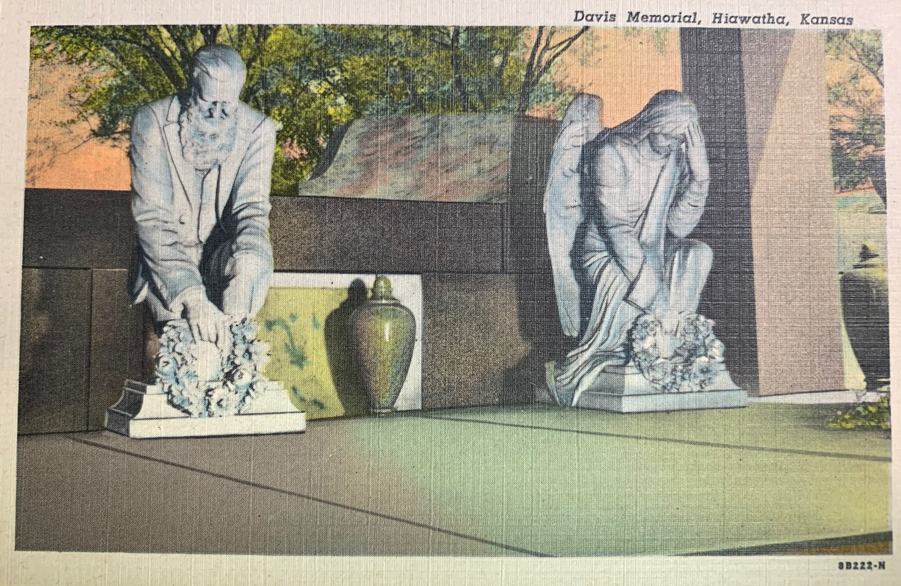

HISTORY MYSTERY

Some time ago, one of the Davis Memorial statue heads was removed and carried off? Perhaps if we share the Davis Memorial's importance to the community and how many people appreciate and treasure this historical gem, the kidnapper might return the head to its proper location.

NEW MEMBERS

Brown County Historical Society would like to welcome new members John Merchant Jr., and Tish Sims both have agreed to serve on the board of directors.

World News Way Back When

1920 is the only decade in history that earns a nickname. The nickname "the roaring twenties" The "League of Nations is established and meets. The first executive meeting occurs on January 16, 1920, in Versailles. The French enthusiastically receives Woodrow Wilson. No American achieved such acceptance since Benjamin Franklin. America never joins the League. In 1920, America had a de-facto female President. While President Wilson was campaigning for the League of Nations, Woodrow suffers a blood clot that caused partial paralysis, partial blindness, and brain damage. Edith Wilson, the first lady, supported her husband during his illness and steps in taking over all official presidential roles and serves the remainder of his term. In 1920, women gained the right to vote. In 1920, the constitution structurally amended TWICE. In 1920, Mass media launched by broadcasting the live results of the presidential election. In 1920, the worst terrorist attack occurred on Wall Street on September 16, 1920. There are many other exciting history gems to be discovered every year. Find them! Be sure to share what you discover!

"Pandemic, Stepping Across Time"

COVID-19 has many shaking our heads over the actions and subsequent actions triggered by COVID19/coronavirus. I will not attempt to establish a motive or reasoning behind any action but perhaps give some history into the number of pandemics that have affected the world. On many occasions throughout history, individuals implored to prevent the further spread of the disease. The following is a timeline of just a few pandemic events in history and perhaps glean perspective during the current pandemic.
430 BC- Athens Plague This is the earliest recorded pandemic. Two-thirds of the population dies and is suspected to be typhoid fever.
Brown County Historical Society
2021 Annual Membership Renewal
611 Utah – Hiawatha, KS 66434
bchsdirect@gmail.com

Telephone #: _________________________

Email:__________________________________________

Membership Level:________________________________

Additional Donation:______________________________

Dedicated for the use of:___________________________

Date Received____________________________________

Please make checks payable to: Brown County Historical Society (BCHS) Mail to: 611 Utah Street, Hiawatha, KS 66434.

The Brown County Historical Society is a “not-for-profit” 501(c)3.

□ please send newsletter by email.

165 AD- Antonine Plague 5 million people killed worldwide. The cause of the plague is still unknown spread through travel/exposure.
250 AD- Cyprian Plague named after the Christian bishop, first afflicted. People in the city traveled to the country to avoid the infection and subsequently spread the plague rapidly.
541 AD – Justinian Plague This plague has two waves over the next century and killed 25 percent of the global population. This plague lays dormant in rats until conditions are right and spread by fleas; it is the Bubonic Plague's first documentation.
1350 CE Black Death (Bubonic Plague) kills one-third of the world population.
1492 CE Columbian Exchange a trifecta of disease spread by travelers carrying smallpox, measles, and the bubonic plague to native people who had not developed immunities as exposure to such conditions had not occurred previously.
1520 CE Smallpox wipes out the Aztec people by exposure from Spanish travelers.
1665 CE Great Plague of London (Bubonic Plague) wipes out twenty percent of London's population. In the fall of 1666, the bubonic plaque gradually tapers off.
1817 CE Cholera The Cholera outbreak has seven waves. Cholera spread through soldiers traveling. One million die globally—the vaccine developed for use in 1855.
1852-1860 Third, Cholera is considered the deadliest. The cholera wave kills one million worldwide. It starts in India spreads quickly to Asia, Europe, North America, and Africa.
1855 CE Third Plague (Bubonic Plague) spreads through China, India, Hong Kong and claims the lives of 15 million. This plague was considered active until 1960, when the cases dropped below a few hundred.
1875 CE Fiji Measles Royal party after Fiji's acquisition transport Measles back to the island where the natives had no immunity to such a disease. One-third of the Fiji Island population die, approximately 40,000 people.
1889 H2N2/Influenza A/Avian "Russian Flu" this virus has a subtype H3N8 quickly spread in Asia, Canada, and Greenland while people immigrated to such locations kills 1 million globally.
1910-1911 6th Cholera Wave kills 800,000 worldwide.
1918-1920 "Spanish Flu," a vaccine was not available until 1940. This Flu is an H1N1, Avian Flu. Spanish Flu kills between 20 and 50 million people worldwide.
1957-58 H2N2/Avian Flu pandemic killed 1 million people worldwide, approximately 116,000 from the United States. Likely spread by travelers and not adhering to safe practices.
1968-69 H3N2/Influenza A/Avian Influenced called the "Hong Kong Flu" originated and is considered a forgotten pandemic.This Flu killed 1 million people globally, 100,000 Americans. Likely spread by travelers and not adhering to safe practices.
1970 H1N1/Swine flu immunization developed within ten months. Consequences from that vaccination resulted in associated diseases such as Guillain-Barre Syndrome. As a result, the vaccine protocol halted.
1976-2012 HIV/AIDS Pandemic surfaced in Congo Africa. HIV/AIDS has killed 36 million people worldwide since origination.
2009-10 H1N1/Swine Flu kills 12,000 Americans. Likely spread by travelers and not adhering to safe practices.
December 2019 to the present day/COVID-19, this disease is known as SARS-CoV-2, is a family of viruses known as coronaviruses. Rarely can a virus jump from human to animal species, but this virus has adapted as has the capability. Other viruses that behave like COVID19 include SARS (severe acute respiratory syndrome) and MERS (Middle Eastern Respiratory Syndrome.) COVID 19 has killed 1.6 million people worldwide and nearly 290,000 Americans to date.
There is a quote that I find particularly meaningful while documenting these pieces of history. 'Those who do not learn history are doomed to repeat it. 'The quote by writer and philosopher George Santayana, its original form read, "Those who cannot remember the past are condemned to repeat it."

John M. Davis, A Handwritten Letter

In sharing that William Rapaport of New Jersey recently uncovered Hiawatha treasures in his family treasure chest. The gem is a beautiful, handwritten letter by John Davis himself. The letter is dated April 22, 1934. In the letter, John apologizes for writing in pencil after falling and injuring his arm. Despite the previously described injury, the beautifully penned letter, which is eighty-six-year-old. The letter in pristine condition. In closing the letter, John mentions that "Mr. England and tourists advise that I should not add any more to the memorial as it would be overdue and spoil the beauty of it as it is. They pronounce it complete as it is" "I meet people at the cemetery not only by the hundreds but by the thousands and cannot remember them all."

TRIBUTE TO THE PIONEERS
“There is a tribute to the pioneers by Mrs. L. E. Harding of Hamlin. She is the daughter of C. E. Parker, once a resident of Hamlin vicinity. He served several terms as a representative from the 12th district, Brown County, in the legislature. He was himself a pioneer, and no doubt, Mrs. Harding received her inspiration to write the tribute from what she had seen and suffered as the daughter of a pioneer:”

“God bless the dear old settlers;
They came to Kansas, young;
And homesteaded these prairies.
And a noble work begun
They brought true courage with them;
Great hardships they endured;
But they trusted God and labored
Until victory is assured.
They built well our statehood,
They laid foundations deep;
And today we sing their praises,
For the benefits we reap.
From their forethought and wise planning,
Which has made our future great;
And we love them for their labors,
In this dear old sunflower state.
But the ranks are growing thinner;
Year by year, they're passing on;
And the ones who meet together,
Feel sadness for those gone.
They are resting from their labors,
In the place of their retreat;
And perhaps they think of Kansas;
And their memories are sweet.
Of those early days and struggles;
Of those friendships strong and grand,
Born of mutual endeavor
To subdue this prairie land
Now with hearts of true affection
We salute this honored throng
Three cheers for the early settlers;
Those brave old pioneers;
When we think of all they suffered
Again for them, three cheers”
THE FIRST MAIL ROUTE
(A.N. Ruley's History of Brown County)

"In 1857, the founding fathers established Hiawatha, Kansas, located in Brown County. The settlers needed some mail facilities, for as it was, all eastern mail was now coming to Iowa Point, a distance of 18 to 20 miles. The mail route between St. Joseph to Marysville was already established. Service for the Walnut Creek area was not readily available until 1858. Settlers determined to lessen vexations of mail troubles. They made a contract with Philip Weiss, uncle of Louis Kessler of Hiawatha, to make a weekly trip to Iowa Point and bring out the mail. A list of names furnished, and an order made on the postmaster to deliver the mail accordingly. Being the first mail route in the county, but a purely private enterprise. For his services as such mail carrier, Mr. Weiss received from the settlers $2 a trip. He added a passenger, freight and express line to this service, doing all with one pair of horses and a lumber wagon.

Now the "Maine Colony," and the other scattering pioneers on Mulberry creek were comparatively happy, as least as far as mail facilities were concerned. Now a letter from the folks in their Far East home, coming by Missouri river steamboat from St. Louis to Iowa Point, would be brought out by the R. F. D. carrier, Philip Weiss, who made prompt trips.

Up to this time, a few settlers owned horses, nearly all the farm work on the patches improved being done with oxen. One settler tilling the few acres with one ox or one old horse, while a more fortunate neighbor was booming along, working either a yoke or occasionally a team of cheap horses. The Kansas pioneers were strong, determined men who scorned to entertain discouragement and did not hesitate to tread upon unbeaten paths boldly. They were wide awake, far-seeing, and resolute. Amid all their trials, suffering, and misfortunes, they laid for future generations the broad, solid, wholesome, and permanent foundation.
The Central Protection Association (C.P.A.) was organized on the pioneers' precedent, who, on Walnut Creek in 1855, organized a protective association to suppress theft. The people's persistent efforts all along the county's course of progress to enforce temperance had a precedent set in 1855.

The religious exercises and church erections have been pushed so rapidly in the county. As early as 1855, Rev. Mr. Alspaugh, of the Methodist church, held spiritual practices in a log cabin upon the old John Krey place, southeast of Hiawatha.

In the march of school interest and industry, the county's people had a precedent when they had a school taught in the log schoolhouse above mentioned, as early as 1856. The progress set a precedent for pioneers, who, under all their difficulties, had to scratch to earn a living. With many others, all these accomplishments sprung to no small extent from the pioneers' wisely wrought foundation. Each subsequent generation owes a debt to these brave men and women. Every name kept, and their memory kept green by pen and tongue, speech and song in prose and poetry throughout the coming ages: for, behold the glorious structure of today, built upon the broad and solid foundation laid by them."

Brown County Historical Society Non-Profit Org.
611 Utah Street U.S. Postage Paid
Hiawatha, KS 66434 Hiawatha, KS 66434
Permit #27
DIRECTORS
Gary Shear –President
Larry Day – Vice President
Wesley Duesing – Secretary
Delores Waite -- Treasurer
Eugene Swearingen
Jim Gibbs
Larry Adcock
Jere Bruning
Gil Bunning
Mark Schmitz
John Merchant Jr.
Tish Sims

become a member! MEMBERSHIP INDIVIDUAL $15.00, FAMILY $30.00, bUSINESS $30.00, lIFE MEMBERSHIP $200 PER individual

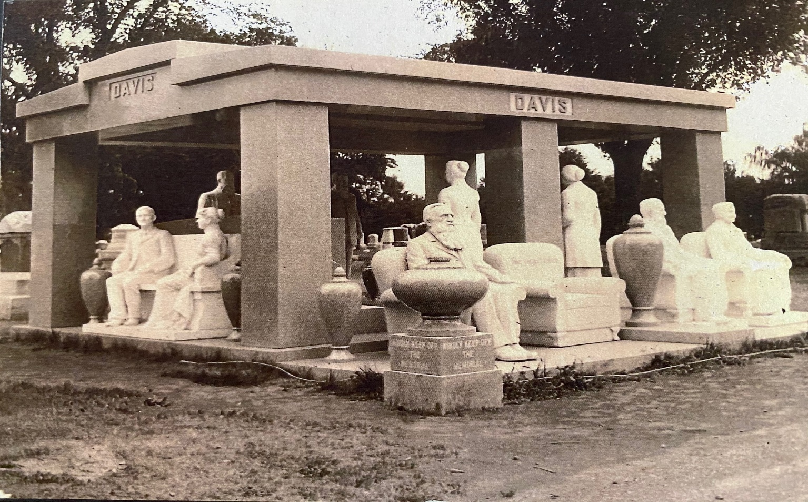
DAVIS Memorial, Hiawatha, KAnsas, Circa 1933

