  - August 14, 2021
NOON

Garden Tractor pull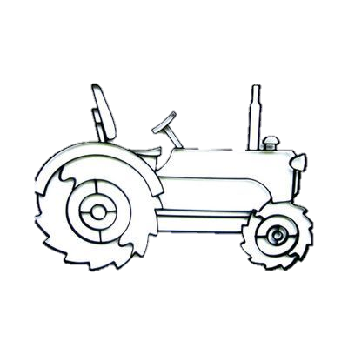

Hosted by:
Lead Sled Pullers
This is a no trophy event! Bring a lawnchair and cool drink!
Brown County Historical Society  301 E. Iowa St. Hiawatha, Kansas | Registration begins  10AM  5.00 Hook Fee  Contact info 785.741.1286  Facebook: Lead Sled Pullers | Pulling Classes  600 700 800  900 1000 1100  1200  1000 UNLIMITED  1100 UNLIMITED  1200 UNLIMITED

