Brown County Historical Society Newsletter
Brown County Historical Society | 1/29/2021 | Issue #1 for 2021

Special Edition Corn Picking Day at the Farm

Brown County Historical Society mailed off the December newsletter last month. The newsletter did not provide information about the 2020 Corn Picking Fun at the Farm by accidental omission. Nathan and the Wright Family partnered with Brown County Historical Society Board members, completing the second annual Corn Picking Day. The corn planting and picking event occurred on the farm ground at the Brown County Historical Society Ag Museum and Windmill Lane. The county provides the land in the form of a lease, which extends traditional farming methods educational experiences to interested individuals. The Wright's also sponsored a larger corn picking event at the Wright Family Farm, which was successful.

When outlining educational farming, the Wrights provided assurances to commissioners to honor traditional farming methods in the planting and harvesting. The corn picking event is a family-friendly inspired event. The second annual successful corn picking day was completed with gathering restrictions and social distancing in place. If you are interested in traditional farming methods, please keep an eye out for next year's planting and picking season.

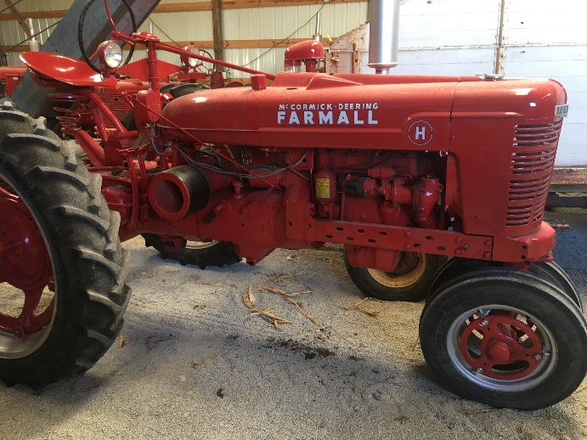
H Farmall Tractor Photograph Intellectual Property of BCHS Collection

Editor's Note
Please note newspaper sections are written verbatim and appear exactly as it appeared in print.
_____________________

Newsletter and Correspondence
To reduce printing costs, please advise if you are willing to receive the newsletter in digital format. Each newsletter edition is posted to the BCHS website for easy access. Please email us @ bchsdirect@gmail.com
BCHS website:
www.browncountyhistoricalsociety.com
Like us on Facebook @BrownCountyHistoricalSocietyMemorialAuditorium
_____________________

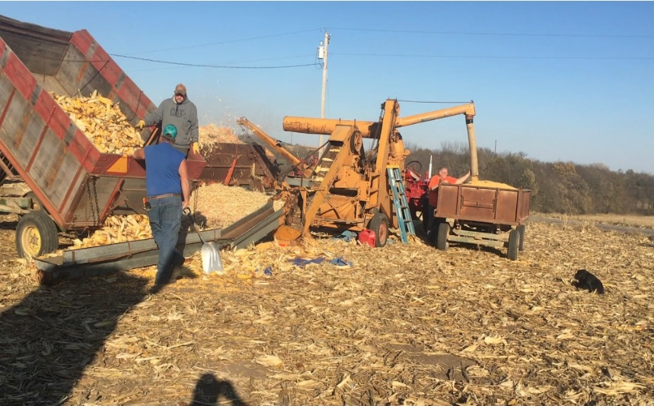
Fun at the FArm, corn picking day, Photograph Intellectual Property of DAY Family Collection

BIG KANSAS ROAD TRIP
May 6-9, 2021
This upcoming event is an exciting opportunity for Brown County to showcase many of the county's historical treasures. The Brown County Historical Society will have special hours this week to accommodate the visitors.
____________________

Auditorium & A.G. Museum
CLOSED Season November 1 – May 1
Please remember to social distancing and avoiding contact/spread with germs. Stay Safe!

memorial auditorium hours

Memorial Auditorium & A.G. Museum is temporarily closed due to COVID.
Stay Safe!

Monday –Closed
Tuesday –closed to visitors
Wednesday – closed to visitors
Thursday -- closed to visitors
Friday -- closed to visitors
Curator at museum @ 8 am

become a member! MEMBERSHIP INDIVIDUAL $15.00, FAMILY $30.00, bUSINESS $30.00, lIFE MEMBERSHIP $200 PER individual

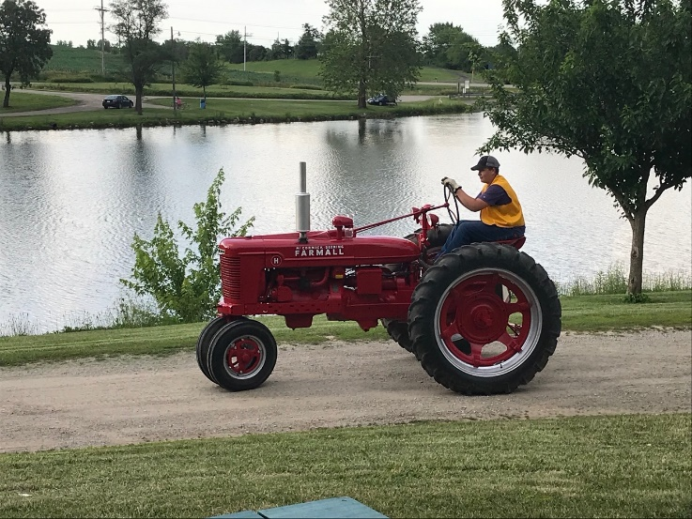
Nathan Wright & H Farmall Tractor Photograph Intellectual Property of Wright Family Collection

MEMORIALS

Many people continually donate to the museum mission, and Brown County Historical Society is grateful to these generous benefactors is essential to operations. Memorial (monetary gifts) contributed to the Historical Society in memory of a person or celebration of a wedding anniversary, birthday, or honoring someone. These gifts keep giving, helping complete projects, and help make plans for other projects.
Brown County Historical Society
2021 Annual Membership Renewal
611 Utah – Hiawatha, KS 66434
bchsdirect@gmail.com

Telephone #: _________________________

Email:__________________________________________

Membership Level:________________________________ Individual $15.00, Family $30.00, Business $30.00,
Life Membership $200.00

Additional Donation:______________________________

Dedicated for the use of:___________________________

Date Received____________________________________

Please make checks payable to: Brown County Historical Society (BCHS) Mail to: 611 Utah Street, Hiawatha, KS 66434.

The Brown County Historical Society is a “not-for-profit” 501(c)3.

□ please send newsletter by email.

MEMBERSHIP INDIVIDUAL $15.00, FAMILY $30.00, bUSINESS $30.00, lIFE MEMBERSHIP $200 PER individual

MEMBERSHIP INDIVIDUAL $15.00, FAMILY $30.00, bUSINESS $30.00, lIFE MEMBERSHIP $200 PER individual

Brown County Historical Society Non-Profit Org.
611 Utah Street U.S. Postage Paid
Hiawatha, KS 66434 Hiawatha, KS 66434
Permit #27
DIRECTORS
Gary Shear –President
Larry Day – Vice President
Wesley Duesing – Secretary
Delores Waite -- Treasurer
Eugene Swearingen
Jim Gibbs
Larry Adcock
Jere Bruning
Gil Bunning
Mark Schmitz
John Merchant Jr.
Tish Sims

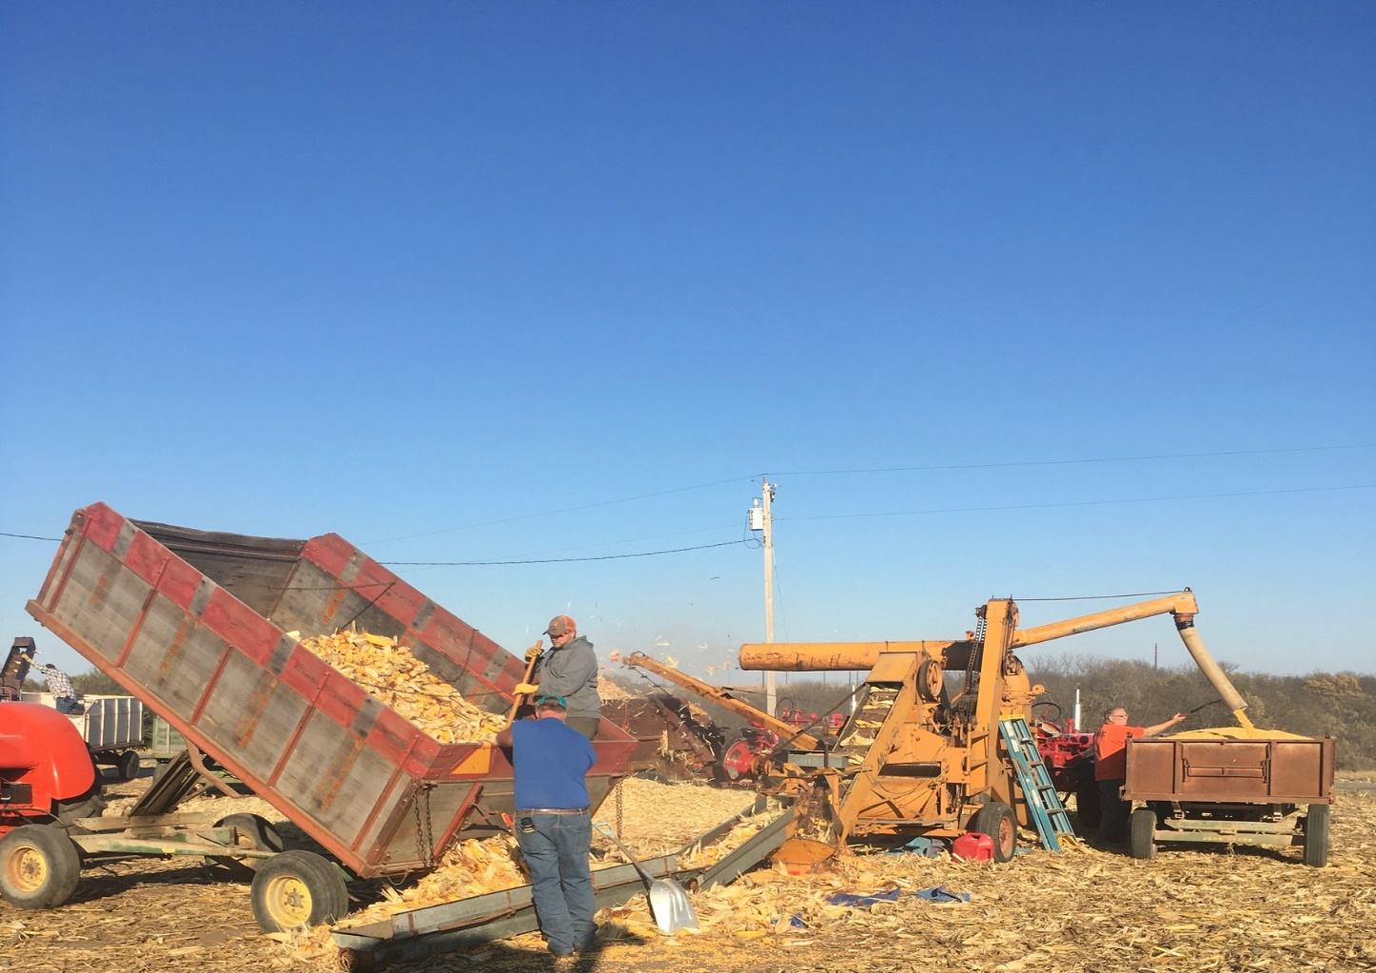
fun AT the farm, corn picking Day, hiawatha, Kansas

