Brown County Historical Society Newsletter
Brown County Historical Society | 6/26/2020 | Issue #2 for 2020

Delay in NEWSLETTER; please accept our apologies due to covid19.

Brown County Historical Society would like to inform you that due to COVID19, Brown County Historical Society will be canceling the following events for 2020, Annual Meeting, Ice Cream Social and Farmers and Merchant Appreciation Dinner. Brown County is hopeful that the Big Kansas Road Trip and Heritage Days will be able to go on as scheduled.

Brigadier General Charles Henry Browne, Sr. Editor Horton Headlight

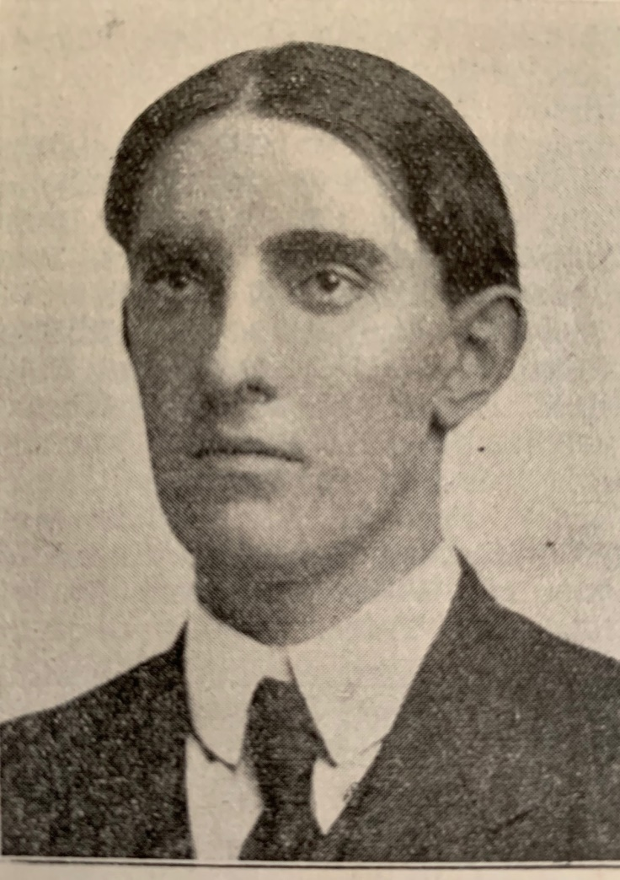
Browne in Youth Photograph, Intellectual Property of Horton Headlight Collection

_____________________
Editor’s Note
Please note newspaper sections are written verbatim and appear exactly as it appeared in print.
_____________________

Newsletter and Correspondence
Brown County Historical Society has entered the digital world. To reduce printing costs, please advise if you are willing to receive the newsletter in digital format. Each edition of the newsletter uploaded to the website for easy access and viewing enjoyment.
Email is bchsdirect@gmail.com
Check us out on Social Media!
Brown County Historical Society's website:
www.browncountyhistoricalsociety.com
Please like us on Facebook
@BrownCountyHistoricalSocietyMemorialAuditorium

_____________________

BIG KANSAS ROAD TRIP
September 10- 13, 2020
This upcoming event is an exciting opportunity for Brown County to showcase many of the historical treasures within the county. The Brown County Historical Society will have special hours this week to accommodate the visitors.
____________________

Auditorium & A.G. Museum
OPEN Season May 1 – October 30
Please remember as you begin to venture out that practicing social distancing and avoiding contact/spread with germs is essential.

memorial auditorium hours

Monday –Closed
Tuesday –10 am to 3 pm
Wednesday -- 10 am to 3 pm
Thursday --10 am to 3 pm
Friday -- 10 am to 3 pm
Curator at museum
Tuesday-Friday @ 8 am

A.G. Museum OPEN BY APPOINTMENT
Visits to the museum are available to friends and visitors wanting to visit. Contact by phone or email to set up your appointment in advance.
become a member! MEMBERSHIP INDIVIDUAL $15.00, FAMILY $30.00, bUSINESS $30.00, lIFE MEMBERSHIP $200 PER PERSON

MEMORIALS
Many people continually donate to the museum mission, and thanking these generous benefactors is essential to operations. Memorial (monetary gifts) donated to the Historical Society in memory of a person or as a celebration of a wedding anniversary, birthday, or honoring someone. These gifts keep giving, helping complete projects, and help make plans for other projects.
history mystery hiawatha, KS

Lynn's Corner
Well, 2020 has undoubtedly shown each of us who is in charge! I am hoping for a much more peaceful later six months to the year. I hope you will be stopping by soon to see many of the projects that are underway.

World News Way Back When

June 13, 1920, U.S. Post Offices declare
Parcel Post cannot be utilized to send children. One such postal child was May Pierstorff, 6-year-old, sent to her grandparent's house located 73 miles away in February 1914 by her parents. The postal worker who took her by Railway Mail train was a relative. The family paid 53 cents for their daughter's coat.

After Postmaster General Albert S. Burleson heard people were mailing children, he officially banned postal workers from accepting humans as mail.

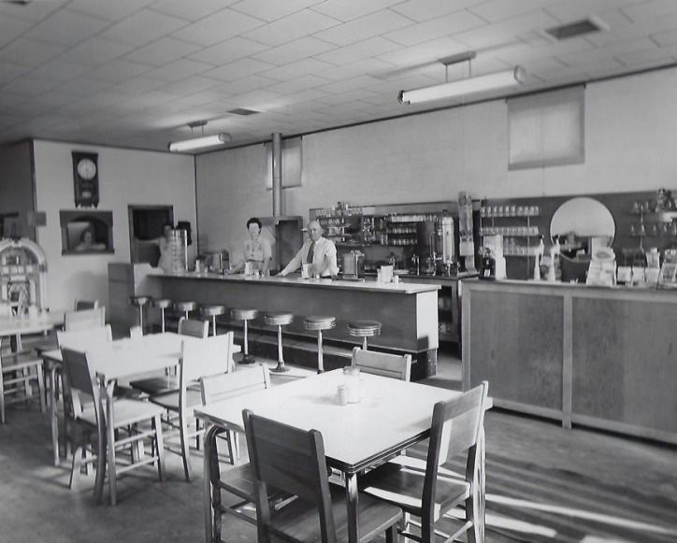
DIRECTORS
Gary Shear –President
Larry Day – Vice President
Wesley Duesing – Secretary
Delores Waite -- Treasurer
Eugene Swearingen
Jim Gibbs
Larry Adcock
Jere Bruning
Gil Bunning
Mark Schmitz

Jules A. Bourquin, Horton's Photographer and Optician

Photographer Jules Alfred Bourquin was born in St. Emir, Switzerland, on November 25, 1877. He immigrated with his family to Horton, Kansas, in 1888. Jules spent the rest of his life in Horton. Bourquin's photography skills spanned from 1898 to 1959. Bourquin's images, for the most part, are taken in and around Horton.
Jules Bourquin died on September 30, 1964, at the age of 86. According to his obituary," Horton lost one of its most loved and respected citizens." Jules was active in city affairs, and the people of Horton much loved his photographs.

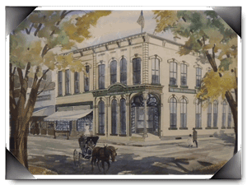
Morrill & Janes Bank, Hiawatha, KS

June 28, 1820, Colonel Robert Gibbon proves that tomatoes are not poisonous by eating one on the steps of the courthouse in Salem, New Jersey.

