Brown County Historical Society Newsletter

Newletter Editor/ Executive Director/Curator/ Lynn Marie Allen
Brown County Historical Society | 3/17/2023 | Issue # for 2023

A NOTE FROM THE president Gary shear

Brown County Historical Society President Gary SHEAR has coordinated with Charlie Messner to host Brown County Historical Societys first annual flea market at ag museum, located at 301 East iowa street, hiawatha, ks. The flea market will be June 9 & June 10, 2023, 8 am to 5 pm Friday & 8 am to 4 pm Saturday! SPots (20X20) at the flea market are $50 each. call Charlie Messner to reserve your slot today! 402-245-5367.
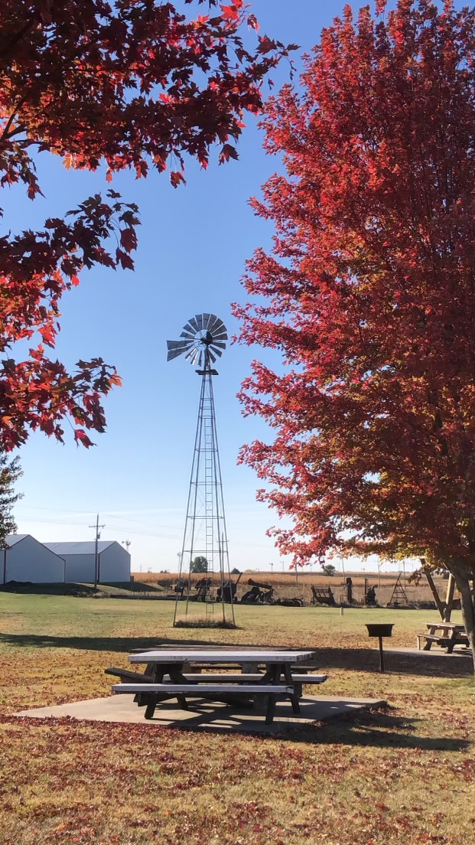
Brown County Historical Society AG Museum and Windmill Lane, Photo courtesy of Kate Miller

CLOSED SEASON
November 1- May 1, 2023
memorial auditorium hours
Monday –Closed
Tuesday –10 am to 3 pm
Wednesday – 10 am to 3 pm
Thursday – 10 am to 3 pm
Friday – 10 am to 3 pm

Curator at museum daily @ 8 am
A.G. Museum & Windmill Lane are
Open by appointment!

A NOTE FROM THE EXECUTIVE DIRECTOR, LYNN MARIE ALLEN

The open season is approaching. While the museum has always had an OPEN and CLOSED season since I began working for Brown County Historical Society there is literally nothing different between open and closed season. As I sit here on a Friday at 3 pm and visitors are touring the museum in their first trip back in over sixty years!

There have been a number of projects that the historical society has been very hard at work completing. The windmill museum is on the grounds of the AG Museum. We are working hard to finish the Jere and Patty Bruning Memorial Barn so that this gorgeous venue space can begin to be appreciated by all. If you have an upcoming date for the space reach out now so we can get you on the calendar! More details such as pricing and deposits will come as the board votes.

The world building will soon have new owners but I think you are really going to love the work they have planned! Stay tuned as we share the progress with each of you!

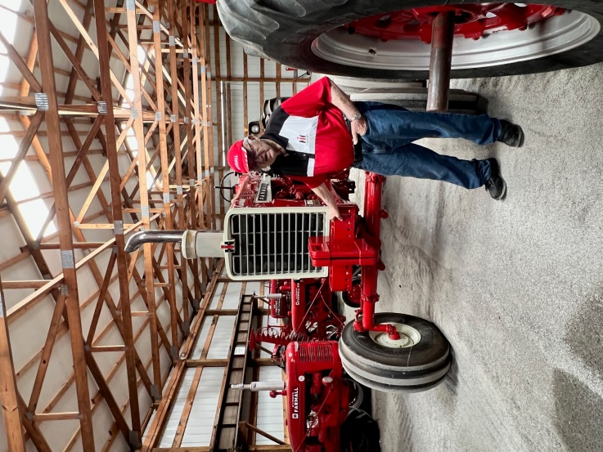
Pictured Jere Bruning with IH tractor collection

“Hiawatha World Tidbit??”
John L. Goldwater is the now infamous creator of “Archie Comics.” John Goldwater created “Riverside” based upon his adventures in Hiawatha, Kansas. Goldwater told sources he grew up in foster care after being orphaned. Goldwater boasted he was only 17 when he left New York to hitchhike across the U.S., stopping first at Hiawatha. Upon arrival, Goldwater was quickly hired as a reporter for what was the Hiawatha Daily World. You might have already guessed from the hints along the way John soon leaves his job at the World after he gets into a scrap with the Newspaper Editor’s son over a girl. The editor at the time was Ewing Herbert, Sr.
In Memory, Gene Swearingen & Jere Bruning”
We lost two of our most devoted directors of the board this year with the passing of Gene and Jere. The memories and time we had with these gentlemen will not be soon forgotten.
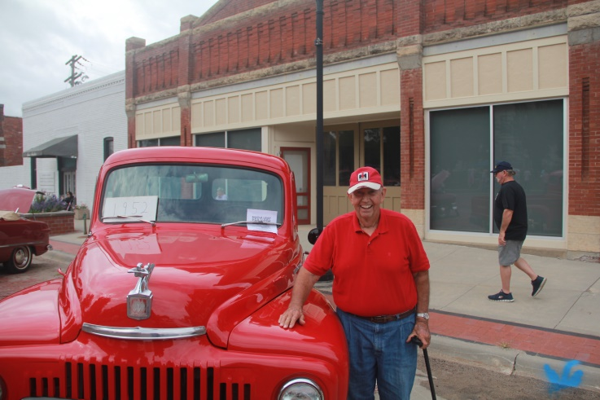
Pictured Gene with his International Truck
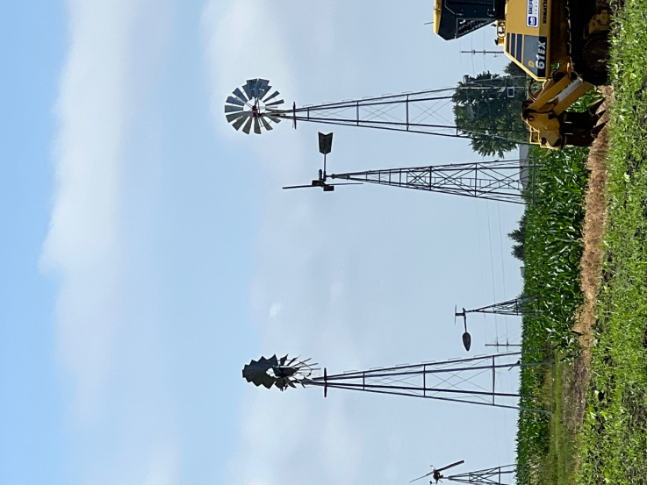
Many thanks to each of the dedicated board members who willingly dedicate their time and services to Brown County Historical Society. The current directors are as follows.
Board of Directors
Gary Shear - President
Larry Day - Vice President
Tim Wenger - Treasurer
Joey May - Secretary
Larry Adcock - Director
Gil Bunning - Director
Mark Schmitz - Director
John Merchant Jr. -Director
Tish Sims - Director
Ryan Shockley -Director
Chris Williams -Director
Quentin Overdick
Marshall Swearingen
Brad Stolzenberger

