Brown County Historical Society Newsletter

|  |  |  |
| --- | --- | --- |
| Brown County Historical Society | **6/26/2020** | Issue #1 for 2020 |

# **Delay in NEWSLETTER; please accept our apologies due to covid19.**

Brown County Historical Society would like to inform you that due to COVID19, Brown County Historical Society will be canceling the following events for 2020, Annual Meeting, Ice Cream Social and Farmers and Merchant Appreciation Dinner. Brown County is hopeful that the Big Kansas Road Trip and Heritage Days will be able to go on as scheduled.

# **Brown County**

Do you have information on the location of this historical treasure? Please reach out and share the story!

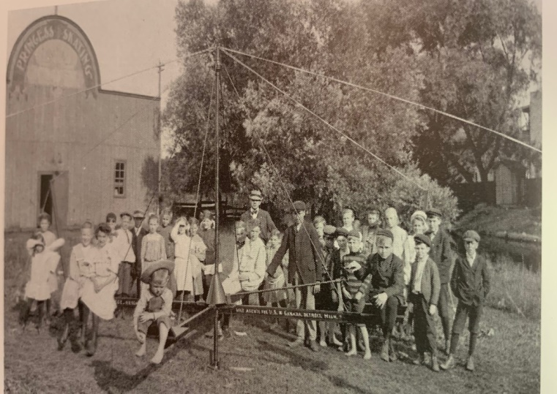

**Electric Park Treasures**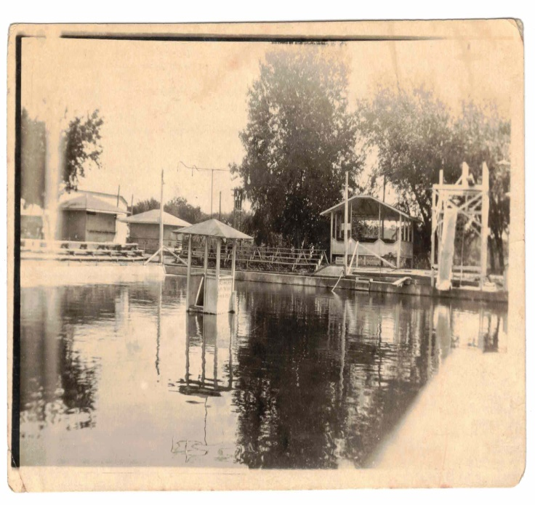

**Electric Park Photographs, Intellectual Property of Denise Yavas Collection**

In the past few weeks, I had an incredible conversation with Electric

Recently I had the great pleasure to visit with the Hiawatha Electric Park's co-founder, Charley Scott's great-great-granddaughter, Denise Yavas. Ms. Yavas, while digitizing family photos, found several Electric Park treasures! We are so fortunate to have been able to be a part of this story.

The Electric Park featured an incredible

500,000-gallon swimming pool. Electric Park has a beloved a 40' X 80' dance pavilion; the area is used alternatively as a skating rink. Electric Park has acres of ground suitable for family gatherings, picnics, and sweetheart outings. Electric Park featured a drive-in movie theatre, two ice skating ponds, and a Jasbo Swing that cost $1,500.00, in today's economy that would be about $21,485.00.

_____________________

**Editor’s Note**

*Please note newspaper sections are written verbatim and appear exactly as it appeared in print.*

_____________________

**Newsletter and Correspondence**

**Brown County Historical Society has entered the digital world. To reduce printing costs, please advise if you are willing to receive the newsletter in digital format. Each edition of the newsletter uploaded to the website for easy access and viewing enjoyment.**

**Email is** [**bchsdirect@gmail.com**](mailto:bchsdirect@gmail.com)

**Check us out on Social Media!**

**Brown County Historical Society's website:**

[**www.browncountyhistoricalsociety.com**](http://www.browncountyhistoricalsociety.com)

**Please like us on Facebook**

**@BrownCountyHistoricalSocietyMemorialAuditorium**

_____________________

**Special Projects**

Brown County Historical Society is working on several projects. On behalf of the Brown County Historical Society, I would like to thank people who have remembered all of the projects that BCHS is striving to complete.

**NEW MEMBERS**

Brown County Historical Society would like to welcome new member, C. Michael George.

**CITY OF CHURCHES**

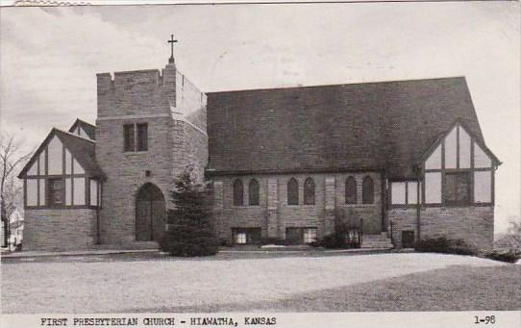

The excerpt is taken from Souvenir Edition issued by the Kansas Democrat. E. Martindale, Publisher, 1877 to 1907.

"Hiawatha is preeminently a city of churches and schools, giving the community a better spiritual-moral and intellectual atmosphere. It has become known as the city of churches, fourteen denominations represented. Our observation has been that everyone, regardless of whether they are church people or not, avoids locating in a community, there are no churches. Even in the wildest places, all join in raising church buildings, and as the community grows older and the people more enlightened, the more church edifices become erected.

The most attended church in Hiawatha is the Presbyterian. The membership is about 378, the church edifice the newest and most modern and the pastor one of the strongest in the West. The new building erected at the cost of architecture and furnishings for $15,000. The church has no debt, no overdraft at the banks, and is continually making improvements.

There have been 140 additions to the church membership. Dr. R. J. Phipps came to Hiawatha three years ago from Hebron, Neb. The orchestra music being a distinctive feature is the evening congregation that has grown from 75 to 500 or 600.

Churches in addition to the First Presbyterian include Baptist, Christian, Catholic, Lutheran, United Evangelical, Congregational, Bethany, Methodist Episcopal Church, Evangelical, St. John's Episcopal."

**BIG KANSAS ROAD TRIP**

**September 10- 13, 2020**

This upcoming event is an exciting opportunity for Brown County to showcase many of the historical treasures within the county. The Brown County Historical Society will have special hours this week to accommodate the visitors.

____________________

**Auditorium & AG Museum**

**OPEN Season May 1 – October 30**

**Please remember as you begin to venture out that practicing social distancing and avoiding contact/spread with germs is essential.**

**memorial auditorium hours**

Monday –Closed

Tuesday –10 am to 3 pm

Wednesday -- 10 am to 3 pm

Thursday --10 am to 3 pm

Friday -- 10 am to 3 pm

**Curator at museum**

**Tuesday-Friday @ 8 am**

**AG Museum OPEN BY APPOINTMENT**

Visits to the museum are available to friends and visitors wanting to visit. Contact by phone or email to set up your appointment in advance.

**MEMORIALS**

Many people continually donate to the museum mission, and thanking these generous benefactors is essential to operations. Memorial (monetary gifts) donated to the Historical Society in memory of a person or as a celebration of a wedding anniversary, birthday, or honoring someone. These gifts keep giving, helping complete projects, and help make plans for other projects.

**Lynn's Corner**

I hope you will be stopping by soon to see many of the projects that are underway. Many updates continue on the newsletter to add additional pieces of information that members may find interesting. For extra history gems, look for weekly history mystery articles are published in the Hiawatha Daily World and Horton Headlight.

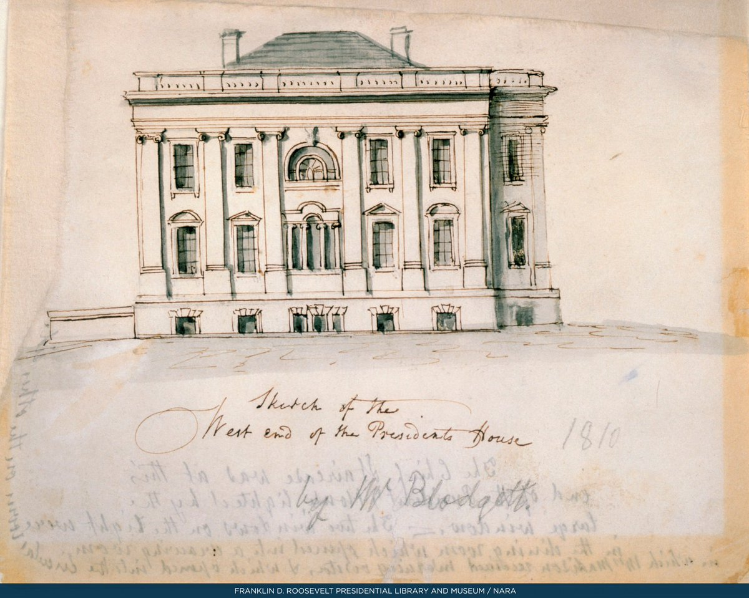

**World News Way Back When**

June 3, 1800, President John Adams will reside briefly in a tavern in Washington, D.C... President Adams moves into the Union Tavern, located in Georgetown, while work was completed at the executive mansion.  
  
On November 1, 1800, President Adams took up residence in the Executive Mansion and wrote a letter to his wife, Abigail. In this letter, President Adams says, "I pray to Heaven to bestow the best of blessings on this house, and all that shall hereafter inhabit it! May none but wise men ever rule under this roof!"

**Personal Diary Entry 1950**

Al Jolson, 62 years old, died of a heart attack in San Francisco, Calif., October 23, 1950. A great singer.

King Gustav V., 92 years old, died October 29, 1950, at the Drottningholm palace in Stockholm, Sweden. His oldest son Gustav Adolph 67 years old will become Sweden's new King Crown Prince Gustave Adolph.

Wednesday afternoon at 2:20 November 1, 1950, an attempt to assassinate Harry S. Truman, President of the U. S. He was living at Blair House at the time. Two Puerto Rican revolutionaries were the assassinators. Oscar Eollazzo, 37, wounded shot in the head. Grijelio Torresola was killed.

Pvt. Leslie Coffelt, 40, of the secret service was killed. Several more were wounded severely.

Tuesday, November 7, 1950 Election Day. Edward Arn was for Gov. of Kansas. Carlson was Gov. Thomas E. Dewey Gov of New York

Earl Warren was for California, Gov. Everett Deirkson for Sen. from Illinois Frank Carlson for Sen. from Kansas Richard Nixson for Sen. from California Herman Welker for Sen. from Idaho. First snow November 3, 1950. Turned warm again in a few days. Thanksgiving Day November 23, 1950. Snow and very cold.

Charles G. Ross, President Truman's press secretary died at his desk in the White House late in the day December 5, 1950. He was 65 years old.

Wednesday morning, December 6, 1950, 8 below zero. Snow but with sunshine.

Mrs. William Allen White, 90 years passed away at her home in Emporia, Kansas December 19, 1950. Burial in Emporia, Kans. Her husband was Editor of Emporia Gazette 1895 – 1944.

|  |
| --- |
|  |
| Brown County Historical Society **Non-Profit Org.**  611 Utah Street U.S. Postage Paid  Hiawatha, KS 66434 Hiawatha, KS 66434  Permit #27  **DIRECTORS**  Gary Shear –President  Larry Day – Vice President  Wesley Duesing – Secretary  Delores Waite -- Treasurer  Eugene Swearingen  Jim Gibbs Larry Adcock  Jere Bruning  Gil Bunning  Mark Schmitz |
| **C:\Users\Owner\AppData\Local\Microsoft\Windows\INetCache\Content.Word\Electric Park, Hiawatha KS - Nettie's dad, Charles Scott Sr. built and owned 1.jpeg**  **become a member! MEMBERSHIP INDIVIDUAL $15.00, FAMILY $30.00, bUSINESS $30.00, lIFE MEMBERSHIP $200 PER PERSON**  **ELECTRIC PARK, HIAWATHA, KANSAS charley scott, co-founder** |

**Brown County Historical Society  
2020 Annual Membership Renewal  
611 Utah – Hiawatha, KS 66434**

[**bchsdirect@gmail.com**](mailto:bchsdirect@gmail.com)

**Telephone #:** _________________________

**Email:**__________________________________________

**Membership Level:**________________________________

**Additional Donation:_**_____________________________

**Dedicated for the use of:**___________________________

**Date Received**____________________________________

Please make checks payable to: **Brown County Historical Society (BCHS) Mail to:** 611 Utah Street, Hiawatha, KS 66434.

**The Brown County Historical Society is a “not-for-profit” 501(c)3.**

□ please send newsletter by email.