Brown County Historical Society Newsletter

|  |  |  |
| --- | --- | --- |
| Brown County Historical Society | **4/2/2021** | Issue #2 for 2021 |

# **Monuments**

Monuments have recently been the impact of a great deal of controversy in the news. For this, individual monuments serve as a visual for a story or particular point in history. Therefore, even if history is not ours, it should be preserved, treasured, honored, and revered. All history plays a vital role in our present, past, and future.

The treasures shared in this newsletter are from a WWII soldier's history of his service. These images were shared with us by a descendant. These images demonstrate that even during a war, a soldier took the time and presence to find beauty in a horrible situation. The donated artifact comes to us from Lloyd Smith, whose father, Verne Smith, served in WWII. These items may find a home later at the Holton Historical Society since he was a part of that community. During Verne's service, he was stationed primarily in Belgium and Germany and participated in the Battle of the Bulge and the Battle of Remagen.

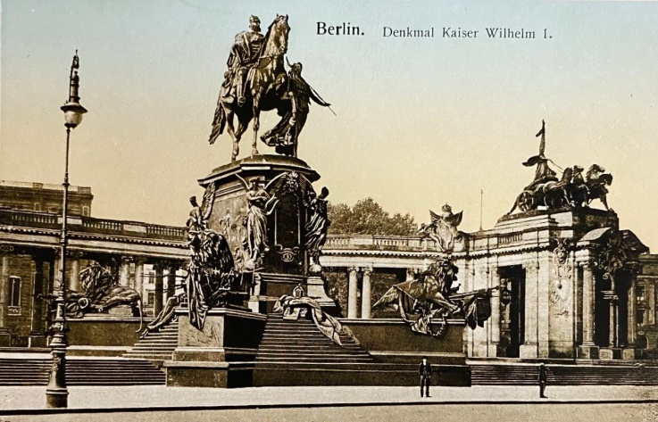

**WWII Postcard Treasure, Intellectual Property of BCHS Collection**

To summarize, for any individual who is not familiar with these battles. The battle of the Bulge is considered one of the most significant turning points by American Soldiers in WWII. Hitler hoped the Ardennes region would prove a successful offensive maneuver where he planned to split the troops and push towards Germany. During extreme weather conditions, the battle takes place and lasted for six weeks, from December 16, 1944, to January 25, 1945.

The German soldiers sought to push American Soldiers deep into the Ardennes Forest. Over 100,000 American soldiers fell during this battle.

The Rhine River is seven hundred sixty-six miles long, and its width is approximately 1,300 feet. The waters are fast-flowing and deep and have served as Germany's defense against invaders throughout history. During Hitler's ambitious plan for world domination, the Rhine River served its purpose again as it had so many times before until March 3, 1945, which begins nearly a month-long campaign for American soldiers to seize the Remagen Bridge. The battle included plans to seize the bridge and force German soldiers deeper into Germany.

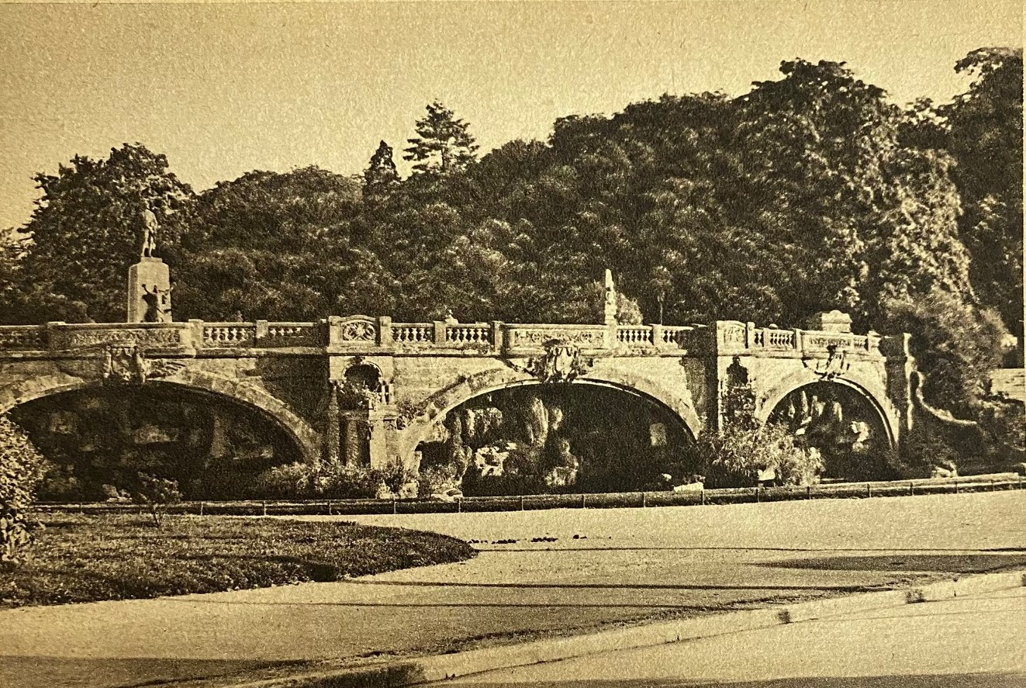

**WWII Postcard Treasure, Intellectual Property of BCHS Collection**

The Battle of Remagen was often considered a turning point in the war. The bridge is damaged during the campaign and will ultimately fall but stands as a testament to the driving force behind soldiers who sought to preserve freedoms. The bridge is a monument and reflection of a period in history.

Author's note: The bridge postcard treasure is one in the collection. It gives few clues and only says on the back 6. METZ –Anlagen. Metz was another area where battles will take place. The bridge, despite war conditions, remained intact.

**MEMORIALS**

Brown County Historical Society is grateful to these generous benefactors who have recently sent donations. We greatly appreciate the continued support of our program. Memorial (monetary gifts) contributed to the Historical Society in memory of a person are gifts that keep giving, helps complete projects, and help make plans for other projects.

**FORMER BCHS DIRECTORS**

Words fail to adequately illustrate and recognize our immense appreciation towards directors who are no longer able to serve on the Brown County Historical Society board. Words can in no way express our gratitude for the years of service and dedication. Each director holds a special place in our hearts.

**FORMER QUILTING CLUB**

**Special Section Contribution by Donna Thonen**

I have been reflecting on the former quilters' society and all the service they provided to Brown County Historical Society. These individuals were hard-working and supported the museum's mission. Extending our gratitude for the many years of support. Donna

**Editor's Note**

*Please note newspaper sections are written verbatim and appear exactly as they appeared in print.*

**Newsletter and Correspondence**

To reduce printing costs, please advise if you are willing to receive the newsletter in digital format. Each newsletter edition is posted to the BCHS website for easy access. Please email us @ [bchsdirect@gmail.com](mailto:bchsdirect@gmail.com)

BCHS website:

[www.browncountyhistoricalsociety.com](http://www.browncountyhistoricalsociety.com)

Like us on Facebook @BrownCountyHistoricalSocietyMemorialAuditorium

**become a member! MEMBERSHIP INDIVIDUAL $15.00, FAMILY $30.00, bUSINESS $30.00, lIFE MEMBERSHIP $200 PER individual**

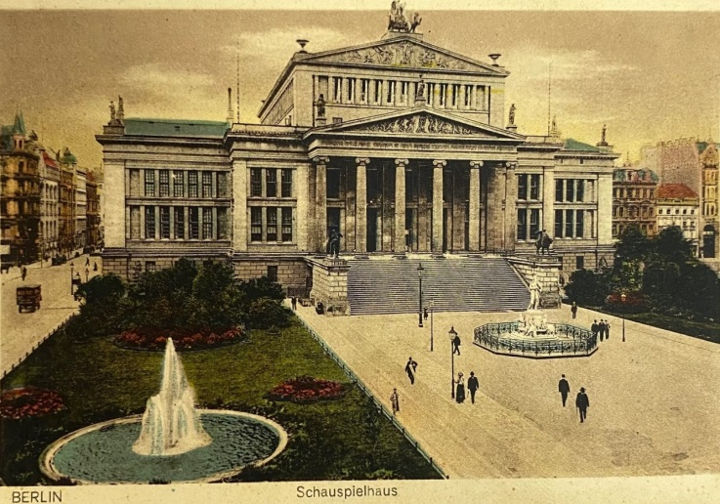

**WWII Postcard Treasure, Intellectual Property of BCHS Collection**

# **noted pioneer family**

Tom Smith was born on March 1, 1874, and the Smith family was considered one of the oldest pioneer families in Brown County. Smith recognized a descendant of James Smith, one of the individuals to sign the Declaration of Independence. The family moves to Hiawatha, Kansas; the family purchased a homestead with 160 acres. Smith attends rural schools in Brown County and then the Hiawatha High School and later graduated from the Hiawatha Academy. Smith was an attorney for Hiawatha and considered to be a powerful speaker. Smith's notable speaking engagements included speaking at President Wilson's home. He later presents with William Taft at Union Square. Smith, a candidate for Lieutenant Governor in 1916, served as Sherriff in Hiawatha, and resided at 115 Miami Street and 406 Shawnee Street.

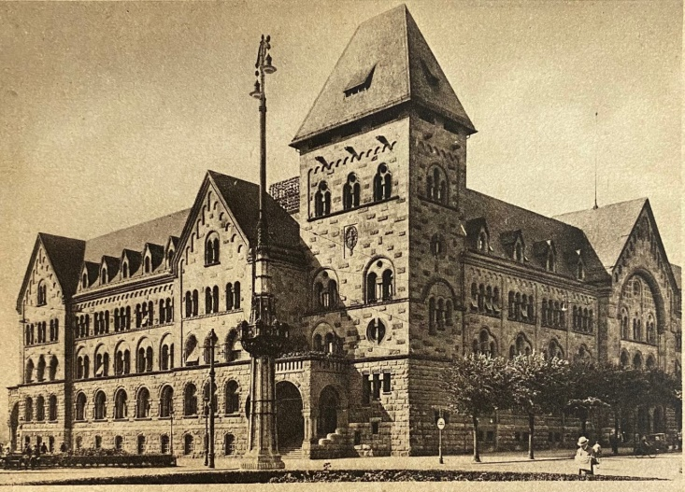

**WWII Postcard Treasure, Intellectual Property of BCHS Collection**

**BIG KANSAS ROAD TRIP**

**May 6-9, 2021**

After much anticipation and a major COVID hurdle, BKRT is an exciting opportunity for Brown County to showcase many of the county's historical treasures. The Brown County Historical Society will have special hours during the event to accommodate the visitors.

____________________

**Auditorium & A.G. Museum**

**CLOSED Season November 1 – May 1**

**memorial auditorium hours**

Monday –Closed

Tuesday –closed to visitors

Wednesday – closed to visitors

Thursday -- closed to visitors

Friday -- closed to visitors

**Curator at museum @ 8 am**

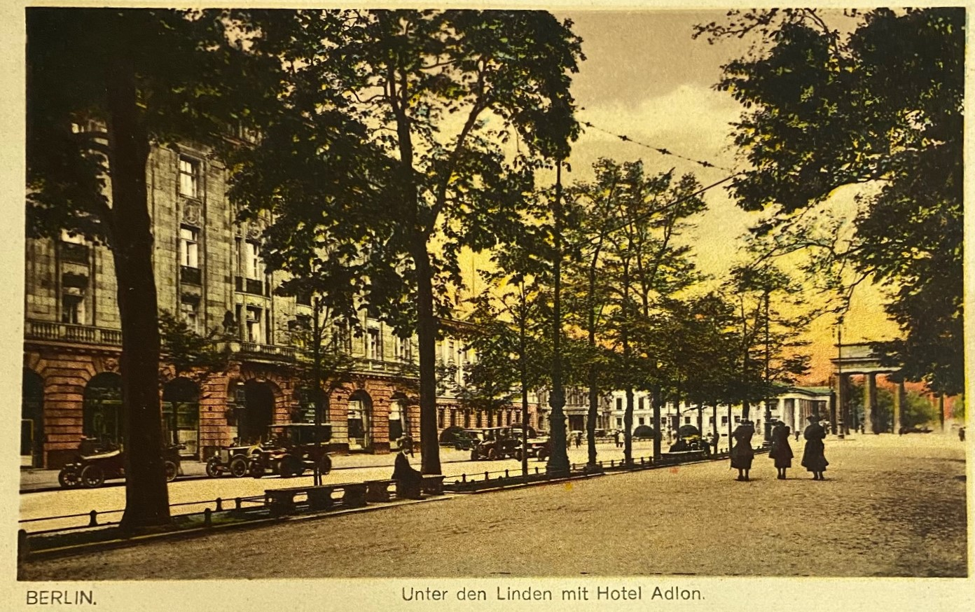

**WWII Postcard Treasure, Intellectual Property of BCHS Collection**

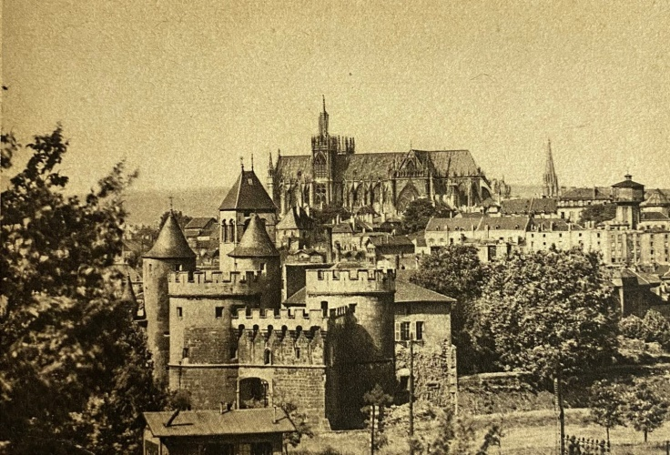

**WWII Postcard Treasure, Intellectual Property of BCHS Collection**

# **reflections on a humanitarian**

On November 13, 1920, Lena Mae Grier was born in Hiawatha, Kansas. Lena will attend school in Hiawatha and moves to Topeka in 1939. When Lena moved to Topeka, she worked at the NYA Center in Topeka under Franklin Delano Roosevelts New Deal for Women.

There are many other accolades to which Lena can claim mother, seamstress, child care worker, and instrumental in the development of the church in which Lena attended. Perhaps the most profoundly significant impact in her life was the acts as a global citizen and humanitarian. Keep in mind Lena was doing all of this before it was trendy. Lena was one of the original plaintiffs who signed Brown v. Board of Education.

Our uniqueness makes each of us sparkle a little brighter. Lena faced each obstacle with perseverance. Lena demonstrates what it means to be a positive influence on the community. Brown County can consider itself fortunate to include Lena as a trailblazer, global citizen, and humanitarian.

March is women's history month, and February was Black history month. March is social worker appreciation month. Lena dedicated her life to acts of social work. I hope you will appreciate this story as much as I have! Another history investigator who is also a descendant of Lena tipped me off to this incredible story!

The New Deal for Women became a launching pad for women to demonstrate their expertise, determination, and capabilities while enhancing and strengthening valuable working partnerships. Women have long illustrated their ability to perform similar tasks working in the workforce alongside male counterparts. Brown County Historical Society has had the privilege of learning more about Lena's life through descendants and working on recognizing Lena as a hometown hero for Hiawatha.

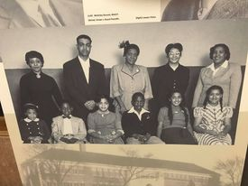**Brown V. Education Photo, Lena Mae Grier Carper family Collection**

|  |
| --- |
| Brown County Historical Society **Non-Profit Org.**  611 Utah Street U.S. Postage Paid  Hiawatha, KS 66434 Hiawatha, KS 66434  Permit #27  **DIRECTORS**  Gary Shear –President  Larry Day – Vice President/Treasurer  Wesley Duesing – Secretary  Eugene Swearingen  Jim Gibbs Larry Adcock  Jere Bruning  Gil Bunning  Mark Schmitz  John Merchant Jr.  Tish Sims  Melissa Gormley  Joey May  **C:\Users\Owner\AppData\Local\Microsoft\Windows\INetCache\Content.Word\Berlin5.jpg**  **postcard treasure, berlin, germany** |