Brown County Historical Society Newsletter

donna thonen NEWSPAPER EDITOR FROM 2001-2019

|  |  |  |
| --- | --- | --- |
| Brown County Historical Society | **9/20/2019** | Issue #3 for 2019 |

# **hiawatha, a community celebrated**

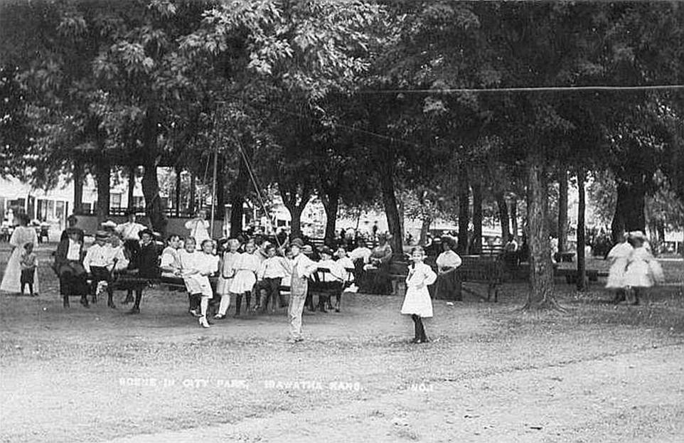

There are a great many things that Hiawatha, Kansas has established. As we follow with the time-honored traditions for fall in Hiawatha, Kansas, perhaps you will take a moment to remember and thank the woman primarily responsible for the delightful tradition Hiawatha celebrates.

Hiawatha’s Halloween frolic is fondly referred to as the oldest Halloween Frolic in the Nation? Since October 31, 1914, this has been a tradition in Hiawatha, Kansas.

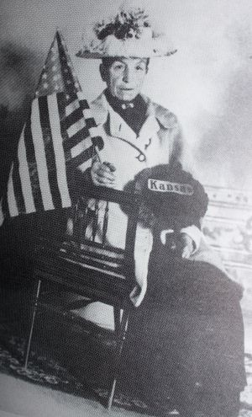

Did you know that Elizabeth always demonstrates interest and love for gardening and will frequently voice her concerns in the Hiawatha World? Elizabeth’s comments will generally speak of her concern for private gardens and the courthouse gardens. Elizabeth Krebs will also be responsible for the establishment of the Hiawatha Garden Club. The night of the Halloween frolic arrives, and Elizabeth and the townspeople wait with great anticipation of whether the frolic will be a success or a complete flop! Much to the townspeople of Hiawatha’ surprise Elizabeth Krebs solution is a triumphant success!

_____________________

**Editor’s note**

*Please note newspaper sections are written verbatim and appear exactly as it appeared in print.*

_____________________

**Printed Reflections**

Donna Thonen has worked with tireless dedication on the Brown County

Historical Society’s newsletter for over 18 years as editor of the Brown County

Historical Newsletter. It is with mixed emotions because the stories and

history mean so much that Donna Thonen has decided to retire from this

position.

Donna writes: Lynn Allen, the Executive Director/Curator of the museums, will

be working in the capacity of editor of the newsletter going forward. Lynn

designed June 2019 edition, and as the news copy was sent off to the printer

I was confident that the direction of the newsletter was in the direction that

everyone who loves history could be proud of the achievements.

I am confident and proud of the accomplishments of the newsletter over the past 18 years. I am convinced that the timing is right to hand over the reins of the newsletter even though I still love the history and plan to be a part of the development and creation of the newsletter. I have enjoyed creating each newsletter and thank everyone for your support and the compliments I have received. To reach Lynn contact the Historical Memorial Auditorium, 611 Utah Street downtown Hiawatha, KS. 66434. The telephone number is 785-742-3330. Lynn has started working on the newsletter fulltime with the September 2019 edition.

**History Mysteries**

The Brown County Historical Society is looking for additional information related to the big cannon, this cannon was on display on Oregon Street for many years and later moved to the Cemetery.

**“Enriching Our Future Through Our Past”**

**Memorial Auditorium AG Museum & Windmill Lane**

**785-742-3330 785-742-3702**

**611 Utah Street 301 East Iowa Street**

**Hiawatha, KS 66434 Hiawatha, KS 66434**

**Website:browncountyhistoricalsociety.com**

**us on Facebook @BrownCountyHistoricalSocietyMemorialAuditorium**

**Homer White Week**

The first week in August 2019 was something to be remembered. The Homer White American Legion Post #66 partnered with people throughout the community to celebrate the life of Homer White. The commissioners of Brown County declared the celebration of Homer White’s life, Homer White Week! What a week it was!

Brown County was the hometown of Homer White. Homer White served his country well and will pass away in service of his country in 1920.

Homer White was a shining example of a person who stood firmly on foundation and model set forth by the founding fathers of this country. Homer White will charge into every opportunity to serve with honor, integrity, and courage. The BCHS Memorial Auditorium erected in honor of individuals who have offered his or her life in service of the fundamental belief that this country is something worth protecting. There is so much more to this story. Find it! Be sure to stop by and share with me what you discover! #History Mysteries.

_____________________

**Memorial Day**

Did you know that "Memorial Day" was previously referred to as Decoration Day? It is called Decoration Day to inspire people to visit the gravesides and decorate loved ones tombstones with flowers and flags. On the first Decoration Day, General James Garfield makes a speech at Arlington Cemetery.

In 1971, congress names "Memorial Day" a national holiday.

[#HistoryMysteries](https://www.facebook.com/hashtag/historymysteries?source=feed_text&epa=HASHTAG&__xts__%5B0%5D=68.ARBaW492bPAiC2uhgJIK0N3ClyjuyxjSU6w_qdLzYymlmDxa2CbF2jyMSU8Tu85kB4X6nRaLNatB4DyReaZKQWVmynXI6YCVn3KQAxD7ZtxRmKUH2tfWxMSk1MAVBEXdXNCAFli-xEVI0xLcyYU4tk649yOh5raNP0AzclhPg3DwnATSc1iR3ioVKFd2_yOlIqF0pSTbGwg3XA6Wuztu1-hobJ2SuJ0i7J1nCW2VoGvmbG4sTh1h8B_-vALqb7xO9ApzyTbvgd81k_x_uxMPdyxXtvwO53-bN2eKMDZpW1XOEVSMrb3BYb7y8z3BgYJAKcMw5Knx7T0CmCoc3j8&__tn__=%2ANK-R)

_____________________

**Brown County Poor Farm**

Did you know Brown County had a poor farm? Originally this was a 350-acre farm. During this period it was not uncommon for the facility to house between 20 and 50 inmates. The farm had an orchard on the south side of the road with apple, peach, pear and cherry trees. The “poor farm” article was written by Grace Moore for the Hiawatha World, "Living on the poor farm in Brown County" June 28, 1999.

_____________________

**Auditorium & AG Museum Open**

**Season May 1 – October 31**

**memorial auditorium hours**

Monday –Closed

Tuesday –10 am to 3 pm

Wednesday -- 10 am to 3 pm

Thursday --10 am to 3 pm

Friday -- 10 am to 3 pm

Curator at museum Tue-Fri @ 8 am

**AG Museum OPEN BY APPOINTMENT**

**NEW MEMBERS**

Brown County Historical Society would like to give a hearty welcome to a new member; Lucy Grothusen, is the owner/operator of Beaux Cheveux.

**Lynn’s Corner**



As with each week, I am amazed at the fascinating history that I am honored to explore. The museum has many projects that are underway. Museum projects include continuation of cleanup, organization of display areas for people in the community to enjoy. The museum, as well as the community has been affected by the stormy season that has been upon us. The Brown County Historical Society has some exciting news to share that you may have already heard little bits of information. Marci Penner, from the Kansas Sampler Foundation, has selected Brown, Doniphan and Nemaha counties for the Big Kansas Road Trip. More details announced at a later date. The event will occur from May 7-10, 2020. We are so thrilled to have been selected! Marci has a couple of books out as well that give exciting ways to explore Kansas. These books include the Kansas Guidebook 2 and 8 Wonders of Kansas. Be sure to snag onto these treasures as well. Be on the lookout for treasures we have in our community.

This gorgeous handwriting card was one of the many treasures uncovered while organizing and cleaning up. Celebrate each story, find and share the treasures discovered along the way!!

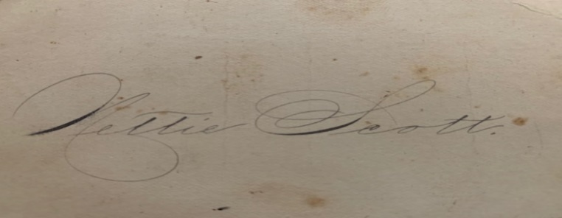

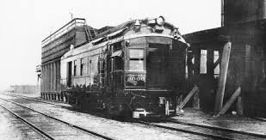

_____________________

**Special Projects**

The Brown County Historical Society is working on several projects.

On behalf of the Brown County Historical Society, I would like to thank people who have remembered the Hiawatha Academy Bell this special project that has received generous donations.

On behalf of the Brown County Historical Society, I would like to thank the people who have remembered the auditorium stage curtain project. Some of the recent benefactors: Jere & Patty Bruning, Bill & Carol Vonderschmidt, and John & Charlene Gernon and Robert & Margaret Hankins. Presently, the donation total is 13,050.00.

On behalf of the Brown County Historical Society, I would like to thank the people who have remembered the monarch waystations project. Anita Pfister has generously and continuously donated to the Monarch’s endeavor.

_____________________

**Brown County “Callboys”**

It will surely come as no surprise that I am often on quest for history. There was a reference to a "call boy." I was aware that this referred to several employment positions such as a bellhop, also the person who informs actors that it is time to go on stage. In Horton's history, however, "call boy" takes another privileged position in Horton.

Photo credit intellectual property of I. E. Quastler <https://www.kshs.org/publicat/history/2004winter_quastler.pdf>

A "call boy" is slang in the railroad industry. It refers to the "railroad employee responsible for ensuring that members of a train crew are on hand for their regular runs and for notifying them of an extra run."

|  |
| --- |
|  |
| Brown County Historical Society **Non-Profit Org.**  611 Utah Street U.S. Postage Paid  Hiawatha, KS 66434 Hiawatha, KS 66434  **DIRECTORS**  Gary Shear –President  Larry Day – Vice President  Wesley Duesing – Secretary  Delores Waite -- Treasurer  Eugene Swearingen  Jim Gibbs Larry Adcock  Jere Bruning  Gil Bunning  Donna Thonen  Dennis Greer  Permit #27 |
| **become a member! MEMBERSHIP INDIVIDUAL $15.00, FAMILY $30.00, bUSINESS $30.00, lIFE MEMBERSHIP $200 PER PERSON** |

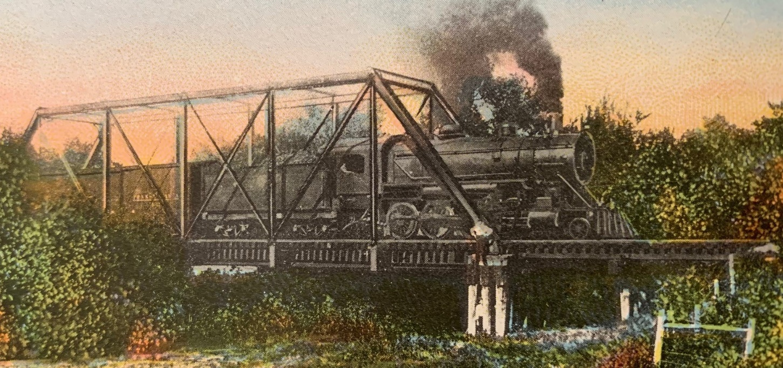

postcard treasure, Missouri pacific railroad crossing walnut creek, hiawatha kansas