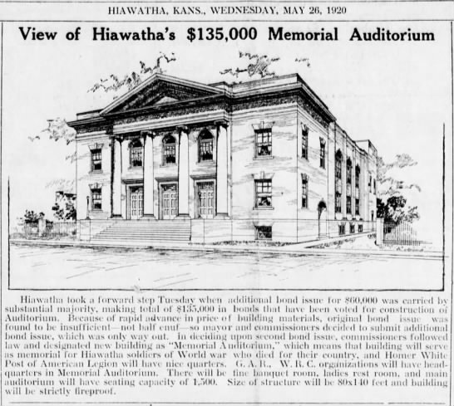
Taken from Hiawatha Daily World 05-26-1920

The Memorial Auditorium was erected in 1920 to honor of Veterans who fought in the Spanish American War, the Civil War and World War I. The auditorium owned by the City of Hiawatha and financed through a “general obligations bond.”

The upper-level offices initially occupied by the Homer White Post of the American Legion, the Grand Army of the Republic (G.A.R.) and the Women’s Relief Corp.

The auditorium was designed to seat over 1200 people comfortably with 800 seats downstairs and over 400 seats on the balcony. The auditorium acoustics were designed so that a speaker on the stage would be heard from any position in the house.

From 1920 through the 1970s the Memorial Auditorium will be widely loved by citizens of the community, and keen interest shown in various aspects of the building. As noted from “The Hiawatha World” article on June 21, 1921. “City Bot Opera Chairs, Scenery and Light Fixtures for Auditorium”

In 1952, wine-colored velvet drapes were installed on the auditorium stage. The auditorium stage would go on to feature hundreds of performers from 1922 through 1960. The auditorium would also feature hundreds of “vaudeville” movies. The original auditorium backdrop screens featured a living room, a dining room, a front porch, a wooded scene, a view of the Mediterranean from the balcony, and the Goddess of Liberty. The Mediterranean Scene is the only original scene hanging on the backstage.

The Memorial Auditorium was proudly maintained, continuously used, and regularly visited by members of the community up into the 1970s. It is at this time that the City determined that upkeep of the Memorial Auditorium was too expensive and closed to the public.

The following article excerpt was published in “Hiawatha Daily World” on May 26, 1921.

Auditorium Highlights:

Size of Auditorium 124 X 80 Feet
Will seat 1,276 people
Auditorium Cost $175,000
Building site cost $10,500
Contractor $113,800
Built by Sanneman Brothers
Scenery $2,700
Electric Light Fixtures $2,800
Seats $6,700
Heating and Ventilation $18,300
Wiring $3,200
Banquet Hall will seat 700 @ tables
Chamber of Commerce plates $325

Today the Memorial Auditorium receives financial assistance annually from Brown County, but the buildings are maintained and upheld by the Brown County Historical Society. It is easy to recognize the place within the community that the Memorial Auditorium once held, and as we continue to approach the 100th year of the Memorial Auditorium, and the years that follow Brown County Historical Society hopes that the charming place that the Auditorium held will once again be vibrantly visible.

As I was reading the newspaper articles surrounding the Memorial Auditorium, it was easy to garner the strong sense of pride the community held for the Memorial Auditorium. As you venture out, perhaps you will stop by the Memorial Auditorium and revel in a bit of the magic. There is so much more to this story! Find it, and be sure to stop by and share with me what you have discovered. #HistoryMystery

Are you or is anyone you know interested in history? Then the Brown County Historical Society is something you may want to be a part of membership is as follows: Individual $15.00, Family $30.00, Business $30.00, Life – One Time Charge $200.00

