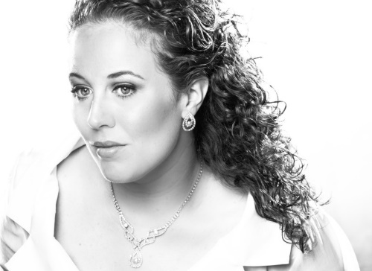
Guest soloist, Sara Emerson, is an engaging singer who has recently performed with the Metropolitan International Music Festival in NYC, Opera Grand Rapids, and AIMS in Graz, Austria. Ms. Emerson was a featured summer artist with Savannah Voice Festival, Connecticut Lyric Opera, and Asheville Lyric Opera. On the operatic stage, she has performed the roles of Mother in Menotti’s Amahl and the Night Visitors, First Lady in Mozart’s Die Zauberflöte, Venus in Offenbach’s Orpehus in the Underworld, and many others. In her musical theater engagements, Ms. Emerson has appeared as Marian Paroo in The Music Man, Nettie in Carousel, and Lady Larken in Once Upon a Mattress. She performed the leading soprano role of Cleria in the North American premier of the revived manuscript of Francesco Cavalli’s La Virtu de’ Stralli d’Amore.
An active recitalist, Ms. Emerson regularly performs solo recitals throughout the Midwest, including a recent concert in Chicago and recital tour throughout Michigan. She made her international recital debut in 2007 in Paris, France. Ms. Emerson made her Carnegie Hall debut in 2010 where she performed Hector Villa-Lobos' Aria from Bachianas Brasileiras. She performed as featured soloist in concert with the Traverse Symphony Orchestra, Southwest Michigan Symphony Orchestra, Lake Michigan Youth Orchestra (Carmina Burana, soprano soloist), Kalamazoo Bach Festival, UMS Choral Union, and Kalamazoo Singers.
Ms. Emerson won First Place in the Opera Idol Competition with Sherrill Milnes; Second Place in the International Chamber Music Ensemble Competition with the PVC Trio, of which Ms. Emerson is the founder; Second Place in the Marjorie Conrad Peatee Art Song Competition; Third Place in the Holland Chorale Nicholas Loren Vocal Competition; Finalist in the Harold Haugh Light Opera Competition; and Finalist in the Just Love to Sing! Opera Competition.
Ms. Emerson lives in Kalamazoo, MI with her husband and 1 year old son. She teaches a successful private voice studio in addition to her classical singing career.
For more on Ms. Emerson, please visit www.saralemerson.com.

