Wareham
for
Law and Democracy

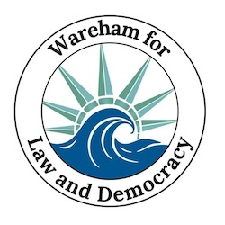

Updates For the Week of Jan. 8-14

  Sat. Jan. 3
  Stand Out
  Attendance
  62
  ❄️
  Thank you, Wareham, for showing up at last Saturday’s protest in front of the town hall, which swelled to 166 people strong! Many protesters wore all black to show sympathy for the murder of an American citizen, poet, mother, wife, and Christian, Renee Nicole Good, at the hands of an ICE agent in Minneapolis. We see the news showing massive protests in big cities, and our smaller community protests are just as vital and important.
  Sat. Jan. 10
  Stand Out
  Attendance
  166
  🔥🧊

Actions to take this week:

1 Minute: Fill out this ACLU form to tell our MA lawmakers to stop ICE

2 Minutes: Fill out this Indivisible form to tell our US lawmakers to stop ICE

3 Minutes: Call your congresspeople and representatives.
Governor Maura Healy: (617) 725-4005
MA Rep 9th District, Bill Keating: (508) 746-9000
State Senator, Kelly A. Dooner: (617) 722-1551

Helpful hint: visit or download 5 Calls, a great app to call your legislators that provides a searchable list of scripts for many important issues. Call after hours to leave it as a voicemail!

A quote for this week:

“The result of a consistent and total substitution of lies for factual truth is not that the lie will now be accepted as truth and truth be defamed as a lie, but that the sense by which we take our bearings in the real world—and the category of truth versus falsehood is among the mental means to this end—is being destroyed."—Hannah Arendt

Hannah Arendt was an influential political theorist of the twentieth century, who fled Germany for America during WWII. She spoke of the strategy of lying in totalitarian propaganda. This strategy was not meant to convince people of lies, but to undermine trust.

  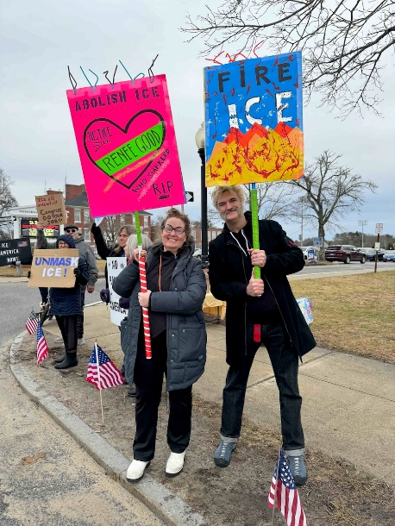
  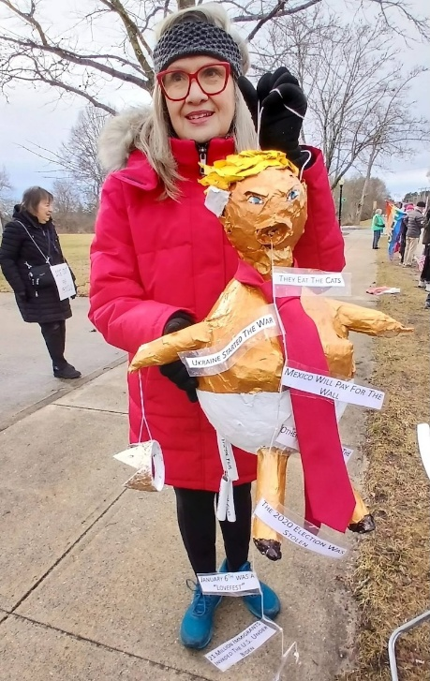
  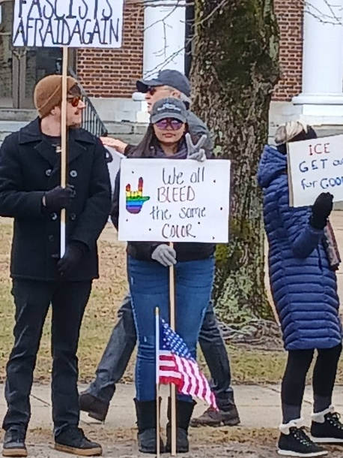

January 14 Readiness, Resilience, and Resistance:
A Workshop for What Lies Ahead

Indivisible continues to build the Democracy movement and mitigate harm. This workshop will help each of us lay the foundation for mutual aid in the face of disruptions by strikes or authoritarian aggressions.

The Boston Trainers Collective is a group of volunteer activists and organizers associated with a variety of racial and social justice organizations in Greater Boston. This is a two-hour workshop on building personal and collective readiness and resilience to resist authoritarianism and prepare our communities for other challenges that may lie ahead, such as climate-related emergencies, economic uncertainty, and social unrest. Participants will leave with a personalized list of actions they can take immediately to start building their readiness, resilience, and resistance muscles and mindset.

Wednesday, Jan. 14 5:30 - 8:00 Wareham Free Library, 59 Marion Rd

Free Workshop Registration

January 20 "Anti-versary" Party

Hey South Coast community! Remember January 20th last year? Sigh....
Let's mark this anti-versary with camaraderie, good food, craft beers and even some fun and games!
It will be like our stand out only warmer and with chairs!
Connect with your Saturday buddies and meet new people!

Join us at Stone Path Malt on Tuesday, Jan 20th from 6:00-8:00PM
We'll be serving complimentary appetizers
$10 donation (more if you can/less if you can't) - cash bar & meal menu

Please RSVP below and bring some new folks too!

Yes! I'm coming to the Anti-versary Party!

January 22 Bridging the Divide Meeting Gathering

We will be meeting at the home of Dr. Carl Swanson at 40 Mayflower Ridge Drive on January 22 at 10 A.M. Carl will be making quiche and I will be bringing resource packets so we really need to know who will be joining us. Please click the button below or email cynthia@blisses.org to let us know you're attending!

Yes, I'm Bridging the Divide!

Thank you to those who have already responded. We are looking forward to getting to know each of you better and grateful that Carl is hosting us so that we can have meaningful conversations. After we eat Carl's delicious quiche and are revived with coffee and camaraderie we will recommence our discussions around polarization and talk about the three levels on which we are affected; within our own thoughts, in our networks of family, friends and work and in the larger community of town, state and country. I expect many of us have some experiences of conflict and of how we responded to it.

Next we will talk about tools and strategies and actual language to use in difficult conversations. To that end we are sharing these links for your perusal and would love it if you could choose one to watch; none of them exceed 18 minutes. They will provide a good foundation for our discussion as well as the packet of materials I will have for you.

Winn Tashman: Bridging Divides: Engaging the Movable Middle for Societal Change

Jennifer Edward and Katie McCleary: Critical Conversations: Bridging the Gap in a Divided World

Monica Guzman: How Curiosity Will Save Us

Julia Dhar: How to Disagree Productively and Find Common Ground

Finally, we will talk about concrete actions we will work toward undertaking. We will watch a brief segment from PBS on a national organization called Braver Angels and discuss if we should start a local chapter. Any and all ideas of yours will be more than welcome. Perhaps we could start by including friends close to us who might be willing to attend a meeting with us where we can practice our newly honed "bridging skills."



Action Updates

Overpass Banner Brigade
Our overpass banner crew is lighting up the evening commute over Rt. 25, put on your bright holiday clothes and some festive lights and join us! We'll continue to shine Liberty's light from 3:00 to 4:00, Fridays and Sundays, over Rt. 25.
Fridays we meet at Tihonet Road, which has a dirt parking spot on the west side of the road at the end of the cranberry bog, just south of the overpass .
Sundays we meet at Maple Springs Road, near the westbound entrance to Rt 25, with parking in the DOT Park & Ride lot just south of the overpass.
Weather Warnings
When winter treats us to some cold, snowy days that make travel hazardous (and staying inside appealing), we'll send out an email on Saturday morning at 10:30 to let you know if we're declaring a snow day. That doesn't mean that you can't go, but if you do, dress warmly and drive safely!

❤️ Thank You ❤️

We know the times are scary and actions may feel futile but every bit helps. Coming to the Saturday Stand Out for an hour makes each of us appreciate a community of kindred spirits. Calling a friend who's struggling to ask "How are you?" lightens their day. Even opening this email encourages us to keep writing them. Thank you for caring.

 | 

Paid for by Indivisible
Wareham for Law and Democracy
Wareham
Wareham, MA 02571
United States

If you believe you received this message in error or wish to no longer receive email from us, please
unsubscribe.

