Wareham
for
Law and Democracy

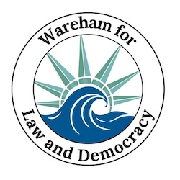

Updates For the Week of Dec. 17 - 24

  Sat. Dec. 13
  Stand Out
  Attendance
  51
  🌤
  Merry Christmas and Happy Hannukah and wishes of warmth and light and love and laughter for all this season! We will be gathering at Wareham Town Hall on Saturday, December 27 if the weather cooperates as well as flying the banner.
  Sat. Dec. 20
  Stand Out
  Attendance
  66
  🌤

January 20 "Anti-versary" Party

Hey South Coast community! Remember January 20th last year? Sigh....
Let's mark the anti-versary with camaraderie, good food, craft beers and even some fun and games!
It will be like our stand out only warmer and with chairs!
Connect with your Saturday buddies and meet new people!

Join us at Stone Path Malt in from 6:00-8:00PM
We'll serve complimentary appetizers
$10 donation (more if you can/less if you can't) - cash bar & meal menu

RSVP here and feel free to bring some new folks too!

Take Action Now!

- Saturday Stand Out 🇺🇸 at Wareham Town Hall from 11:30 - 12:30 every Saturday and that includes Dec. 27th and Jan. 3rd!
- Overpass Banner Brigade 🚙 on Fridays and Sundays from 3:00 - 4:00 (see details below)

  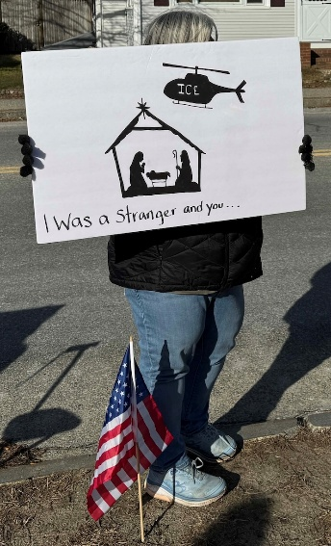
  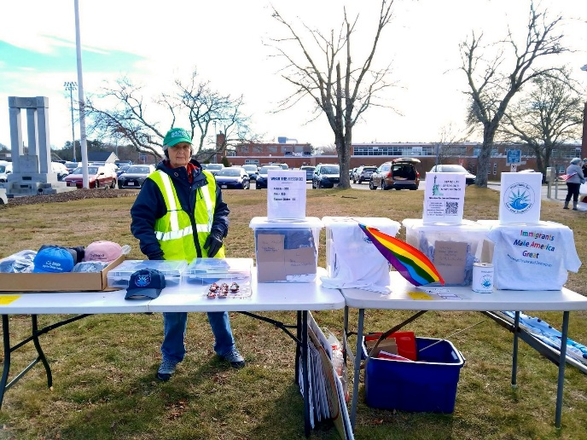
  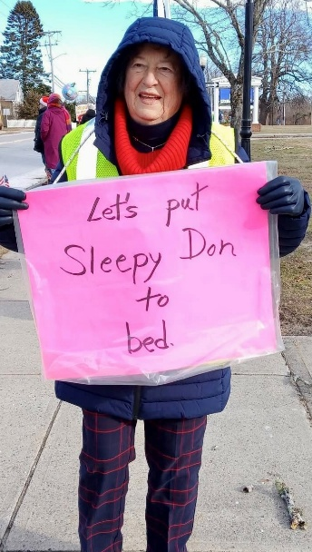

📝❓Super Quick Survey by Indivisible 📝❓
Whether or not you joined the boycott of Amazon, Target and Home Depot, please spend a few clicks to help Indivisible get a read on why people do or do not participate in this survey about the boycott. Thanks!

START THE SURVEY

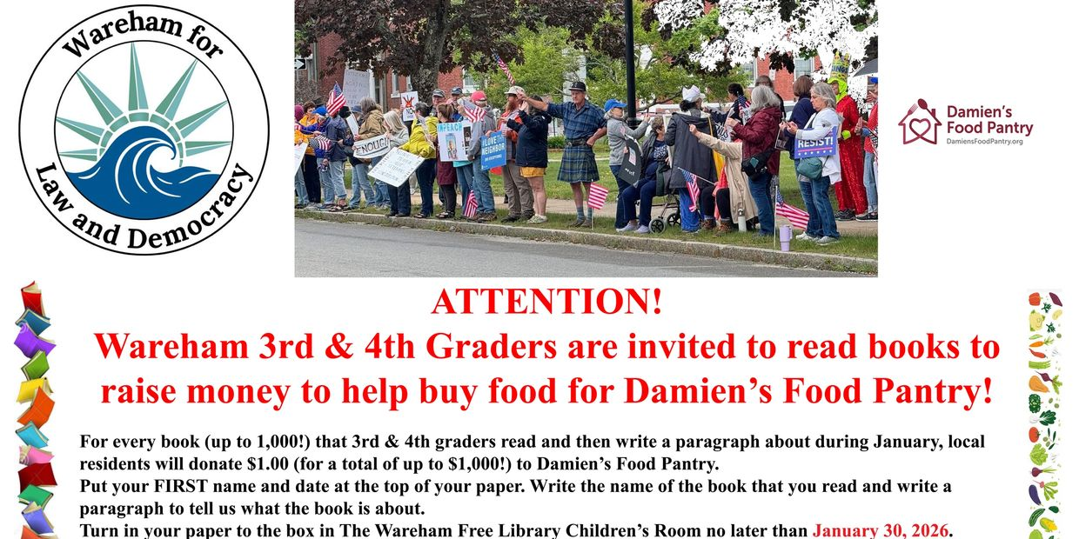

Action Updates

Overpass Banner Brigade
Our overpass banner crew is lighting up the evening commute over Rt. 25, put on your bright holiday clothes and some festive lights and join us! We'll continue to shine Liberty's light from 3:00 to 4:00, Fridays and Sundays, over Rt. 25.
Fridays we meet at Tihonet Road, which has a dirt parking spot on the west side of the road at the end of the cranberry bog, just south of the overpass .
Sundays we meet at Maple Springs Road, near the westbound entrance to Rt 25, with parking in the DOT Park & Ride lot just south of the overpass.
Bridging the Divide
Our next meeting to explore ways to restore civility with our neighbors across sociopolitical boundaries will be Thursday, Jan. 22 (details coming soon).
We'll hand out a resource packet modeling language which can diffuse contention and invite collaborative conversation and look at a national organization established during the first Trump administration with the precise purpose of building civic and civil discourse. We'll use these materials to reflect on our own past interactions as well as to discuss steps forward.
Weather Warnings
When winter treats us to some cold, snowy days that make travel hazardous (and staying inside appealing), we'll send out an email on Saturday morning at 10:30 to let you know if we're declaring a snow day. That doesn't mean that you can't go, but if you do, dress warmly and drive safely!

❤️ Thank You ❤️

We know the times are scary and actions may feel futile but every bit helps. Coming to the Saturday Stand Out for an hour makes each of us appreciate a community of kindred spirits. Calling a friend who's struggling to ask "How are you?" lightens their day. Even opening this email encourages us to keep writing them. Thank you for caring.

 | 

Paid for by Indivisible
Wareham for Law and Democracy
Wareham
Wareham, MA 02571
United States

If you believe you received this message in error or wish to no longer receive email from us, please
unsubscribe.

