Wareham
for
Law and Democracy

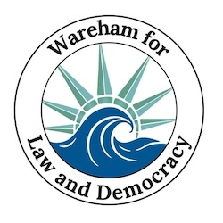

Updates For the Week of Dec. 9 - 16

  Sat. Dec. 6
  Stand Out
  Attendance
  77
  🌤
  The community meeting on Dec. 10 was a delicious success. We powered through 90 minutes of brainstorming about goals and capabilities with a spread of holiday cookies and cider. The steering committee will be building on that by identifying which objectives we have the people and resources to pursue in 2026, and we'll let you know about those in upcoming weeks. Thanks to all who came to the meeting and contributed their careful thoughts!
  Sat. Dec. 13
  Stand Out
  Attendance
  51
  🌤

📝❓Super Quick Survey by Indivisible 📝❓
Whether or not you joined the boycott of Amazon, Target and Home Depot, please spend a few clicks to help Indivisible get a read on why people do or do not participate in this survey about the boycott. Thanks!

START THE SURVEY

Take Action Now!

- Saturday Stand Out 🇺🇸 at Wareham Town Hall from 11:30 - 12:30 every Saturday!
- Saturday Sing Out 🎶 at Wareham Library from 10:00 -11:00 Sat., Dec. 20. Warm up before the Stand Out!
- Overpass Banner Brigade 🚙 on Fridays and Sundays from 3:00 - 4:00 (see details below)
- Social Gathering at Stone Path Malt 🍻Tues, Jan. 20 6:00 - 8:00 (see details below)

  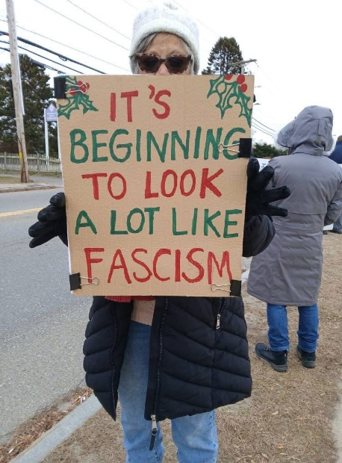
  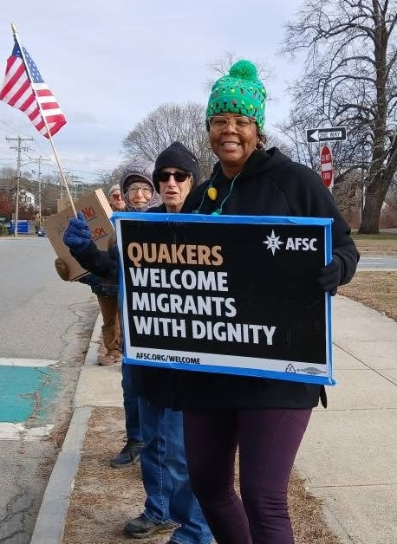
  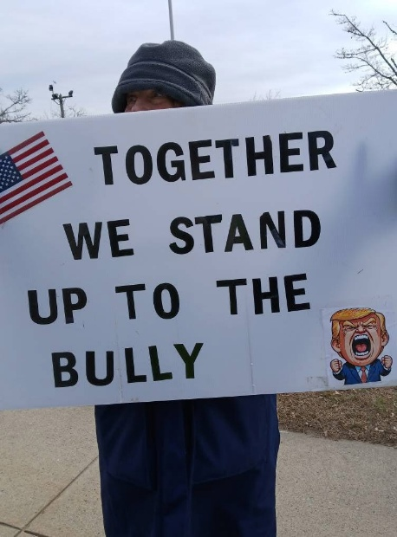

Monthly Meeting Report

  On Wednesday, Dec. 10 we met at the Council on Aging to focus on answering a series of questions. We divided into three groups of about 10 people to discuss the questions below and then came back together as a whole to compare and compile our responses. The energy and ideas were great; we expressed our grave concerns and then inspired each other to identify ways we can address them. The steering committee is refining the ideas into clear goals and specific and achievable actions for 2026.
  1. How has the climate changed since we started?
  2. What changes do we anticipate in the coming year?
  3. What are our strengths?
  4. Why must we act?
  5. What opportunities do we have to make an even bigger difference?
  6. What will we want to say we have accomplished this time next year?
  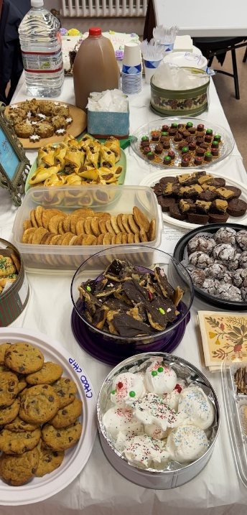

If you have your own responses to these questions, we would love to hear them! Please reply back and let us know so we can continue the success we had in 2025 and grow stronger in 2026!

And we enjoyed some delicious home-baked goodies together for a little added seasonal inspiration.

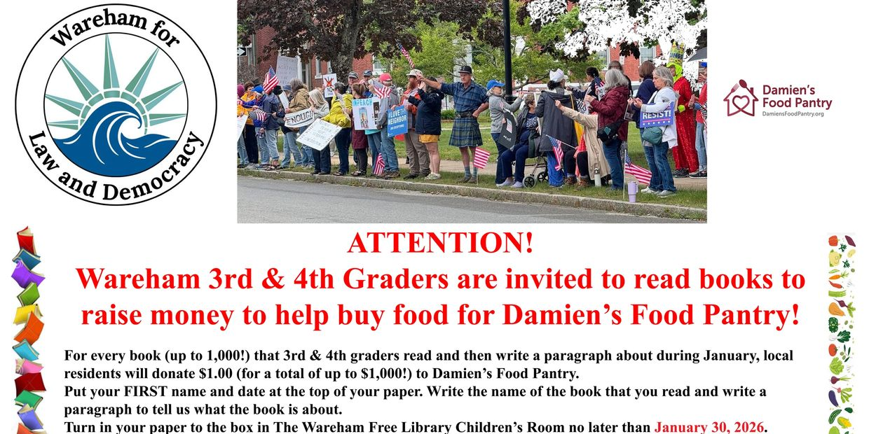

Action Updates

Overpass Banner Brigade
Our overpass banner crew is lighting up the evening commute over Rt. 25, put on your bright holiday clothes and some festive lights and join us! We'll continue to shine Liberty's light from 3:00 to 4:00, Fridays and Sundays, over Rt. 25.
Fridays we meet at Tihonet Road, which has a dirt parking spot on the west side of the road at the end of the cranberry bog, just south of the overpass .
Sundays we meet at Maple Springs Road, near the westbound entrance to Rt 25, with parking in the DOT Park & Ride lot just south of the overpass.
Jan. 20 Antiversary at Stone Path Malt
Stone Path Malt is opening just for us on Tuesday, Jan. 20 from 6:00 - 8:00 for our first social gathering. We're asking for a suggested donation of $10 to fund WLD's community building actions. The evening will have only brief announcements so instead we can spend the time with friends and neighbors and the great food and drink available at Stone Path Malt.
Saturday Sing Out!
Let’s lift our voices in harmony at our Saturday Stand Outs with this list of chants and song lyrics you can pull up on your phone, or better yet, print out a copy! And if you’re interested in really harmonizing, join the rehearsals at the Wareham Library from 10-11am on Dec. 20th right before the stand outs!
Bridging the Divide
Our next meeting to explore ways to restore civility with our neighbors across sociopolitical boundaries will be Thursday, Jan. 22 (details coming soon).
We'll hand out a resource packet modeling language which can diffuse contention and invite collaborative conversation and look at a national organization established during the first Trump administration with the precise purpose of building civic and civil discourse. We'll use these materials to reflect on our own past interactions as well as to discuss steps forward.
Weather Warnings
When winter treats us to some cold, snowy days that make travel hazardous (and staying inside appealing), we'll send out an email on Saturday morning at 10:30 to let you know if we're declaring a snow day. That doesn't mean that you can't go, but if you do, dress warmly and drive safely!

❤️ Thank You ❤️

We know the times are scary and actions may feel futile but every bit helps. Coming to the Saturday Stand Out for an hour makes each of us appreciate a community of kindred spirits. Calling a friend who's struggling to ask How are you? lightens their day. Even opening this email encourages us to keep writing them. Thank you for caring.

 | 

Paid for by Indivisible
Wareham for Law and Democracy
Wareham
Wareham, MA 02571
United States

If you believe you received this message in error or wish to no longer receive email from us, please
unsubscribe.

