Hello and thank you for registering for NO KINGS 2.0 in Wareham, MA! There is joy in resistance! And this Saturday, we will show it to the world. It's not too late to get folks you know off the sidelines to be part of this historic day - they can register HERE or just show up!

WHEN: TOMORROW!! October 18th, 2025 from 11:30-1:00 PM
WHERE: In front of Wareham Town Hall (54 Marion Road)
PARKING: In the lot between Town Hall and the Multiservice Center, or at the Library across the street, or at the Shaws/Walgreens shopping area (127 Marion Rd)
RESTROOMS: Library or Shaws

What to know before you come:

Watch this short best practices video to get oriented, stay safe and have fun!

Wear yellow on No Kings Day. For generations, people around the world have used color to show collective strength in the face of oppression. Movements around the world have used yellow as a symbol of nonviolent resistance. Ours is no different: We align ourselves with this historic context while taking a step into our shared future. *Think of it as a shared symbol. It does not need to be an entire outfit. A bandana, a hat, a shirt -- any bright pop of yellow will work perfectly.

Use these graphics to add the NO KINGS logo on your own social media! We want No Kings to be everywhere. If people see their friends and family on social media as a part of the movement, they will be more likely to join themselves.

Be strategic in your signs: Check out THIS VIDEO promoting signs that show what we are FOR - what we all have in common - rather than what we are against. (To bring more people into the movement!)

Logistics and Safety Tips:
We will have safety monitors in hi-viz vests placed along Marion Road, feel free to connect with them if you have an idea, a question or concern. Monitors will have police contact information. If a medical emergency occurs, contact a monitor and call 911.

We will maintain our commitment to safe, non-violent, joyful dissent: not engaging with those with opposing views, not bringing weapons of any sort, not blocking pedestrian or vehicular traffic, not bringing amplified sound, using crosswalks, and being vigilant of our surroundings.

We would love to see your photos and videos!
Please send them to us at warehamforlawanddemocracy@gmail.com Connect with us on FB: Wareham for Law and Democracy; Instagram: @Wareham4LawandDemocracy and use hashtags #NoKingsWareham and #NoKings

After No Kings Day:

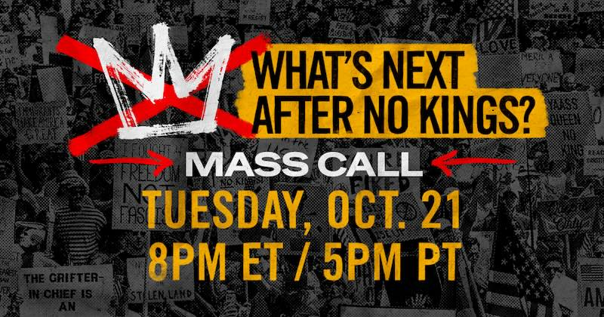

Join the What’s Next After No Kings Mass Call on Tuesday, October 21, at 8pm ET/5pm PT. No Kings will be massive, powerful, and meaningful -- but it won’t be the end of our work. Join movement leaders and fellow local activists after the big day to come together, celebrate what we accomplished, and learn about what’s next.

If this is your first event with Wareham for Law and Democracy - WELCOME! While we do have regular community gatherings, we are hosting a special open meeting to debrief NO KINGS 2.0 on Wednesday, October 29th at the Wareham Free Library from 6:00-7:30PM.

Upcoming events include: Weekly Saturday Standouts at Wareham Town Hall (54 Marion Road) 11:30-12:30 (collecting food for local food pantries) ; Friday and Sunday afternoon overpass visibility events, monthly meetings each second Wednesday, and groups working on postcarding, youth/school intervention, churches/faith groups, communications, voter registration, ICE/immigration and more. To get in touch go to our website and complete the short interest form - we'll get back to you!

Thank you again for joining us on this important day! Maryanne, Wareham For Law and Democracy

