Wareham
for
Law and Democracy

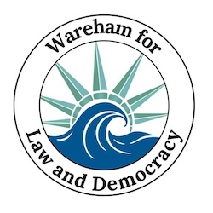

Updates For the Week of Jan. 1 - 7
Party and Prep Edition

  Sat. Dec. 27
  Stand Out
  Attendance
  43
  ❄️
  Welcome to 2026! We got through 2025 and saw devastating changes as well as brave communities protecting their neighbors, concerned citizens venting their outrage by the millions and grassroots organizations finding ways to oppose and rebuild.
  Do Something Different
  WLD is more than just the Saturday Stand Outs. Join our upcoming events to find ways to make a difference that build on your concerns, strengths, resources and experiences.
  Sat. Jan. 3
  Stand Out
  Attendance
  62
  🌤

Our 1st big event is hopefully an easy one: come party with us! We're hosting a "Friend-Raising" event on Jan. 20 to get to know each other better and enhance our resistance and readiness.

Which brings us to our 2nd event: come to next week's workshop! On Jan. 14 We'll learn just how much we can do in the face of a flood of bad government and how to stay motivated in the face of a flood of bad media.

Please register at those links so we can keep you updated and let our sponsors & speakers know that Wareham turns out when called to action.

  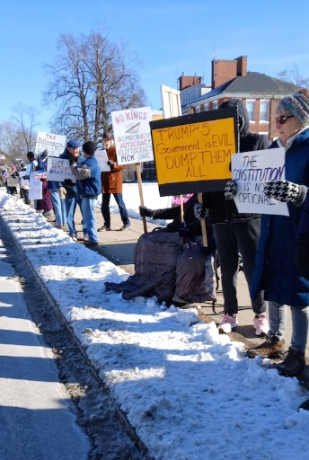
  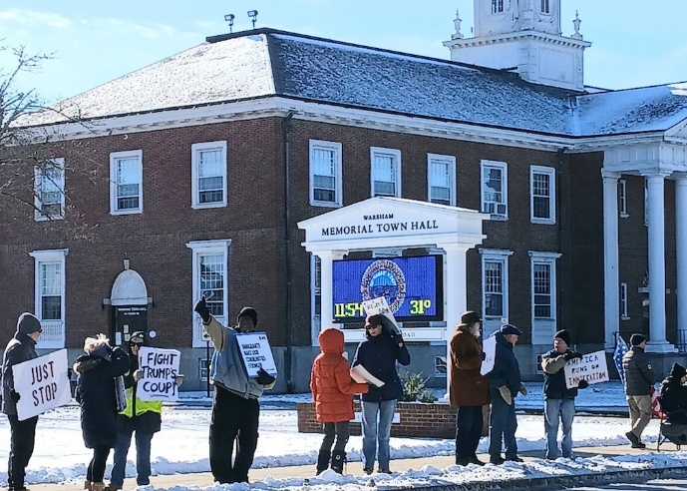
  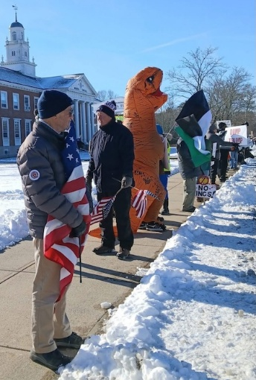

Jan. 14 Readiness, Resilience, and Resistance:
A Workshop for What Lies Ahead

Indivisible continues to build the Democracy movement and mitigate harm. This workshop will help each of us lay the foundation for mutual aid in the face of disruptions by strikes or authoritarian aggressions.

The Boston Trainers Collective is a group of volunteer activists and organizers associated with a variety of racial and social justice organizations in Greater Boston. This is a two-hour workshop on building personal and collective readiness and resilience to resist authoritarianism and prepare our communities for other challenges that may lie ahead, such as climate-related emergencies, economic uncertainty, and social unrest. Participants will leave with a personalized list of actions they can take immediately to start building their readiness, resilience, and resistance muscles and mindset.

Free Workshop Registration

January 20 "Anti-versary" Party

Hey South Coast community! Remember January 20th last year? Sigh....
Let's mark this anti-versary with camaraderie, good food, craft beers and even some fun and games!
It will be like our stand out only warmer and with chairs!
Connect with your Saturday buddies and meet new people!

Join us at Stone Path Malt on Tuesday, Jan 20th from 6:00-8:00PM
We'll be serving complimentary appetizers
$10 donation (more if you can/less if you can't) - cash bar & meal menu

Please RSVP below and bring some new folks too!

Yes! I'm coming to the Anti-versary Party!

Take Action Now!

- Saturday Stand Out 🇺🇸 at Wareham Town Hall from 11:30 - 12:30 every Saturday!
- Overpass Banner Brigade 🚙 on Fridays and Sundays from 3:00 - 4:00 (see details below)
- Bridging the Divide coffee, quiche & conflict-resolution Jan. 22 10:00am (see details below)

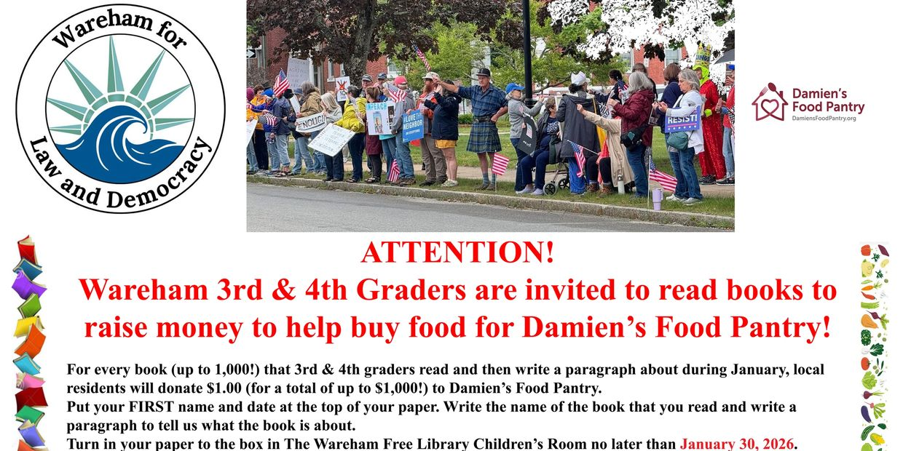

Action Updates

Overpass Banner Brigade
Our overpass banner crew is lighting up the evening commute over Rt. 25, put on your bright holiday clothes and some festive lights and join us! We'll continue to shine Liberty's light from 3:00 to 4:00, Fridays and Sundays, over Rt. 25.
Fridays we meet at Tihonet Road, which has a dirt parking spot on the west side of the road at the end of the cranberry bog, just south of the overpass .
Sundays we meet at Maple Springs Road, near the westbound entrance to Rt 25, with parking in the DOT Park & Ride lot just south of the overpass.
Bridging the Divide
Our next meeting to explore ways to restore civility with our neighbors across sociopolitical boundaries will be Thursday, Jan. 22 , 10 AM at Dr. Carl Swanson's house, 40 Mayflower Ridge Dr., please RSVP to puccini1@aol.com if you can make it! There'll be coffee and quiche and camaraderie.
We'll hand out a resource packet modeling language which can diffuse contention and invite collaborative conversation and look at a national organization established during the first Trump administration with the precise purpose of building civic and civil discourse. We'll use these materials to reflect on our own past interactions as well as to discuss steps forward.
Weather Warnings
When winter treats us to some cold, snowy days that make travel hazardous (and staying inside appealing), we'll send out an email on Saturday morning at 10:30 to let you know if we're declaring a snow day. That doesn't mean that you can't go, but if you do, dress warmly and drive safely!

❤️ Thank You ❤️

We know the times are scary and actions may feel futile but every bit helps. Coming to the Saturday Stand Out for an hour makes each of us appreciate a community of kindred spirits. Calling a friend who's struggling to ask "How are you?" lightens their day. Even opening this email encourages us to keep writing them. Thank you for caring.

 | 

Paid for by Indivisible
Wareham for Law and Democracy
Wareham
Wareham, MA 02571
United States

If you believe you received this message in error or wish to no longer receive email from us, please
unsubscribe.

