Wareham
for
Law and Democracy

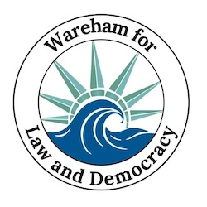

Updates For the Week of Nov. 15-22

  Winter weather is arriving but we aren't going anywhere! As long as it's safe to drive, we'll keep our Saturday Stand Outs going strong, and that includes Saturday, November 29 when we'll give thanks for our neighbors and strong community. We hope you'll continue to join us, no signs needed, we have extras! We want Wareham to know that we're not fair-weather citizens and we'll stand up for Americans, our laws and our democracy against the storm.
  Saturday
  Stand Out
  Attendance
  98

We have new Wareham for Law and Democracy t-shirts and caps available at Saturday Stand Outs for a suggested donation of $20 and we can now accept donations on our website through our partnership with Indivisible and ActBlue. 100% of the donations will be received by Wareham for Law and Democracy.
But as much as we appreciate your donations, if you have to choose, please donate to Damien's Food Pantry or the Friends of Bourne Council on Aging Food Pantry to ensure that our neighbors have happier holidays this year.

  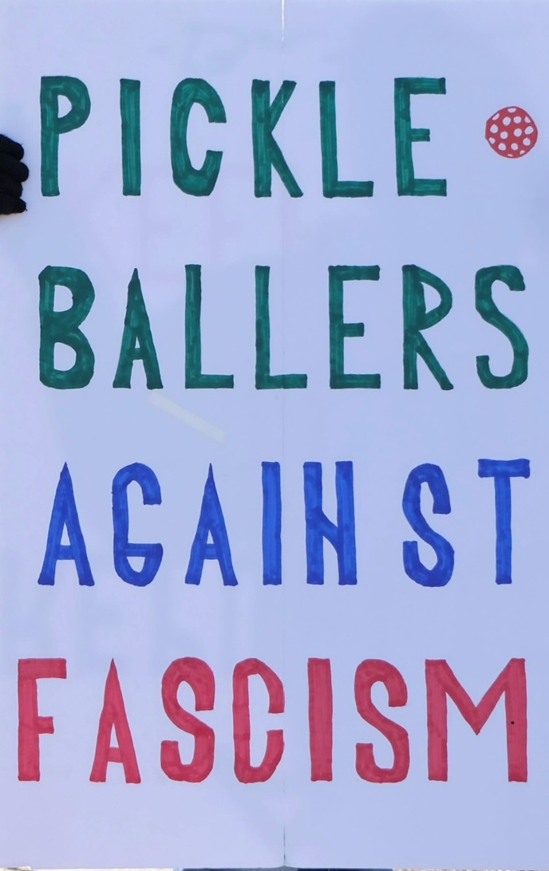
  Take Action Now!
  - Saturday Stand Out at Wareham Town Hall from 11:30 - 12:30 every Saturday!
  - Overpass Banner Brigade on Fridays and Sundays from 3:00 - 4:00 (see details below)
  - Community Gathering to discuss actions on Weds. Dec. 10, 6:00pm (location TBD)
  - Black Friday Boycotts of Amazon, Target & The Home Depot (see details below)

Have a Brush (or Ramp or Window) with Kindness

Habitat for Humanity is well-known for building houses for people in need but did you know they also provide them with wheelchair ramps, weatherization and critical home improvements? The "Brush with Kindness" program is part of the Home Preservation initiative to provide low income families with safe homes, to help seniors stay in their homes and to solve accessibility challenges with porch repairs and ramps. The work is performed by local volunteers with guidance from professional builders and architects to ensure structural safety and reliability. The materials are donated by local businesses or purchased with donations.
Since starting in 2024, Buzzards Bay Area Habitat for Humanity has completed 40 ramp installs and home repairs in our area, for recipients aged 17 to 95 years old.
Volunteering is easy and requires no prior building skills, in fact it's a great way to learn about tools and home maintenance from seasoned professionals! Most ramp builds only take 2-3 hours and everything you'll need is on-site. If you're interested, visit Buzzards Bay Area Habitat for Humanity to sign up, or to share information with other potential volunteers, donors and especially with those who need this kind of help!

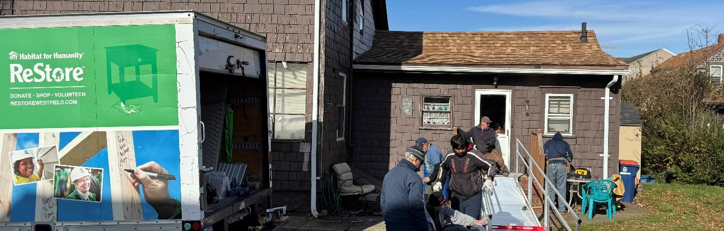

Lead with Hope not Fear

Our events are non-violent and each other's well-being is our greatest concern. If you feel confronted or endangered by someone, don't engage them or yell back, just walk away and find one of our event organizers in a yellow safety vest who are trained for de-escalation and community safety. Avoid feeding into the hostile atmosphere that disrupters may attempt to create. Stay cool, calm, and respectful.

Action Updates

Overpass Banner Brigade is Back!
After pausing for a few weeks to make sure we're in compliance with local ordinances, we've returned with even better signs to the overpass! Our overpass visibilities are held from 3:00 to 4:00, Fridays and Sundays, over Rt. 25.
Fridays we meet at Tihonet Road, which has a dirt parking spot on the west side of the road at the end of the cranberry bog, just south of the overpass .
Sundays we meet at Maple Springs Road, near the westbound entrance to Rt 25, with parking in the DOT Park & Ride lot just south of the overpass.
Economic Boycotts
Multiple groups are focusing boycotts on Amazon, Target and The Home Depot for the end of November and start of December. This is a great time to buy from local merchants instead and support our community economy while sending a message to giant corporations. And you can amplify your effect by posting on social media with help from We Ain't Buying It!
Bridging the Divide
The Bridging the Divide breakfast at Cranberry Cottage on Thursday was a success and we're hoping to organize more events about civil discussion among Americans so stay tuned! Until then, this brief documentary of Bernie Sanders talking with West Virginians is inspirational and the book Getting to Yes is a helpful guide to negotiating difficult conversations (over turkey dinners or otherwise).
Communications
Saturday Sing Out! Let’s lift our voices in harmony at our Saturday Stand Outs with this list of chants and song lyrics you can pull up on your phone. And if you’re interested in really harmonizing, join the rehearsals at the Wareham Library from 10-11am on Dec. 13th and Dec. 20th right before the stand outs!
Voter Registration (+ Youth Outreach)
Our volunteers assisted the Wareham Democratic Town Committee with its annual outreach to pre-register high school seniors to vote so they're ready to go on their 18th birthday. Over 300 postcards and envelopes were prepared and mailed this week.
ICE Watch
Our local volunteers have started attending verifier trainings presented by LUCE, the Immigrant Justice Network of Massachusetts, to ensure that we know safe and effective methods of documenting incidents and advocating for victims. If you’re interested in participating, register here.

❤️ Thank You ❤️

We know the times are scary and actions may feel futile but every bit helps. Coming to the Saturday Stand Out for an hour makes each of us appreciate a community of kindred spirits. Calling a friend who's struggling to ask How are you? lightens their day. Even opening this email encourages us to keep writing them. Thank you for caring.

 | 

paid for by Indivisible
Wareham for Law and Democracy
Wareham
Wareham, MA 02571
United States

If you believe you received this message in error or wish to no longer receive email from us, please
unsubscribe.

