



FOR OFFICE USE ONLY: BC__

M __ AP___

M

_

T__ W__ Th_

_ F

__

DSS __ NEW__



Contact: Kirk - 914-481-7415 | Fax: 914-963-4140

Email: Goalprogram@live.com

Website: www.mygoalprogram.com

# APPLICATION

(Please Print)

Child’s Last Name: ______________________ First Name:_______________________ M.I. ___ DOB ____________

Child Teachers Name: _____________ Child Grade: ____Age: ____ Gender: M__ F__ School: ________________

Mother’s Full Name/Guardian________________________________________ Cell: ________________________

Personal Email: ________________________________________________________________________________

Address_______________________________________ apt # ____City ______________State____ Zip __________

Job Location & Address: ___________________________________________ City ________ State ____ Zip ______

Work Phone: __________________ ext _______ Work Email:____________________________________________

Father’s Full Name/Guardian_____________________________________ Cell: ____________________________

Personal Email: ________________________________________________________________________________

Address_______________________________________ apt # ____City ______________State____ Zip __________

Job Location & Address: ___________________________________________ City ________ State ____ Zip ______

Work Phone: __________________ ext _______ Work Email:____________________________________________

Emergency Contact List:

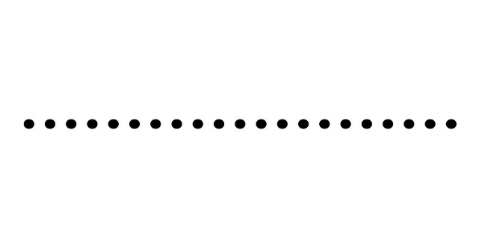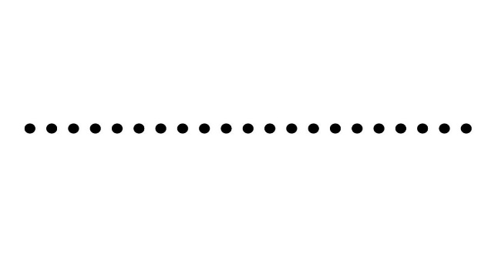Name:____________________________Phone:______________________Cell___________________ Name:____________________________Phone:______________________Cell___________________

Does your child have any allergies? __________, If YES, must complete additional forms.

Does your child have any medical conditions or taking any medications? ______________________

Primary care Physician’s name ________________________ Phone#:__________________________

A COPY OF YOUR CHILD’S MEDICAL FORM IS NEEDED TO COMPLETE THIS APPLICATION!

I agree for my child’s picture to be taken for the After-School bulletin board, flyer, and website. Yes ___ or No ____

AFTER-SCHOOL PROGRAM

We agree to provide After-School programs for your child (ren), during the hours of 2/3:00 pm to 6:00pm, Monday through Friday.

AFTER-SCHOOL FEES

Payment is due every week on Monday or first school day of that week. Registration is a one time fee of $25. Late fee is $15 per 15 minutes after 6pm.We provide sibling discount please ask After-School Director for further details.

HOLIDAY & SCHOOL CLOSINGS:

After-School Program will follow Yonkers Public School calendar. *AFTER-SCHOOL PROGRAM WILL BE CLOSED, WHEN SCHOOL IS CLOSED, AND CLOSED FOR HALF SCHOOL DAYS AS WELL.* Weekly after-school fees will be adjusted for weeks when school is closed for two or more consecutive days per week (due to emergency closings).

SICKNESS:

If your child becomes sick during After-School programs, a Parent/Guardian will be called immediately. If any child is hurt or severely injured, After-School Program will follow the NYS Office of Children and Family Services guidelines. *Additional information will be provided in the GOAL Program Parent Guide.*

We reserve the right to exclude any child (ren) from attending our After-School Program who is clearly physically aggressive, as well as poses a physical threat to themselves or the safety of the other children in our care.

My child will attend Afterschool at: School 31____ School 29_____ School 22______ Pearls_______

Option 1 - For After-School Programs 4-5 days a week is $155 per week (Children attending Pearls, fee is $170 per week). Please check following days your child will attend. M____ T ____W _____ Th _____ F_____

Option 2 – For After-School Programs 2-3 days per week is $130 per week (Children attending Pearls, fee is $145 per week). Please check following days your child will attend, M _____ T ______W _____ Th ______ F ______

ALL AFTER-SCHOOL FEES ARE NON-REFUNDABLE. ALL FEES ARE PAID USING THE GOAL PROGRAM AUTOMATIC PAYMENT FORM. THANK YOU FOR CHOOSING THE GOAL PROGRAM!

______________________________________________ ______________________

Parent/Guardian Signature Date

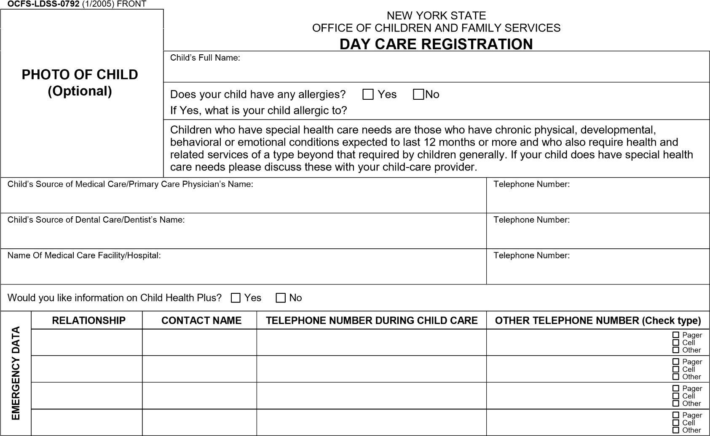

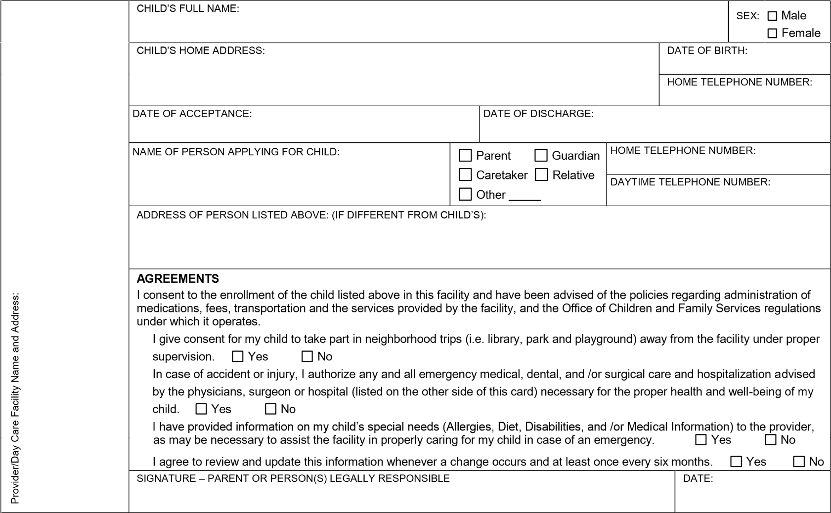



### Recurring Payment Authorization Form

Schedule your payments to be automatically deducted from your bank account, or charged to your Visa, MasterCard, American Express or Discover Card. Just complete and sign this form to get started!

Recurring Payments Will Make Your Life Easier:

* It’s convenient (saving you time and postage)
* Your payment is always on time (even if you’re out of town), eliminating late charges

Here’s How Recurring Payments Work:

You authorize regularly scheduled charges to your checking/savings account or credit card. You will be charged each billing period for the total amount due for that period. A receipt will be emailed to you and the charge will appear on your bank or credit card statement.

Please complete the information below:

Child(ren) Names: ____________________________________ After-School attending: ______________________

I ______________________________________ authorize The Goal Program to charge/debit my account

(full name)

indicated below on the MONDAY of each week for payment of my Afterschool Service.

Total Due: $_____________ Payment Frequency:__________________

Start Date: ______________ End Date: _________________________

Billing Address ________________________________ Phone# ________________________

City, State, Zip ________________________ (required)Email_______________________________

*Checking/ Savings Account Credit Card*

|  |  |  |
| --- | --- | --- |
| Checking Savings  Name on Acct _________________________  Bank Name _______________________  Account Number ____________________  Bank Routing # ____________________  Bank City/State ____________________ |  | Visa MasterCard Amex Discover  Cardholder Name ______________________  Account Number ______________________  Exp. Date _________  CVV (3 digit number on back of card) ______ |

I understand that this authorization will remain in effect until I cancel it in writing, and I agree to notify The Goal Program in writing of any changes in my account information or termination of this authorization at least 7 days prior to the next billing date. If the above noted payment dates fall on a weekend or holiday, I understand that the payments may be executed on the next business day. For ACH debits to my checking/savings account, I understand that because these are electronic transactions, these funds may be withdrawn from my account as soon as the above noted periodic transaction dates. In the case of an ACH Transaction being rejected for Nonsufficient Funds (NSF) I understand that The Goal Program will process the charge again within 2 business days, and agree to an additional $10 charge for each attempt returned NSF which will be added to the current bill. I acknowledge that the origination of ACH transactions to my account must comply with the provisions of U.S. law. I certify that I am an authorized user of this credit card/bank account and will not dispute the scheduled transactions with my bank or credit card Company; provided the transactions correspond to the terms indicated in this authorization form.



Medical Statement of Child in Childcare

To Be Completed By Licensed Physician, Physician’s Assistant or Nurse Practitioner

|  |  |  |  |  |
| --- | --- | --- | --- | --- |
| Name of Child: |  | Date of Birth: |  | Date of Examination: |

Immunizations required for entry into day care Yes No

Medical Exemption The physical condition of the named child is such that one or more of the immunizations would endanger life or health. Attach certification specifying the exempt immunization(s).

|  |  |  |  |  |  |
| --- | --- | --- | --- | --- | --- |
| Diphtheria, Tetanus and Pertussis (DPT) Diphtheria and Tetanus and acellular Pertussis (DTaP) | 1st Date | 2nd Date | 3rd Date | 4th Date | 5th Date |
| Polio (IPV or OPV) | 1st Date | 2nd Date | 3rd Date | 4th Date |  |
| Haemophilus influenzae type B (Hib) | 1st Date | 2nd Date | 3rd Date | 4th Date OR 1st Date (if given on or after 15 months of age) | |
| Pnuemococcal Conjugate (PCV) for those born on or after 1/1/08) | 1st Date | 2nd Date | 3rd Date | 4th Date |  |
| Hepatitis B | 1st Date | 2nd Date | 3rd Date |  |
| Measles, Mumps and Rubella (MMR) | 1st Date | 2nd Date |  |
| Varicella (also known as Chicken Pox) | 1st Date | 2nd Date |

Other Immunizations may include the recommended vaccines of Rotavirus,

Influenza and Hepatitis A

|  |  |  |  |
| --- | --- | --- | --- |
| Type of Immunization: | Date: | Type of Immunization: | Date: |
| Type of Immunization: | Date: | Type of Immunization: | Date: |
| Type of Immunization: | Date: | Type of Immunization: | Date: |

Tests

|  |
| --- |
| Tuberculin Test Date: / / Mantoux Results: Positive Negative mm  TB Tests are at the physician’s discretion.  If positive, or if x-ray ordered, attach physician’s statement documenting treatment and follow-up.  Lead Screening Date: / /  Attach lead level statement  Lead Screening (Include All Dates and Results)  1 year / / Result: mcg/dL Venous Capillary  2 years / / Result: mcg/dL Venous Capillary  Most recent date of lead screening (if different from above):  / / Result: __________________ mcg/dL Venous Capillary  Per NYS law, a blood lead test is required at 1 and 2 years of age and whenever risk of lead poisoning is likely. If the child has not been tested for lead, the day care provider may not exclude the child from child day care, but must give the parent information on lead poisoning and prevention, and refer the parent to their health care provider or the county health department for a lead blood screening test. |

*ADDITIONAL INFORMATION ON REVERSE SIDE*→

OCFS-LDSS-4433 (Rev. 4/2008) REVERSE



Medical Statement of Child in Childcare

(continued)

Health Specifics Comments

|  |  |  |  |
| --- | --- | --- | --- |
| Are there allergies? (Specify) | Yes | No |  |
|  |
| Is medication regularly taken?  (Specify drug and condition) | Yes | No |  |
|  |
| Is a special diet required?  (Specify diet and condition) | Yes | No |  |
|  |
| Are there any hearing, visual or dental conditions requiring special attention? | Yes | No |  |
|  |
| Are there any medical or developmental conditions requiring special attention? | Yes | No |  |
|  |

Summary of Physical Exam

  Include special recommendations to Day Care Providers

On the basis of my findings as indicated above and on my knowledge of the named child, I find

that: he/she is free from contagious and communicable disease and is able to participate in day

care. Yes No

Signature of Examiner Address

Please Print Name City, State, Zip

Title Phone Date

Religious Exemptions

Public Health law Section 2164 allows a child to be religiously exempted from immunization. A written and signed statement from a parent, parents or guardian of the child stating that they object of the immunization of their child due to their sincere and genuine religious beliefs should be submitted to the day care owner, operator or administrator who shall determine whether the statement of religious belief is acceptable.