All 12 MyEverythingDiSC Style Podcasts​
- 60 Minutes -
(click to stream)

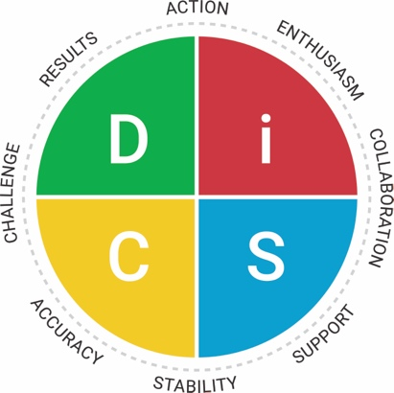
The Di Style The iD Style
The D Style The i Style
The DC Style The iS Style
The CD Style The Si Style
The C Style
The S Style
The CS Style The SC Style

Compliments of The HR Lady ® and Wiley
www.thehrlady.com

All 12 My Everything DiSC Style Podcasts​
60 Minutes each
(click to stream)

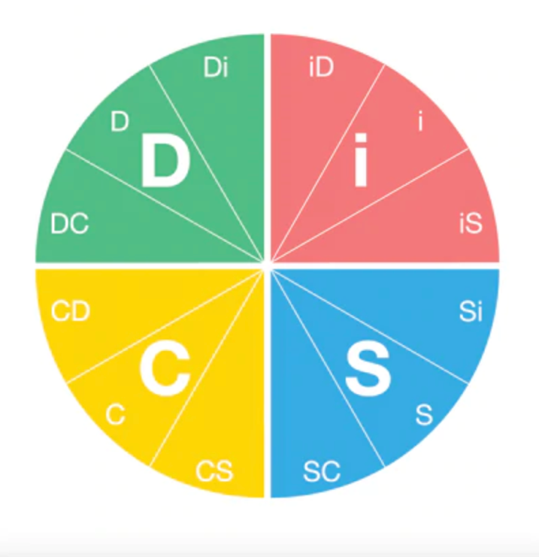
The DC Style
The D Style
The Di Style

The iD Style
The i Style
The iS Style

The Si Style
The S Style
The SC Style

The CS Style
The C Style
The CD Style

Compliments of The HR Lady ® and Wiley

